

**American University of Beirut**

**School of Engineering and Architecture**

**Department of Electrical and Computer Engineering**



Team 9

A Database Design for a Library

By:

**Mohamad Hamdan (Group Leader)**

([myh17@mail.aub.edu](mailto:myh17@mail.aub.edu))

**Tia El Khoury**

([tne12@mail.aub.edu](mailto:tne12@mail.aub.edu))

**Zakaria Labban**

([zbl00@mail.aub.edu](mailto:zbl00@mail.aub.edu))

A REPORT

submitted to Dr. Hussein Bakri in partial fulfillment of the requirements of the database project for the course EECE433 – Database Systems

December 2024

Table of Contents

**1.** **Introduction** 5

**2.** **References/ Copyright** 6

**3.** **Tool used to draw the ER** 6

**4.** **System Description and Requirements** 7

**5.** **Legend of ER diagram symbols** 8

**6.** **Complete OLD ER Diagram for the LibTech Database** 9

**7.** **New Complete Amended ER Diagram for the LibTech Database** 10

**7.1 Entity Types & Their Attributes** 11

**7.2 Relationships and their explanations** 17

**8.** **ER to Relational Mapping** 23

**8.1 – Step 1 – Mapping Strong Entity Types** 23

**8.2 – Step 2 – Mapping of Weak Entity Types** 24

**8.3 – Step 3 – Mapping of Binary 1:1 Relationship Types** 24

**8.4 – Step 4 – Mapping of Binary 1:N Relationship Types** 25

**8.5 – Step 5 – Mapping of Binary M:N Relationship Types** 26

**8.6 – Step 6 – Mapping of multivalued attributes** 26

**8.7 – Step 7 – Mapping of N-ary attributes** 27

**9.** **Final Display – all tables** 27

**10.** **Table States** 29

**11.** **Creation of Tables** 36

**12.** **Insertion of Data** 56

**13.** **Complex Transactions** 92

**14.** **Views / Triggers / Functions / Procedures** 114

**15.** **Bonuses** 133

**15.1 Recursive Query: Track Borrowing Chains for a Book** 133

**15.2 Security Mechanism 1: Encryption & Decryption of Sensitive Data** 137

**15.3. Security Mechanism 2: Implementing SQL Injection Prevention** 139

**15.4 Security Mechanism 3: Row Level Security** 141

**16.** **Normalization** 143

**17.** **Conclusion** 157

Table of Figures

Figure 1: Legend of ER Diagram 8

Figure 2: Old ER Diagram of LIBTECH 9

Figure 3: New ER Diagram of LIBTECH 10

Figure 4: Library Entity 11

Figure 5: Books_for_Sale Entity 11

Figure 6: Books_for_Rent Entity 12

Figure 7: Items Entity 13

Figure 8: Supplier Entity 13

Figure 9: Authentication_System Entity 14

Figure 10: Staff Entity 14

Figure 11: Dependents Entity 15

Figure 12: Customer Entity 16

Figure 13: Publisher Entity 16

Figure 14: Supervises Relationship 17

Figure 15: Dependents Relationship 17

Figure 16: Logs_in Relationship 18

Figure 17: Works_at Relationship 18

Figure 18: Supplies Relationship 19

Figure 19: Stores_items Relationship 19

Figure 20: Borrows Relationship 20

Figure 21: Publishes Relationship 20

Figure 22: Sale_to_Rent Relationship 21

Figure 23: Stores_Booksforrent Relationship 21

Figure 24: Stores_bookforsale Relationship 22

Figure 25: Purchase_Items Relationship 22

Figure 26: Buys_Books Relationship 23

Figure 27: Creation of Authentication_System Relation 36

Figure 28: Creation of Customer Relation 37

Figure 29: Creation of Libraryy Relation 38

Figure 30: Creation of Staff Relation 38

Figure 31: Creation of Dependents Relation 39

Figure 32: Creation of Supplier Relation 40

Figure 33: Creation of Publisher Relation 41

Figure 34: Creation of Items Relation 41

Figure 35: Creation of Books_for_Sale Relation 42

Figure 36: Creation of Books_for_Rent Relation 43

Figure 37: Creation of Authors_BookSale Relation 44

Figure 38: Creation of Authors_BookRent Relation 44

Figure 39: Creation of Stores_Items Relation 45

Figure 40: Creation of Stores_BooksforSale Relation 46

Figure 41: Creation of Buys_Books Relation 46

Figure 42: Creation of Purchases_Items Relation 47

Figure 43: Creation of Borrows Relation 48

Figure 44: Creation of Sales_to_Rent Relation 48

Figure 45: Inserting Data into Authentication_System Relation 57

Figure 46: Inserting Data into Customer Relation 58

Figure 47: Inserting Data into Libraryy Relation 59

Figure 48: Inserting Data into Staff Relation 60

Figure 49: Inserting Data into Dependents Relation 61

Figure 50: Inserting Data into Supplier Relation 62

Figure 51: Inserting Data into Items Relation 63

Figure 52: Inserting Data into Publisher Relation 64

Figure 53: Inserting Data into Books_for_Sale Relation 65

Figure 54: Inserting Data into Books_for_Rent Relation 66

Figure 55: Inserting Data into Authors_booksale Relation 67

Figure 56: Inserting Data into Authors_bookrent Relation 68

Figure 57: Inserting Data into Stores_Items Relation 69

Figure 58: Insertingt Data into Stores_booksforsale Relation 70

Figure 59: Inserting Data into Buys_Books Relation 71

Figure 60: Inserting Data into Purchases_Items Relation 72

Figure 61: Inserting Data into Borrows Relation 73

Figure 62: Inserting Data into Sale_to_Rent Relation 74

Figure 63: Complex Transcation: Top 5 Borrowed Books 93

Figure 64: Complex Transaction 2: Customers with Unreturned Books 95

Figure 65: Complex Transaction 3: Branch with High Number of Rentals 96

Figure 66: Compelx Transaction 4: Customer with Total Spendings and most Visited Branch 98

Figure 67: Complex Transaction 5: Categorization of Customers 101

Figure 68: Complex Transaction 6: Top 5 Suppliers 103

Figure 69: Complex Transaction 7: Customers Purchasing more than one time from a Branch 105

Figure 70: Complex Transaction 8: Staff Managing Highest Number of Items 106

Figure 71: Complex Transaction 9: Library Branches Low on Inventory 108

Figure 72: Complex Transaction 10: Total Revenue from Sales by Library Branch 110

Figure 73: Complex Transaction 11: Customers Borrowing and Selling Same Book Title 112

Figure 74: Librarians Working Most Hours across all Branches 113

Figure 75: View 1: Supplier Supply Summary 116

Figure 77: Trigger 1: Updating Quantity after a Purchase 118

Figure 78: Trigger 2: Preventing a User from Borrowing if Due Date has passed **Error! Bookmark not defined.**

Figure 79: Function 1: Book Availability in a Branch 123

Figure 80: Function 2: Total Inventory Value for a Branch 125

Figure 81: Stored Procedure: Transfer Books among Branches 127

Figure 82: Trigger and Function: Moving a book from Sale to Rent 133

Figure 83: Recursive Query: Track Borrowing Chains for a Book 135

Figure 84: Decryption of Sensitive Data 138

Figure 85: Encryption of Sensitive Data 138

Figure 86:SQL Injection Prevention 140

Figure 87: Row Level Security 143

# **Introduction**

Following Dr. Zaher's suggestion to expand the scope of our library management system, we embraced the opportunity and accepted the challenge to enhance its functionality. The aim was to go beyond traditional borrowing and introduce the option for customers to both purchase books and buy additional items such as CDs, games, and stationery. In response, we have adjusted the ER diagram to reflect these new capabilities. The updated design now includes entities such as Customer, Books for Rent, Books for Sale, and a consolidated Items entity that incorporates all non-book products. These modifications provide a more comprehensive and versatile system, allowing users to borrow, and purchase a variety of items within a single platform, streamlining the library's services.

The main motivation for creating the database system for the library is to address and solve these challenges by offering a structured database for data management. This database will help keep track of items, users, and transactions more precisely, reducing errors, and making resources easier to find and draw inferences when needed. By organizing information in a clear and accessible way, our goal is to satisfy the demands of different stakeholders, including library staff and customers. The requirements of each of these user groups vary; for instance, library staff needs efficient tools for inventory management, while customers want quick access to a wide variety of high-quality, reliable information that may not be available through a general search engine like Google; this includes articles from academic journals, magazines, and newspapers.

This report outlines the new design of the LibTech database using an Entity-Relationship (ER) diagram. Section 1 introduces the scope and objectives of the report. Section 2 provides references and addresses copyright considerations for all sources, including articles and books. Section 3 describes the tool employed to create the ER diagram. Section 4 elaborates on the system’s description and its requirements. Section 5 includes a legend explaining the symbols used in the ER diagram.

Section 6 showcases the complete old ER diagram for the LibTech database. Section 7 introduces the amended ER diagram, which includes detailed descriptions of entity types and their attributes (Section 7.1) as well as the relationships and their explanations (Section 7.2). Section 8 discusses the ER-to-relational mapping process, breaking it down into several steps: mapping strong entity types (Section 8.1), weak entity types (Section 8.2), binary relationships (Sections 8.3–8.5), multivalued attributes (Section 8.6), and N-ary relationships (Section 8.7).

Section 9 presents all tables resulting from the mapping process, highlighting primary and foreign keys. Section 10 focuses on the states of these tables. Section 11 provides detailed steps for creating tables, while Section 12 demonstrates the insertion of sample data into the database. Section 13 delves into complex transactions, offering practical examples.

Section 14 explores advanced functionalities of the database, including views, triggers, functions, and stored procedures. Section 15 highlights bonus implementations, such as a recursive query to track borrowing chains for a book (Section 15.1) and security mechanisms, including encryption and decryption of sensitive data (Section 15.2), SQL injection prevention (Section 15.3), and row-level security (Section 15.4). Section 16 handles the normalization of our relations and checks whether each table satisfies 1NF, 2NF, 3NF, and BCNF. Finally, Section 17 concludes the report.

# **References/ Copyright**

Elmasri, R., & Navathe, S.B. (2017). Fundamentals of database Systems.

Library of Congress Network Development and MARC Standards Office. (n.d.). MARC 21 format for bibliographic data: Table of Contents (Network Development and MARC Standards Office, Library of Congress). <https://www.loc.gov/marc/bibliographic/>

GeeksforGeeks. (2024, January 19). ER diagram of Library Management System. *GeeksforGeeks.* <https://www.geeksforgeeks.org/er-diagram-of-library-management-system/>

Engineering Library at AUB – Mr. Khaled Noubani

Jafet Library at AUB – Ms. Basma Chebani

Chat Gpt for the generation of data inserted into the tables

W3Schools Online Web Tutorials

# **Tool used to draw the ER**

For the design of the Entity-Relationship (ER) diagram for the library database, we utilized Draw.io. This diagramming tool offers a user-friendly interface and a wide range of features that facilitate the creation of complex diagrams. Draw.io allows users to easily drag and drop shapes and connect entities with lines.

# **System Description and Requirements**

* We have several libraries; each library has a branch ID, an address, and a phone number.
* We have several Staff members; each staff member has a name composed of first name and last name, a salary, a date of birth, a position, an SSN, a blood type, and an address.
* Each staff member may supervise one or many other staff members. A staff member may be supervised by another staff member.
* Each staff member can have many dependents. Dependents have a date of birth, a name, a sex and a relationship with the staff member. Dependents shall be dependents of one and only one staff member.
* Each one of the staff must log in to our Authentication System which stores the email and the password of the staff member. Each staff member must log in and create an account only once.
* A staff member must work at only one branch where we keep a record of his/her working hours. A branch shall have at least one staff member.
* We have publishers where each publisher has a name, a phone number and an address.
* A publisher may publish several books for rent and several books for sale.
* A book for rent should be published by only one publisher. A book for sale should also be published by one and only publisher.
* We have customers where each customer has a name composed of first name and last name, a sex, a username, a phone number and an address.
* Each customer must log in to our authentication system only once and create one account.
* We have books for rent, where each book has an ISBN, an edition, a language, a translator, an author or more, a shelf location composed of the shelf number and the row number, a title, a book ID, a price, a genre and a number of pages.
* Each library branch may store a specific book for rent that must be stored at one library branch.
* We have books for sale where each book for sale has a title, an ISBN, a genre, a price, a translator, an edition, a number of pages, a language, and an author or more.
* Each library may store several books for sale where we keep a record of the number of copies.
* A book for sale may be found in several branches of the library.
* Books for sale can be transferred to become books for rent, and we record the date of the transfer, and the discount applied. Some books for rent may have originally been books for sale.
* A customer may borrow many books for rent where we keep a record of the due date, date out, and the penalty that could be applied. A book for rent can be borrowed by one customer.
* A customer can buy many books for sale from many branches of the library where we keep a record of the quantity bought and the date of the purchase.
* We have items where each item has an age group, a name, a barcode, a price, and a genre.
* We have suppliers where each supplier has a name, an address, and a phone number.
* A supplier may supply many items where we keep a record of the date supplied and the quantity supplied. An item shall be supplied by one and only supplier.
* Items may be stored in many library branches where we keep a record of the quantity stored. A library branch may store many items.
* A customer can purchase many items from many library branches where we keep a record of the quantity purchased and the date of the purchase.

# **Legend of ER diagram symbols**

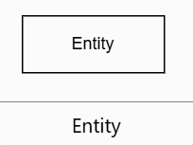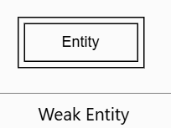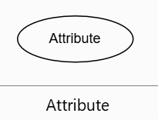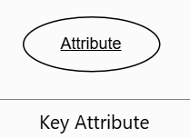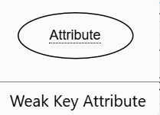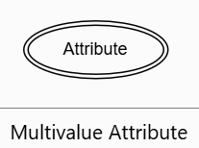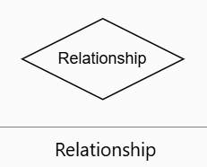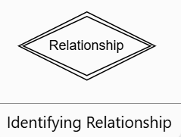

Figure 1: Legend of ER Diagram

# **Complete OLD ER Diagram for the LibTech Database**

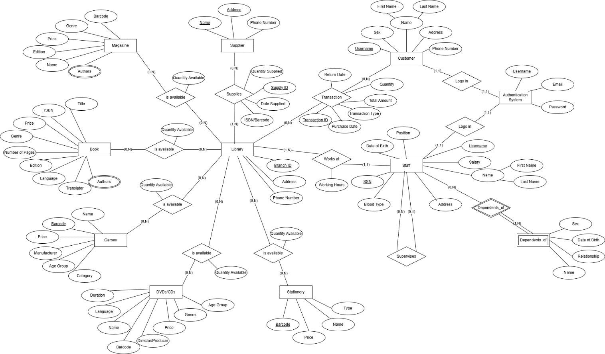

Figure 2: Old ER Diagram of LIBTECH

# **New Complete Amended ER Diagram for the LibTech Database**

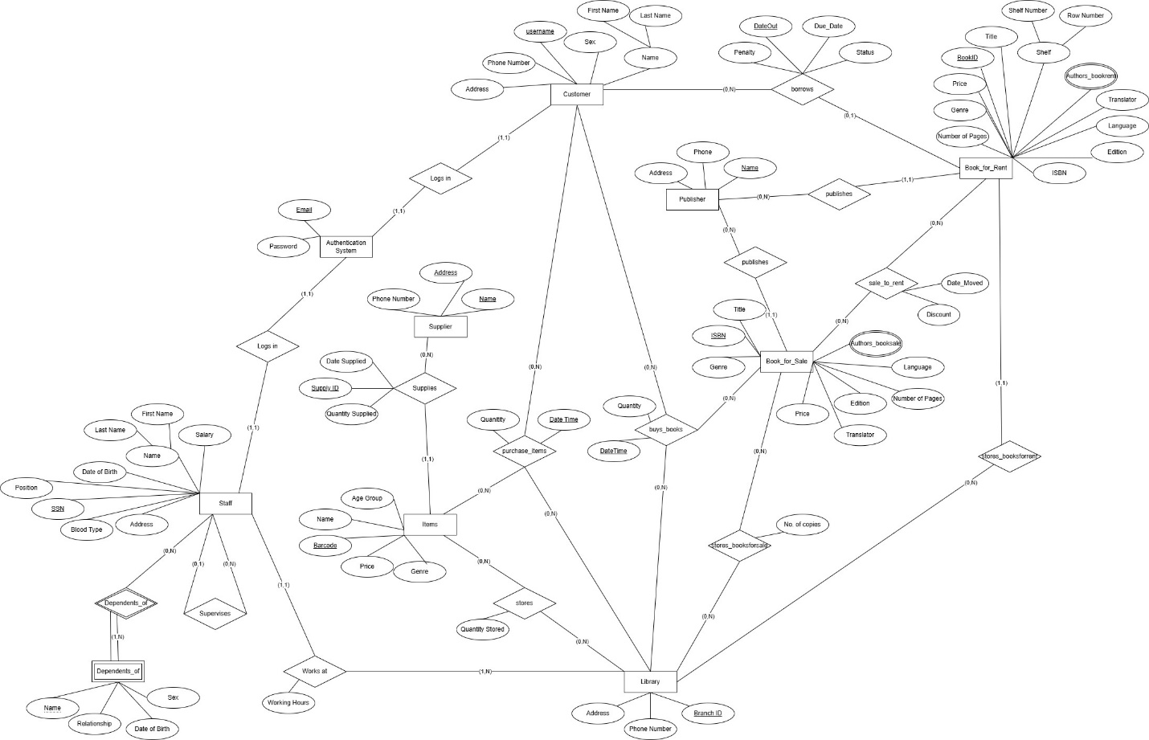

Figure 3: New ER Diagram of LIBTECH

## **7.1 Entity Types & Their Attributes**

**7.1.1 Library:**

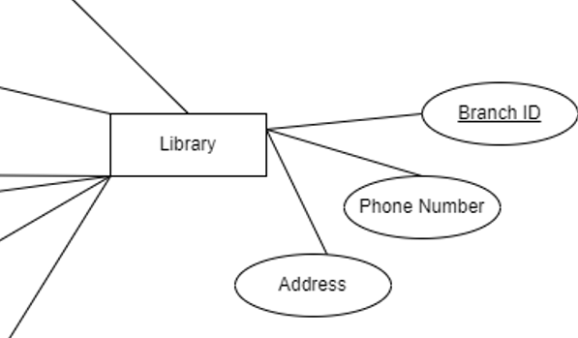

Figure 4: Library Entity

The **library** entity represents the physical or digital branches of the library system. It includes the **Branch ID**, the key attribute uniquely identifying each branch. The **Address** and **Phone Number** attributes provide contact information for each branch, which is essential for users who may need to visit or communicate with a specific location. This entity is central to the library's operations, as it links to other entities like books, magazines, and staff. The **Branch ID** serves as the key attribute because it differentiates between the various branches or physical locations of the library.

**7.1.2 Books_for_Sale:**

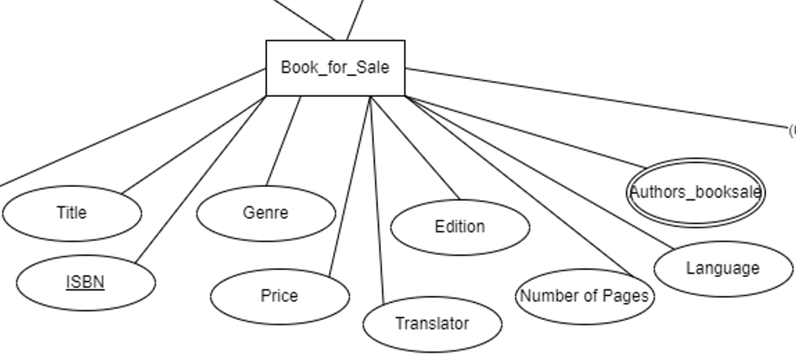

Figure 5: Books_for_Sale Entity

The **Book_for_Sale** entity represents the details of books available for purchase within the library system. It includes key attributes such as **ISBN**, which serves as a unique identifier for each book. Other essential attributes include the **Title**, which specifies the name of the book, and **Genre**, which categorizes the book according to its literary classification, such as fiction, non-fiction, etc.

Additional attributes include the **Price**, and the **Edition**, which provides information on the specific version or release of the book. The **Number of Pages** attribute conveys the length of the book, while **Language** specifies the primary language in which the book is written. For books translated into other languages, the **Translator** attribute identifies the individual or organization responsible for the translation, and finally **Authors_booksale** represents the author(s) of the book.

**7.1.3 Books_for_Rent:**

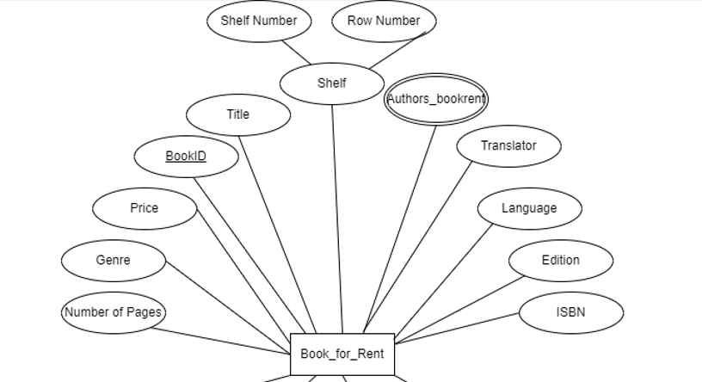

Figure 6: Books_for_Rent Entity

The **Book_for_Rent** entity represents books that are available for borrowing from the library. One key attribute is the **BookID**, which uniquely identifies each book available for rent, allowing for efficient tracking and management. Additionally, the **Title** specifies the book's name, while the **Genre** categorizes the book into specific literary classifications. The **Price** attribute refers to the rental fee, and the **Number of Pages** provides information on the book's length. The **ISBN** serves as a secondary identifier, commonly used to distinguish different editions or versions of the same title. Attributes such as **Edition**, **Language, Authors_bookrent,** and **Translator** give further details about the version of the book available for rent, including its specific edition, the language it is written in, and whether it has been translated. In addition to the book-specific attributes, the **Shelf** attribute represents the physical location of the book in the library. This entity is broken down into **Shelf Number** and **Row Number**, making it easier to find the book within the library's physical space.

**7.1.4 Items:**

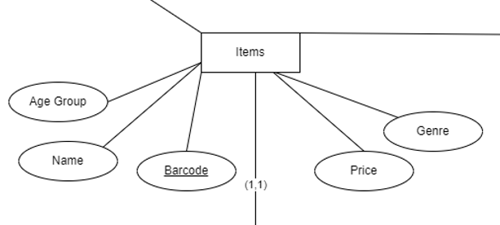

Figure 7: Items Entity

The **Items** entity represents a collection of items available within the library system. Each item in this collection is uniquely identified using a **Barcode**, which serves as the key attribute to differentiate between individual items. The **Name** attribute provides the title or name of the item. Additionally, the **Age Group** attribute specifies the intended audience for the item, whether it be children, teens, or adults. The **Genre** attribute further categorizes the item. The **Price** attribute indicates the cost. Items could range from stationery to DVDs or other forms of media.

**7.1.5 Supplier:**

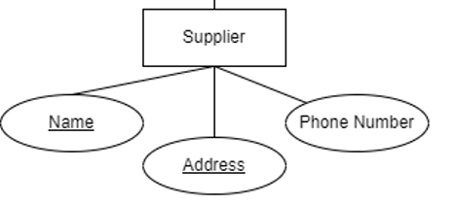

Figure 8: Supplier Entity

The **Supplier** entity represents vendors who provide the items and the books to the library. It includes the **Name**, **Phone Number**, and **Address** attributes. The **Name** identifies the supplier, while the **Phone Number** and **Address** provide contact details. The combination of the **Name** and **Address** uniquely distinguishes one supplier from another, ensuring proper tracking and communication.

**7.1.6 Authentication System:**

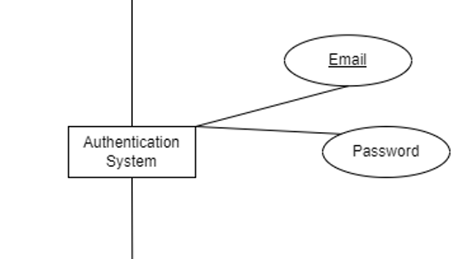

Figure 9: Authentication_System Entity

The **Authentication System** entity is responsible for verifying user access within the library system. It includes two attributes: **Email** and **Password**. The **Email** is the key attribute that identifies the user, while the **Password** ensures secure access.

**7.1.7 Staff:**

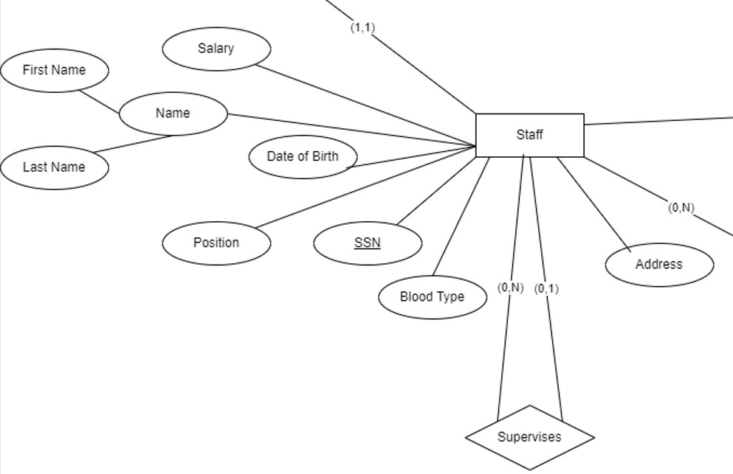

Figure 10: Staff Entity

The **Staff** entity represents employees working within the library. It contains personal and professional attributes. **Name** which is composed of **First Name**, **Last Name**, and **Date of Birth** are used to identify staff members, while the **SSN** (Social Security Number) provides a unique identifier for each staff member. The **Position** attribute defines the employee's role within the organization, and the **Salary** indicates their compensation. Other attributes include **Address**, which stores the employee’s residence, and **Blood Type**, which may be relevant for health or emergency purposes.

**7.1.8 Dependents:**

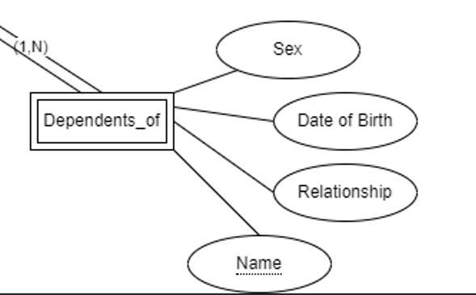

Figure 11: Dependents Entity

The **Dependents_of** entity represents the dependents associated with a staff member. It includes key attributes such as **Name**, which identifies the dependent, and **Date of Birth**, which provides the dependent's age. The **Sex** attribute indicates the gender of the dependent, while the **Relationship** attribute specifies how the dependent is related to the staff member (e.g., child, spouse, etc.).

**7.1.9 Customer:**

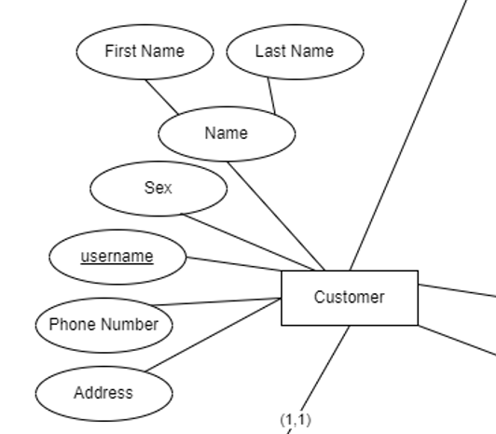

Figure 12: Customer Entity

The **Customer** entity represents individuals who interact with the library’s services, such as borrowing or purchasing items. The entity includes personal attributes like **First Name** and **Last Name**, which together form the **Name** attribute. The **Sex** attribute provides additional demographic details. The **username** attribute serves as a unique identifier for each customer in the system, used for authentication and access to services. **Phone Number** and **Address** provide contact and location information for communication and mailing purposes.

**7.1.10 Publisher:**

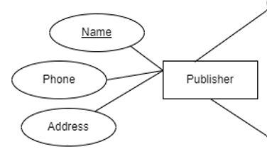

Figure 13: Publisher Entity

The **Publisher** entity represents organizations or individuals responsible for publishing books. The **Name** attribute uniquely identifies the publisher, while the **Phone** and **Address** attributes provide contact details, allowing the library to communicate with the publisher for orders, inquiries, or coordination.

## **7.2 Relationships and their explanations**

**7.2.1 Supervises:**

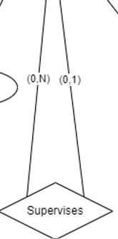

Figure 14: Supervises Relationship

The **Supervises** relationship connects the **Staff** entity to itself, indicating a hierarchical structure within the organization. The cardinality (0, N) on one side means that a staff member can supervise multiple other staff members, while the (0,1) on the other side indicates that each staff member can be supervised by at most one other individual. This relationship allows for flexibility, as some staff members may not supervise anyone, and others may not have a supervisor.

**7.2.2 Dependents_of:**

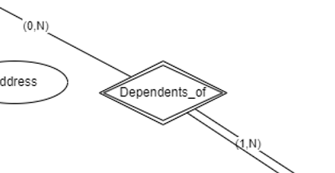

Figure 15: Dependents Relationship

The **Dependents of** relationship connects **Staff** and their **Dependents**. The cardinality on the staff side is (0, N), indicating that not all staff members have dependents, but if they do, they might have many dependents connected to them. On the dependents' side, the cardinality is (1, N), meaning that a dependent must always be associated with a staff member, and a staff member can have multiple dependents. This relationship exists to manage personal information about staff members and their families, showing optionality on the staff side and mandatory association for dependents.

**7.2.3 Logs_in:**

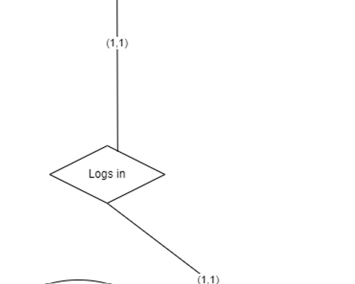

Figure 16: Logs_in Relationship

The **Logs in** relationship connects **Staff** and **Customer** to the **Authentication** **System**. The cardinality is (1,1) on both sides, meaning that each customer or staff member must log in with one set of credentials, and those credentials are unique to that individual.

**7.2.4 Works at:**

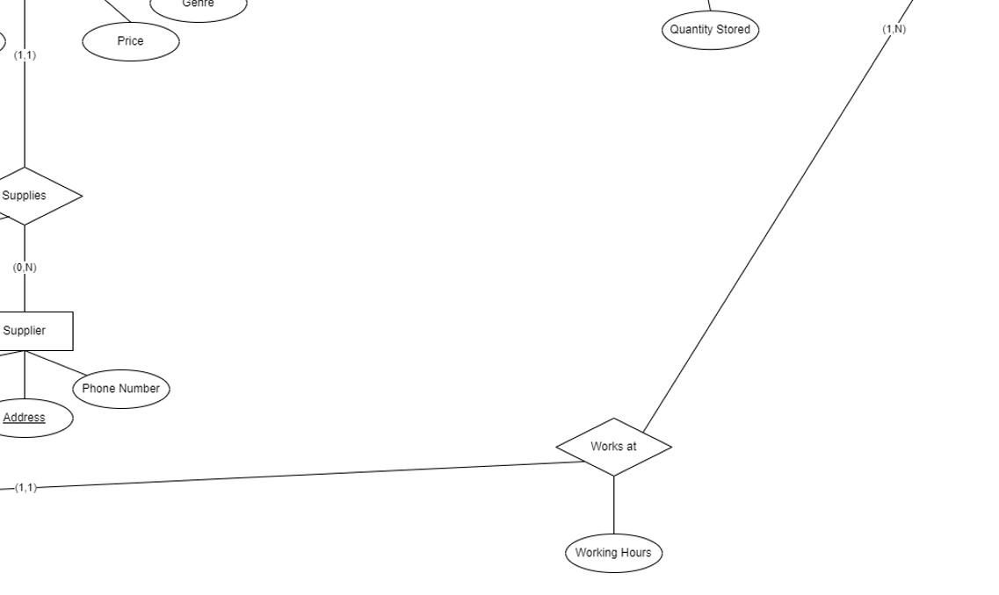

Figure 17: Works_at Relationship

The **Works at** relationship involves the **Staff** and **Library** entities. The cardinality on the Staff side is (1,1), meaning that each staff member must work at exactly one library branch. On the Library side, the cardinality is (1,N), indicating that a single branch can have multiple staff members working there. This relationship's cardinality ensures that every branch has at least one staff member, and each staff member is uniquely tied to one branch. This relationship has one attribute **Working Hours** to keep track of the number of hours a staff has been working.

**7.2.5 Supplies:**

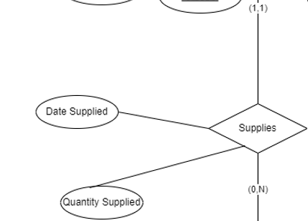

Figure 18: Supplies Relationship

The **Supplies** relationship connects **Items** and **Suppliers**. The cardinality on the supplier side is (0,N), indicating that a supplier may provide many different items, but not all suppliers are required to supply items. On the items' side, the cardinality is (1,1), meaning that each item must be supplied by exactly one supplier.

**7.2.6 Stores_items:**  
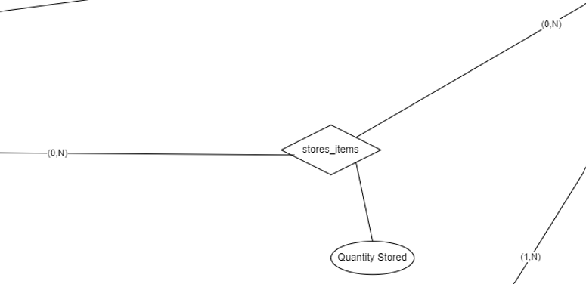

Figure 19: Stores_items Relationship

The **stores_items** relationship connects **Library** and **Items**. The cardinality on the **Library** side is (0,N), meaning that a library branch can store many different items, but some branches may store none. On the **Items** side, the cardinality is (0,N), indicating that each item is stored in at least one library branch but can be stored in multiple branches.

This relationship includes the attribute **Quantity Stored**, which tracks how many units of a particular item are available at a specific library branch.

**7.2.7 Borrows**

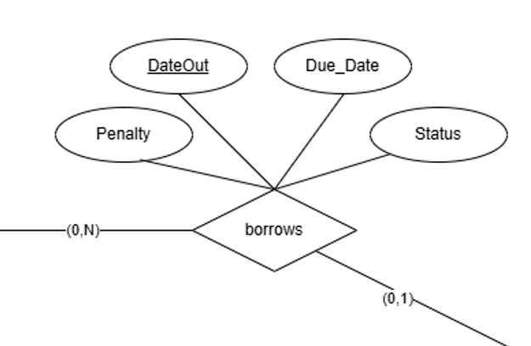

Figure 20: Borrows Relationship

The **borrows** relationship connects **Customers** and **Books_for_Rent**. The cardinality on the **Customer** side is (0,N), meaning that a customer can borrow many books or may not borrow any at all. On the **Books_for_Rent** side, the cardinality is (0,1), indicating that only one customer can borrow a book at a time or may not be borrowed at all. This relationship includes one key attribute: **DateOut**, which records when the book was borrowed. **DueDate** indicates when the book is expected to be returned, **Penalty** which tracks any fines incurred for late returns, and **Status** which indicates whether the book is still borrowed or returned to the library.

**7.2.8 publishes:**

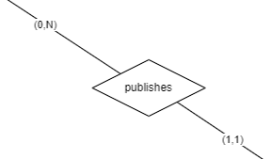

Figure 21: Publishes Relationship

The **publishes** relationship connects **Publisher** with **Books_for_Sale** at a side and **Publisher** with **Books_for_Rent** at another side. The cardinality on the **Publisher** side is (0,N), indicating that a publisher may publish many different books or may not publish any. On the **Books_for_Sale** and **Books_for_Rent** side, the cardinality is (1,1), meaning that each book must be associated with exactly one publisher.

**7.2.9 Sale to rent:**

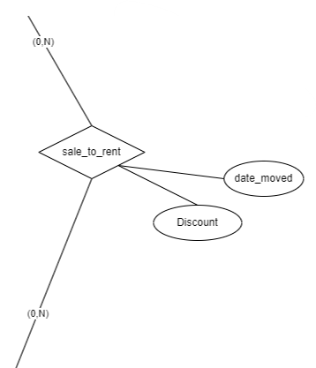

Figure 22: Sale_to_Rent Relationship

The **sale_to_rent** relationship connects **Books_for_Sale** and **Books_for_Rent**, representing books that have transitioned from being available for sale to being available for rent. The cardinality on both sides is (0,N), meaning that a book may move from sale to rent multiple times or not at all.

This relationship includes two important attributes: **date_moved**, which records the date when the book transitioned from sale to rental, and **Discount**, which indicates any price reduction applied when the book moves from sale to rent.

**7.2.10 stores_booksforrent:**  
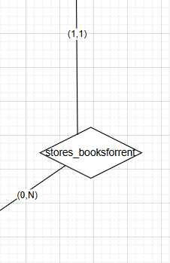

Figure 23: Stores_Booksforrent Relationship

The **stores_booksforrent** relationship connects **Books_for_Rent** and **Library** branches. The cardinality on the **Books_for_Rent** side is (1,1), meaning that each book available for rent must be stored in at one library branch only. On the **Library** side, the cardinality is (0,N), indicating that a library branch may store zero or many copies of each book available for rent.

**7.2.11 stores_bookforsale:**

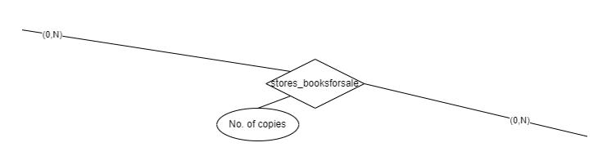

Figure 24: Stores_bookforsale Relationship

The **stores_booksforsale** relationship connects **Books_for_Sale** and **Library** branches. The cardinality on both sides is (0,N), meaning that a library branch can store multiple copies of various books for sale or none at all. Similarly, a book for sale can be stored at multiple library branches or none at all. This relationship includes the attribute **No. of copies**, which tracks how many copies of a particular book are available for sale at a specific library branch.

**7.2.12 purchase items:**

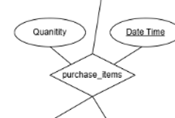

Figure 25: Purchase_Items Relationship

The **purchase_items** relationship connects **Customers**, **Items**, and **Library**. The cardinality on all sides is (0,N), meaning that a customer can purchase many items or none at all, a library branch can facilitate many purchases or none, and an item can be purchased multiple times or not at all. This relationship includes the attribute **Quantity**, which records the number of units of an item purchased by a customer at a specific library and the attribute **DateTime** which records the timestamp in which the transaction occurred.

**7.2.13 buys books:**  
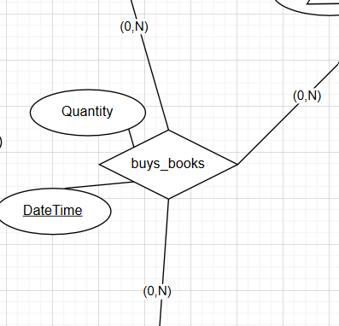

Figure 26: Buys_Books Relationship

The **buys_books** relationship connects **Customers**, **Books_for_Sale**, and **Library** branches. The cardinality on all sides is (0,N), meaning that a customer can buy many books or none at all, a library branch can facilitate many book purchases or none, and a book can be purchased multiple times or not at all. This relationship includes the attribute **Quantity**, which tracks how many copies of a particular book a customer buys through the library, and the attribute **DateTime** which records the timestamp in which the transaction occurred.

# **ER to Relational Mapping**

## **8.1 – Step 1 – Mapping Strong Entity Types**

We map each strong entity type from the ER model to a corresponding relational table. For each strong entity, we create a relation that includes all its simple (atomic) attributes. A primary key is chosen to uniquely identify each tuple in the relation, and if the key is composite, all the attributes that make up the composite key are used as the primary key.

The first entity is the **Authentication_System**, which has the following attributes: Email and Passcode. In the relational table, we create a relation Authentication_System (Email, Passcode), where the Email attribute serves as the primary key since it uniquely identifies each record in the system.

The second strong entity is **Customer**, which includes attributes like: Username, Phone_Number, Address, Sex, First_Name, and Last_Name. This is mapped to the relation Customer (Username, Phone_Number, Address, Sex, First_Name, Last_Name), with “username” chosen as the primary key, as it uniquely identifies each customer.

Next, the **Staff** entity has attributes such as SSN, First_Name, Last_Name, DoB, Blood_Type, Address, Salary, and Post. The corresponding relation is Staff (SSN, First_Name, Last_Name, DoB, Blood_Type, Address, Salary, Post), where SSN acts as the primary key, given its role in uniquely identifying staff members.

For the **Items** entity, the attributes include Barcode, Name, Age_Group, Price, and Genre. We create the relation Items (Barcode, Name, Age_Group, Price, Genre) and use Barcode as the primary key since it uniquely identifies each item.

The **Supplier** entity includes attributes such as Name, Address, and Phone_Number. The corresponding relation is Supplier (Name, Address, Phone_Number), and the combination of Name and Address serves as the primary key as it is a unique identifier for each supplier.

The **Library** entity contains the attributes BranchID, Address, and Phone_Number. It is mapped to the relation Library (BranchID, Address, Phone_Number), with BranchID being the primary key since it uniquely identifies each library branch.

Similarly, the **Publisher** entity, with attributes Name, Address, and Phone_Number, is mapped to the relation Publisher (Name, Address, Phone_Number), where Name is the primary key, distinguishing each publisher.

The **Books_for_Sale** entity includes attributes like ISBN, Title, Genre, Price, Translator, Edition, Pages, and Language. The relation Books_for_Sale (ISBN, Title, Genre, Price, Translator, Edition, Pages, Language) is created, with ISBN serving as the primary key to ensure that each book for sale is uniquely identified.

Finally, the **Books_for_Rent** entity has attributes such as BookID, ISBN, Title, Genre, Price, Translator, Edition, Pages, Language, Shelf_No, and Row_No. The relation Books_for_Rent (BookID, ISBN, Title, Genre, Price, Translator, Edition, Pages, Language, Shelf_No, Row_No) is formed, with BookID as the primary key to uniquely identify each book available for rent.

## **8.2 – Step 2 – Mapping of Weak Entity Types**

Weak entities depend on strong entities for their existence and identification, meaning their primary keys are derived from the primary keys of the related strong entities. To map a weak entity, we create a relation that includes all its attributes, and we add the primary key of the owner strong entity as a foreign key. The combination of this foreign key and the weak entity’s partial key forms the composite primary key.

The weak entity is **Dependents**, which includes the attributes SSN, Dep_Name, Relationship, DoB, and Sex. The Dependents entity is dependent on the strong entity Staff, which is identified by SSN as the primary key. To map the Dependents entity, we create the relation Dependents (SSN, Dep_Name, Relationship, DoB, Sex).

In this relation, the SSN attribute is added as a foreign key, referencing the SSN from the Staff entity, since Dependents relies on Staff for its identification. The primary key for the Dependents relation is the combination of SSN (foreign key) and Dep_Name, which serves as the partial key for the weak entity. This composite primary key ensures that each dependent is uniquely identified with the staff member associated with.

## **8.3 – Step 3 – Mapping of Binary 1:1 Relationship Types**

The most common method for mapping a 1:1 relationship is the Foreign Key approach**,** where the primary key of the entity is included as a foreign key in the relation of the other entity.

There are three 1:1 relationships that need to be mapped. The first is between **Authentication_System** and **Customer**, where the Email attribute from Authentication_System is linked to the Email attribute in the Customer entity. Using the foreign key approach, we add Email as a foreign key in the Customer table to reference the Authentication_System. This creates a direct link between the two entities, ensuring that each customer has a corresponding email in the authentication system.

Similarly, the second 1:1 relationship exists between **Authentication_System** and **Staff**. Each staff member must be authenticated via the system. Therefore, we add the Email attribute from Authentication_System as a foreign key in the Staff table. This allows each staff member to be associated with his/her email in the authentication system, ensuring proper identification and authentication for staff members.

By using the foreign key approach for these binary 1:1 relationships, we ensure that the entities remain properly connected and that referential integrity is maintained across the tables.

## **8.4 – Step 4 – Mapping of Binary 1:N Relationship Types**

The used approach for mapping binary 1: N (one-to-many) relationship types is to place a foreign key in the relation representing the entity on the "N" side of the relationship, referring to the primary key of the entity on the "1" side. Additionally, any attributes specific to the relationship are included in the relation on the "N" side.

We have several 1:N relationships that need to be mapped. First, we map the **supervisory relationship** within the Staff entity. Each staff member may report to one supervisor, but a supervisor can oversee multiple staff members. To represent this, we add the Super_SSN (the primary key of the supervising staff member) as a foreign key in the Staff table, linking each staff member to his/her supervisor.

Next, we map the relationship between **Library** and **Staff**. Each staff member works at one library branch, while a branch can have multiple staff members. To represent this relationship, we add BranchID (the primary key of the Library entity) as a foreign key in the Staff table. Additionally, since each staff member has specific working hours at the branch, we include the Hours attribute to represent this relationship.

The third relationship involves **Books_for_Sale** and **Publisher**. Each book for sale is published by a specific publisher, but a publisher can be associated with many books. To map this, we add Publisher_Name (the primary key of the Publisher entity) as a foreign key in the Books_for_Sale table.

The forth 1:N relationship involves the **Books_for_Rent** entity and the **Library** entity. Each book available for rent is associated with a specific library branch. To represent this, we add the BranchID attribute from the Library entity to the Books_for_Rent table as a foreign key.

Similarly, for **Books_for_Rent**, we map the relationship with **Publisher** by adding Publisher_Name to the Books_for_Rent table as a foreign key, representing the publisher of each book available for rent.

The last 1:N relationship involves **Customer** and **Books_for_Rent**, represented by the **Borrows** relation. Here, we include Username and BookID as foreign keys, referencing the primary keys of the Customer and Books_for_Rent tables respectively. The combination of Username, BookID, and Date_Out forms the primary key for the Borrows relation. Additionally, we include the attribute Penalty, which provides information about any penalties associated with late returns, and the attribute Status, which determines whether the books have been returned .As mentioned in ElMasri book, in some special cases, a 1:N relationship can be mapped into a relation and this is what happened in our case. By doing so, we will be avoiding redundancy and meaningless repetitions. This relationship is best represented in a table.

By following the 1:N relationship mapping rules, we ensure that each entity on the "1" side is correctly linked to its related entity on the "N" side, while maintaining the integrity of the relationships through foreign keys and relationship specific attributes.

## **8.5 – Step 5 – Mapping of Binary M:N Relationship Types**

To represent M:N (many-to-many) relationship types in a relational database, we create new relations for each M:N relationship type, which will include foreign keys referencing the primary keys of the participating entity types.

The first M:N relationship we mapped is Stores_Items, which represents the association between **Library** and the **Items** relations. In the Stores_Items relation, we include the attributes BranchID and Barcode as foreign keys, referencing the primary keys of the Library and Items tables, respectively. The combination of BranchID and Barcode forms the primary key of the Stores_Items relation. Additionally, we include the Qty_Stored attribute, which indicates the quantity of each item stored at the corresponding branch.

Next, we address the M:N relationship between **Library** and **Books_for_Sale** with the Stores_Booksforsale relation. In this case, we include BranchID and ISBN as foreign keys, referring to the primary keys of the Library and Books_for_Sale tables. The combination of these two attributes serves as the primary key for the Stores_Booksforsale relation. We also add the Number_of_Copies attribute to indicate how many copies of each book are available for sale at each branch.

Lastly, we map the relationship between **Books_for_Rent** and **Books_for_Sale** with the Sale_to_Rent relation. This relation includes BookID and ISBN as foreign keys, linking it to the primary keys of the Books_for_Rent and Books_for_Sale tables. The combination of BookID and ISBN serves as the primary key for the Sale_to_Rent relation. We also include the attributes Date_Moved and Discount to capture when the book was moved from sale to rent and any applicable discounts.

By creating these new relations to represent the M:N relationships, we maintain the integrity of our database design and ensure that all relevant attributes are properly associated with their corresponding entities.

## **8.6 – Step 6 – Mapping of multivalued attributes**

We address the mapping of multivalued attributes, which are attributes that can hold multiple values for a single entity instance. To effectively represent these attributes in a relational database, we create new relations that include the multivalued attribute and a foreign key referencing the primary key of the entity it belongs to.

For the **Authors** multivalued attribute associated with the **Books_for_Sale** relation, we create the Authors_BookSale table. This relation includes the attributes ISBN and Author_Name. Here, ISBN serves as a foreign key referencing the primary key of the Books_for_Sale relation. The combination of ISBN and Author_Name forms the primary key for the Authors_BookSale table.

Similarly, for the **Authors** multivalued attribute related to the **Books_for_Rent** relation, we establish the Authors_BookRent table. This relation consists of the attributes BookID and Author_Name, where BookID functions as a foreign key referencing the primary key of the Books_for_Rent relation. The combination of BookID and Author_Name forms the primary key for the Authors_BookRent table.

## **8.7 – Step 7 – Mapping of N-ary attributes**

For each N-ary relationship type, we create a new relation to accurately represent the connections and attributes associated with that relationship.

To represent the ternary relationship of buying books, we create the Buys_Books table, which includes the attributes Username, BranchID, ISBN, Quantity, and DateTime. In this table, the primary key consists of the combination of Username, BranchID, ISBN, and DateTime which uniquely identifies each purchase transaction. This table is formed by combining the **Customer** table (for Username), the **Library** table (for BranchID), and the **Books_for_Sale** table (for ISBN). The inclusion of Quantity and DateTime as additional attributes provides essential information about the transaction, such as how many copies of the book were purchased and when the purchase took place. This structure allows us to efficiently manage and track book purchases by customers across different library branches.

Similarly, for the ternary relationship for purchasing items, we establish the Purchases_Items table. This relation contains the attributes Username, BranchID, Barcode, Quantity, and DateTime. The primary key for this table is formed by combining Username, BranchID, Barcode, and DateTime ensuring that each item purchase is uniquely identified. This table is created by combining the **Customer** table (for Username), the **Library** table (for BranchID), and the **Items** table (for Barcode). This structure allows us to effectively monitor inventory levels for various items within the library system.

# **Final Display – all tables**

The following tables show each relation with its corresponding attributes after mapping the ER diagram according to the algorithm taught in class.

Legend:

* Bold + Underlined = Primary Key
* Italic = Foreign Key
* Bold + Underlined + Italic = Part of the Primary Key + Foreign Key for Another Primary Key

**Relation1: ‘Authentication_System’**

|  |  |
| --- | --- |
| **Email** | Passcode |

**Relation2: ‘Customer’**

|  |  |  |  |  |  |  |
| --- | --- | --- | --- | --- | --- | --- |
| **Username** | Phone_Number | Address | Sex | First_Name | Last_Name | *Ct_Email* |

**Relation3: ‘Staff’**

|  |  |  |  |  |  |  |  |  |  |  |  |
| --- | --- | --- | --- | --- | --- | --- | --- | --- | --- | --- | --- |
| **SSN** | First_Name | Last_Name | DoB | Blood_Type | Address | Salary | Post | *Super_SSN* | *St_Email* | *BranchID* | Hours |

**Relation4: ‘Dependents’**

|  |  |  |  |
| --- | --- | --- | --- |
| ***SSN*** | **Dep_Name** | Relationship | Sex |

**Relation5: ‘Items’**

|  |  |  |  |  |  |  |  |  |
| --- | --- | --- | --- | --- | --- | --- | --- | --- |
| **Barcode** | Name | Age_Group | Price | Genre | *Supp_Name* | *Supp_Address* | Qty_Supplied | Date_Supplied |

**Relation6: ‘Supplier’**

|  |  |  |
| --- | --- | --- |
| **Name** | **Address** | Phone_Number |

**Relation7: ‘Library’**

|  |  |  |
| --- | --- | --- |
| **BranchID** | Address | Phone_Number |

**Relation8: ‘Publisher’**

|  |  |  |
| --- | --- | --- |
| **Name** | Address | Phone_Number |

**Relation9: ‘Books_for_Sale’**

|  |  |  |  |  |  |  |  |  |
| --- | --- | --- | --- | --- | --- | --- | --- | --- |
| **ISBN** | Title | Genre | Price | Translator | Edition | Pages | Language | *Publisher_Name* |

**Relation10: ‘Books_for_Rent’**

|  |  |  |  |  |  |  |  |  |  |  |  |  |
| --- | --- | --- | --- | --- | --- | --- | --- | --- | --- | --- | --- | --- |
| **BookID** | ISBN | Title | Genre | Price | Translator | Edition | Pages | Language | *Publisher_Name* | Shelf_No | Row_No | *BranchID* |

**Relation11: ‘Authors_BookSale’**

|  |  |
| --- | --- |
| ***ISBN*** | **Author_Name** |

**Relation12: ‘Authors_BookRent’**

|  |  |
| --- | --- |
| ***BookID*** | **Author_Name** |

**Relation13: ‘Stores_Items’**

|  |  |  |
| --- | --- | --- |
| ***BranchID*** | ***Barcode*** | Qty_Stored |

**Relation14: ‘Stores_Booksforsale’**

|  |  |  |
| --- | --- | --- |
| ***BranchID*** | ***ISBN*** | Number_of_Copies |

**Relation15: ‘Buys_Books’**

|  |  |  |  |  |
| --- | --- | --- | --- | --- |
| ***Username*** | ***BranchID*** | ***ISBN*** | Quantity | **DateTime** |

**Relation16: ‘Purchases_Items’**

|  |  |  |  |  |
| --- | --- | --- | --- | --- |
| ***Username*** | ***BranchID*** | ***Barcode*** | Quantity | **DateTime** |

**Relation17: ‘Borrows’**

|  |  |  |  |  |  |
| --- | --- | --- | --- | --- | --- |
| ***Username*** | ***BookID*** | **Date_Out** | Due_Date | Penalty | Status |

**Relation18: ‘Sale_to_Rent’**

|  |  |  |  |
| --- | --- | --- | --- |
| ***BookID*** | ***ISBN*** | Date_Moved | Discount |

# **Table States**

The following tables contain sample data for our database.

**Authentication_System**

|  |  |
| --- | --- |
| **Email** | **Passcode** |
| elias.nasr@gmail.com | Nasr321# |
| elie.salameh@gmail.com | passElie56& |
| fouad.maalouf@gmail.com | Fouadex231% |
| georges.hareb@gmail.com | Passgeoerges45 |
| jad.barakat@gmail.com | Passjadbarakatt2 |
| joelle.fares@gmail.com | Jojo9024% |
| nadine.mabsout@gmail.com | Nadounemabsout#@ |
| nour.najjar@gmail.com | najjarNour@1w |
| ramzi.haddad@gmail.com | Rh45362@# |
| rima.halabieh@gmail.com | halabiehrima@32 |

**Customer**

|  |  |  |  |  |  |  |
| --- | --- | --- | --- | --- | --- | --- |
| **Username** | **Phone_no** | **Address** | **Sex** | **First_Name** | **Last_Name** | **Email** |
| en01 | 71812354 | Tripoli,Mina | M | Elias | Nasr | elias.nasr@gmail.com |
| gh21 | 76123765 | Baabda,Hazmieh | M | Georges | Hareb | georges.hareb@gmail.com |
| jf10 | 81209453 | Baalback, Kaa | F | Joelle | Fares | joelle.fares@gmail.com |
| fm02 | 70231539 | Jbeil,Edde | M | Fouad | Maalouf | fouad.maalouf@gmail.com |
| jb01 | 03356472 | Beirut,Verdun | M | Jad | Barakat | jad.barakat@gmail.com |
| nn12 | 78324536 | Zahle,Ksara | F | Nour | Najjar | nour.najjar@gmail.com |
| rh17 | 03564992 | Saida,Taameer | M | Ramzi | Haddad | ramzi.haddad@gmail.com |
| rh18 | 76172321 | Beirut,Raouche | F | Rima | Halabieh | rima.halabieh@gmail.com |
| es02 | 71342764 | Beirut,Verdun | M | Elie | Salameh | elie.salameh@gmail.com |
| nm01 | 78876520 | Beirut,Hamra | F | Nadine | Mabsout | nadine.mabsout@gmail.com |

**Staff**

|  |  |  |  |  |  |  |  |  |  |  |  |
| --- | --- | --- | --- | --- | --- | --- | --- | --- | --- | --- | --- |
| **SSN** | **First_Name** | **Last_Name** | **Dob** | **BloodType** | **Address** | **Salary** | **Post** | **Super_SSN** | **St_Email** | **BranchID** | **Hours** |
| 123 | Jad | Bader | 1992-10-10 | B+ | Zahle | 3850 | Manager | Null | jb89@gmail.com | 101 | 40 |
| 124 | Dani | Kanaan | 2000-02-28 | O- | Beirut | 2500 | Librarian | 123 | dk176@gmail.com | 101 | 50 |
| 125 | Lama | Saab | 2001-01-22 | A- | Beirut | 2300 | Librarian | 123 | ls@gmail.com | 101 | 50 |
| 126 | Mona | Ramadan | 1998-05-16 | A+ | Saida | 1000 | Clerk | 125 | mn56@gmail.com | 101 | 60 |
| 127 | Marwan | Kodeih | 1987-07-07 | A- | Jbeil | 3000 | Librarian | Null | mk56@gmail.com | 103 | 40 |
| 128 | Wael | Fattouh | 1990-12-12 | B+ | Tyr | 2850 | Librarian | 127 | wf02@gmail.com | 103 | 50 |
| 129 | Adam | Serhan | 2000-11-25 | B- | Saida | 2500 | Librarian | 127 | as67@gmail.com | 105 | 50 |
| 130 | Noura | Succar | 1997-04-04 | AB+ | Beirut | 2000 | Clerk | 127 | ns09@gmail.com | 105 | 50 |
| 131 | Reem | Karam | 2000-09-09 | AB- | Baalback | 1850 | Librarian | 127 | rm12@gmail.com | 105 | 45 |
| 132 | Randa | Takouch | 1998-10-20 | O+ | Beirut | 1850 | Librarian | 127 | rt65@gmail.com | 105 | 45 |

**Dependents**

|  |  |  |  |
| --- | --- | --- | --- |
| **SSN** | **Name** | **Relationship** | **Sex** |
| 123 | Sawsan | wife | F |
| 123 | Mohamad | son | M |
| 124 | Tartour | wife | F |
| 125 | Akram | spouse | M |
| 126 | Zach | father | M |
| 127 | Samira | mother | F |
| 130 | Adam | spouse | M |
| 130 | Roy | son | M |
| 132 | Joyce | mother | F |
| 132 | Goerges | father | M |

**Items**

|  |  |  |  |  |  |  |  |  |
| --- | --- | --- | --- | --- | --- | --- | --- | --- |
| **Barcode** | **Name** | **Age_Group** | **Price** | **Genre** | **Supp_Name** | **Supp_Address** | **Qty** | **Date** |
| 10001 | Puzzle | 5-12 | 50.00 | Toys | JoueClub | Beirut | 100 | 2024-10-20 |
| 20198 | Maped Pencil | None | 2.50 | Stationery | Maped | Beirut | 250 | 2024-10-10 |
| 20290 | Maped Eraser | None | 2.00 | Stationery | Maped | Beirut | 250 | 2024-10-10 |
| 30278 | Frozen | 4-14 | 10.00 | DVD | DVDhome | Saida | 40 | 2024-09-25 |
| 30240 | Spy | 18+ | 10.00 | DVD | DVDhome | Saida | 40 | 2024-09-25 |
| 30560 | Spiderman | 6+ | 10.00 | DVD | DVDhome | Saida | 40 | 2024-09-26 |
| 40134 | GtaV | 18+ | 25.00 | Games | Najjar | Beirut | 150 | 2023-02-20 |
| 40250 | Fifa24 | None | 25.00 | Games | Najjar | Beirut | 400 | 2023-11-11 |
| 40255 | Uncharted3 | 16+ | 25.00 | Games | Najjar | Beirut | 100 | 2024-05-31 |
| 40300 | Fifa23 | None | 25.00 | Games | Najjar | Beirut | 120 | 2024-01-05 |

**Supplier**

|  |  |  |
| --- | --- | --- |
| **Name** | **Address** | **Phone_Number** |
| Najjar | Beirut | 01255412 |
| KhouryHome | Beirut | 01453123 |
| AbedTahhan | Beirut | 01879034 |
| HamdanElectronics | Beirut | 01334455 |
| DVDhome | Saida | 07565432 |
| Maped | Beirut | 01776853 |
| JoueClub | Beirut | 01212343 |
| Crafts&More | Jounieh | 04312366 |
| Virgin | Jounieh | 04565723 |
| ReadPlus | Zahle | 09623657 |

**Library**

|  |  |  |
| --- | --- | --- |
| **BranchID** | **Address** | **PhoneNumber** |
| LB01 | Hamra | 01412344 |
| LB02 | Mazraa | 015134788 |
| LB03 | Jal El Dib | 04234432 |
| LB04 | Jounieh | 04512987 |
| LB05 | Jbeil | 08212121 |
| LB06 | Tripoli | 08787654 |
| LB07 | Zahle | 09128220 |
| LB08 | Saida | 07987098 |
| LB09 | Nabatieh | 07565890 |
| LB10 | Tyre | 07987911 |

**Publisher**

|  |  |  |
| --- | --- | --- |
| **Name** | **Address** | **Phone_Number** |
| Dar Al-Kitaba | Beirut,Hamra | 03355097 |
| Dar Al-Nour | Mount Lebanon,Aley | 71232156 |
| Lebanon Readings | Beirut, Cola | 76876425 |
| Dar Al-Nasher | Jounieh | 03436352 |
| Today News | Beirut | 09824262 |
| Dar Al-Balad | Saida | 81423536 |
| Dar Al-Maarifa | Nabatieh | 07634562 |
| Dar Al-Fikr | Tripoli | 09643225 |
| WassupLebanon | Jbeil | 71232321 |
| Dar Al-Salam | Beirut | 81123333 |

**Books_for_Sale**

|  |  |  |  |  |  |  |  |  |
| --- | --- | --- | --- | --- | --- | --- | --- | --- |
| **ISBN** | **Title** | **Genre** | **Price** | **Translator** | **Edition** | **Pages** | **Language** | **Publisher_Name** |
| 2431 | Electronics | Engineering | 89.00 | Null | 3 | 356 | English | Dar Al-Fikr |
| 3421 | Alg&Geo | Maths | 24.50 | Null | 1 | 87 | English | Dar Al-Fikr |
| 4562 | LearnArbic | Literature | 30.00 | Asmaa Karam | 2 | 102 | Arabic | Dar Al-Salam |
| 4989 | MenDuties | Psychology | 35.50 | Null | 1 | 234 | English | Dar Al-Balad |
| 5232 | GirlsPower | Psychology | 120.00 | Null | 1 | 675 | English | WassupLebanon |
| 5900 | LifeonEarth | Geography | 100.00 | Null | 4 | 200 | English | Today News |
| 6113 | Voila | Literature | 31.25 | Karim Akram | 5 | 150 | French | Dar Al-Salam |
| 6772 | Quand? | Literature | 76.25 | Yolga Safa | 2 | 89 | French | Dar Al-Maarifa |
| 7880 | Seniorita | Literature | 55.00 | Monica Smith | 1 | 56 | Spanish | Dar Al-fikr |
| 7994 | Wander | Geography | 46.00 | Sandra Kenaan | 1 | 89 | English | Dar Al-Balad |

**Books_for_Rent**

|  |  |  |  |  |  |  |  |  |  |  |  |  |
| --- | --- | --- | --- | --- | --- | --- | --- | --- | --- | --- | --- | --- |
| **BookID** | **ISBN** | **Title** | **Genre** | **Price** | **Translator** | **Edition** | **Pages** | **Language** | **Publisher_Name** | **Shelf_No** | **Row_No** | **BranchID** |
| 2431#01 | 2431 | Electronics | Engineering | 10.00 | Null | 3 | 356 | English | Dar Al-Fikr | 25 | 1 | LB01 |
| 3421#12 | 3421 | Alg&Geo | Maths | 10.00 | Null | 1 | 87 | English | Dar Al-Fikr | 12 | 3 | LB01 |
| 4562#12 | 4562 | LearnArbic | Literature | 15.00 | Asmaa Karam | 2 | 102 | Arabic | Dar Al-Salam | 12 | 5 | LB02 |
| 4989#23 | 4989 | MenDuties | Psychology | 12.00 | Null | 1 | 234 | English | Dar Al-Balad | 16 | 4 | LB05 |
| 5232#03 | 5232 | GirlsPower | Psychology | 70.00 | Null | 1 | 675 | English | WassupLebanon | 17 | 6 | LB05 |
| 5900#02 | 5900 | LifeonEarth | Geography | 80.00 | Null | 4 | 200 | English | Today News | 02 | 2 | LB06 |
| 6113#20 | 6113 | Voila | Literature | 15.00 | Karim Akram | 5 | 150 | French | Dar Al-Salam | 13 | 4 | LB07 |
| 6772#12 | 6772 | Quand? | Literature | 20.00 | Yolga Safa | 2 | 89 | French | Dar Al-Maarifa | 19 | 1 | LB02 |
| 7880#01 | 7880 | Seniorita | Literature | 25.00 | Monica Smith | 1 | 56 | Spanish | Dar Al-fikr | 19 | 3 | LB02 |
| 7994#10 | 7994 | Wander | Geography | 16.00 | Sandra Kenaan | 1 | 89 | English | Dar Al-Balad | 02 | 5 | LB05 |

**Authors_booksale**

|  |  |
| --- | --- |
| **ISBN** | **Author_Name** |
| 2431 | Sandra Smith |
| 3421 | Francois Olivier |
| 3421 | Maurice Dupont |
| 4562 | Rawad Kaadan |
| 4562 | Raed Lawand |
| 4562 | Wael Kassis |
| 6772 | Zeinab Kalach |
| 6772 | Pamela Hokayem |
| 7880 | Camilla Ponduras |
| 7994 | Donald Harris |

**Authors_bookrent**

|  |  |
| --- | --- |
| **BookID** | **Author_Name** |
| 2431#01 | Sandra Smith |
| 3421#12 | Francois Olivier |
| 4562#12 | Maurice Dupont |
| 4989#23 | Rawad Kaadan |
| 5232#03 | Raed Lawand |
| 5900#02 | Wael Kassis |
| 6113#20 | Zeinab Kalach |
| 6772#12 | Pamela Hokayem |
| 7880#01 | Camilla Ponduras |
| 7994#10 | Donald Harris |

**Stores_Items**

|  |  |  |
| --- | --- | --- |
| **BranchID** | **Barcode** | **Qty_Stored** |
| LB01 | 10001 | 25 |
| LB01 | 20198 | 30 |
| LB02 | 20290 | 29 |
| LB03 | 30278 | 34 |
| LB03 | 30240 | 35 |
| LB04 | 30560 | 12 |
| LB05 | 40134 | 34 |
| LB09 | 40250 | 5 |
| LB03 | 40255 | 14 |
| LB03 | 40300 | 38 |

**Stores_booksforsale**

|  |  |  |
| --- | --- | --- |
| **BranchID** | **ISBN** | **Number_of_Copies** |
| LB01 | 2431 | 12 |
| LB03 | 3421 | 34 |
| LB02 | 3421 | 23 |
| LB03 | 4562 | 21 |
| LB04 | 4562 | 23 |
| LB05 | 4562 | 33 |
| LB06 | 6772 | 10 |
| LB07 | 6772 | 09 |
| LB08 | 7880 | 03 |
| LB09 | 7994 | 18 |

**Buys_Books**

|  |  |  |  |  |
| --- | --- | --- | --- | --- |
| **Username** | **BranchID** | **ISBN** | **Quantity** | **DateTime** |
| en01 | LB01 | 2431 | 2 | 2024-10-01 11:12:23 |
| gh21 | LB02 | 3421 | 1 | 2024-09-10 13:31:02 |
| jf10 | LB02 | 3421 | 1 | 2024-06-30 17:05:15 |
| fm02 | LB01 | 4562 | 2 | 2024-04-01 20:45:09 |
| jb01 | LB09 | 4562 | 1 | 2024-07-31 18:10:10 |
| nn12 | LB07 | 4562 | 1 | 2024-05-23 10:40:34 |
| rh17 | LB05 | 6772 | 1 | 2024-08-17 11:11:09 |
| rh18 | LB08 | 6772 | 2 | 2024-04-14 12:30:23 |
| es02 | LB09 | 7880 | 3 | 2024-05-31 17:32:06 |
| nm01 | LB10 | 7994 | 1 | 2024-08-06 11:57:05 |

**Purchases_Items**

|  |  |  |  |  |
| --- | --- | --- | --- | --- |
| **Username** | **BranchID** | **Barcode** | **Quantity** | **DateTime** |
| en01 | LB01 | 10001 | 2 | 2024-10-01 11:12:23 |
| gh21 | LB02 | 20198 | 1 | 2024-09-10 13:31:02 |
| jf10 | LB02 | 20290 | 1 | 2024-06-30 17:05:15 |
| fm02 | LB01 | 30278 | 2 | 2024-04-01 20:45:09 |
| jb01 | LB09 | 30240 | 1 | 2024-07-31 18:10:10 |
| nn12 | LB07 | 30560 | 1 | 2024-05-23 10:40:34 |
| rh17 | LB05 | 40134 | 1 | 2024-08-17 11:11:09 |
| rh18 | LB08 | 40250 | 2 | 2024-04-14 12:30:23 |
| es02 | LB09 | 40255 | 3 | 2024-05-31 17:32:06 |
| nm01 | LB10 | 40300 | 1 | 2024-08-06 11:57:05 |

**Borrows**

|  |  |  |  |  |  |
| --- | --- | --- | --- | --- | --- |
| **Username** | **BookID** | **Date_Out** | **DueDate** | **Penalty** | **Status** |
| en01 | 2431#01 | 2024-05-05 | 2024-05-15 | 10.00 | Returned |
| gh21 | 3421#12 | 2024-07-25 | 2024-08-05 | 10.00 | Returned |
| jf10 | 4562#12 | 2024-01-03 | 2024-01-13 | 15.00 | Returned |
| fm02 | 4989#23 | 2024-06-15 | 2024-06-25 | 12.00 | Returned |
| jb01 | 5232#03 | 2024-09-23 | 2024-10-03 | 11.00 | Returned |
| nn12 | 5900#02 | 2024-03-20 | 2024-03-31 | 10.00 | Returned |
| rh17 | 6113#20 | 2024-05-22 | 2024-06-02 | 13.00 | Returned |
| rh18 | 6772#12 | 2024-04-12 | 2024-04-22 | 13.00 | Returned |
| es02 | 7880#01 | 2024-09-01 | 2024-09-11 | 12.00 | Returned |
| nm01 | 7994#10 | 2024-02-04 | 2024-02-14 | 10.00 | Returned |

**Sale_to_Rent**

|  |  |  |  |
| --- | --- | --- | --- |
| **BookID** | **ISBN** | **Date_Moved** | **Discount** |
| 2431#01 | 2431 | 2024-10-10 | 35% |
| 3421#12 | 3421 | 2024-10-11 | 35% |
| 4562#12 | 4562 | 2024-10-12 | 35% |
| 4989#23 | 4989 | 2024-09-30 | 35% |
| 5232#03 | 5232 | 2024-09-29 | 35% |
| 5900#02 | 5900 | 2024-10-17 | 35% |
| 6113#20 | 6113 | 2024-09-27 | 35% |
| 6772#12 | 6772 | 2024-08-31 | 35% |
| 7880#01 | 7880 | 2024-08-30 | 35% |
| 7994#10 | 7994 | 2024-08-23 | 35% |

# **Creation of Tables**

After successfully mapping the ER diagram into relations, we have created our 18 tables in the following order to ensure the smooth insertion of data later.

**Relation1: Authentication_System**

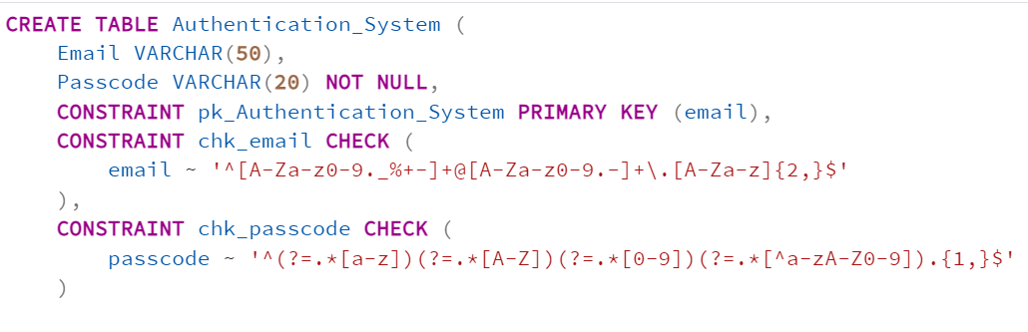

The SQL code creates a table named **Authentication_System** with two columns: Email and Passcode. The Email column is designated as the primary key. It must follow a specific email format validated by a regular expression in a CHECK constraint, ensuring it is a properly formatted email address. The Passcode column is required (NOT NULL). It must meet complexity requirements enforced by another CHECK constraint, mandating at least one lowercase letter, one uppercase letter, one digit, and one special character.

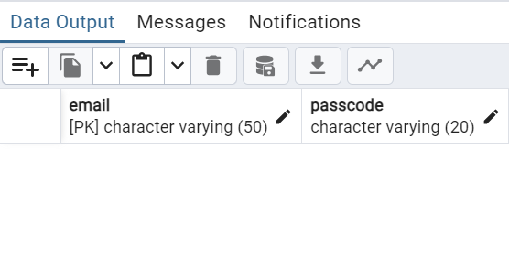

Figure 27: Creation of Authentication_System Relation

**Relation2: Customer**

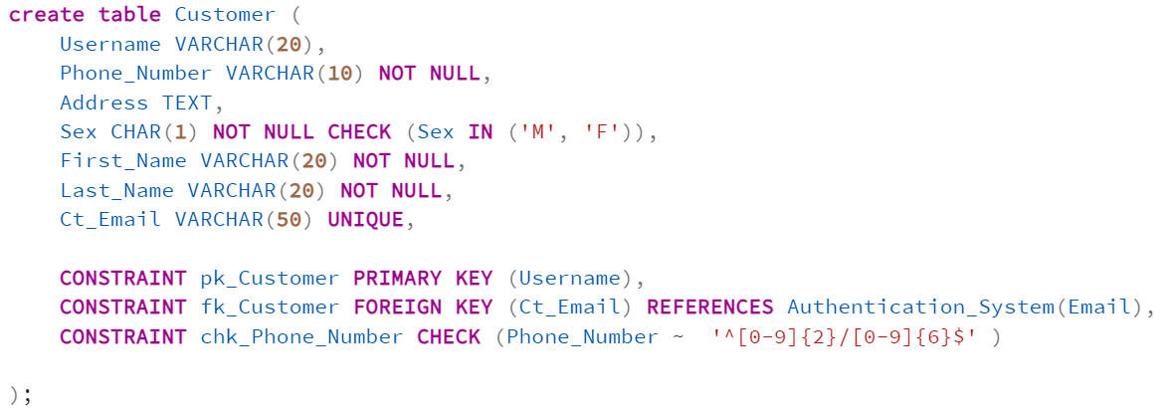

The **Customer** table stores customer information with Username as the primary key and Ct_Email as a unique foreign key referencing the Email column in the Authentication_System table. Constraints ensure data integrity: Sex must be 'M' or 'F', Phone_Number must follow a specific pattern, and Ct_Email updates or sets to NULL if the referenced email changes or is deleted. This structure enforces proper relationships and formatting for customer records.

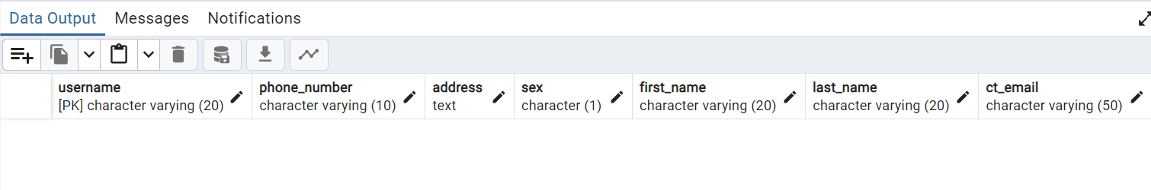

Figure 28: Creation of Customer Relation

**Relation3: Library**

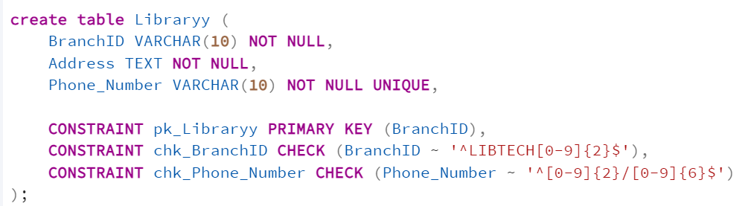

The **Libraryy** table stores branch information with BranchID as the primary key, ensuring uniqueness and a specific format starting with "LIBTECH" followed by two digits. The Phone_Number column must follow a defined pattern and be unique, while the Address is required. These constraints ensure proper formatting and data integrity for library branch records.

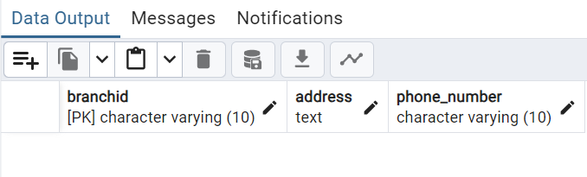

Figure 29: Creation of Libraryy Relation

**Relation4: Staff**

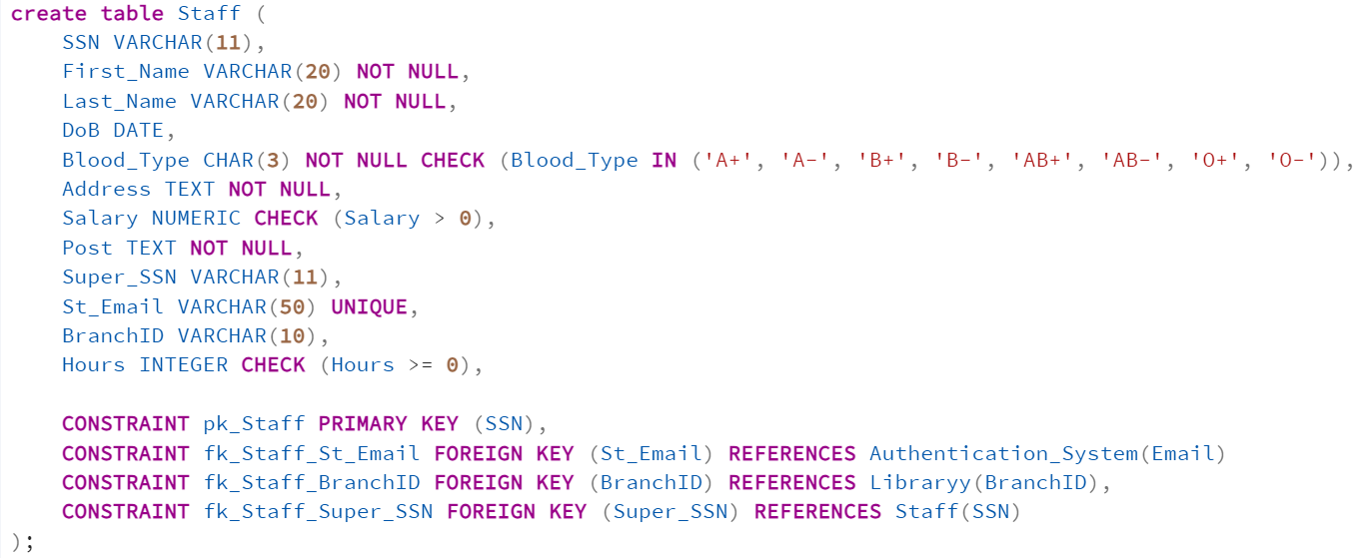

The **Staff** table stores employee data with SSN as the primary key, ensuring uniqueness. Constraints enforce data integrity: Blood_Type must be one of the specified valid types (e.g., 'A+', 'O-'), Salary must be positive, and Hours must be zero or higher. The St_Email column is unique and references the Email column in the Authentication_System table, with cascading updates and deletions (ON UPDATE CASCADE, ON DELETE SET NULL). The BranchID links to the Libraryy table, ensuring consistency between staff and library branches, and cascades updates and deletions. The Super_SSN references another staff member’s SSN to define a supervisory relationship, with cascading updates and deletions as well.

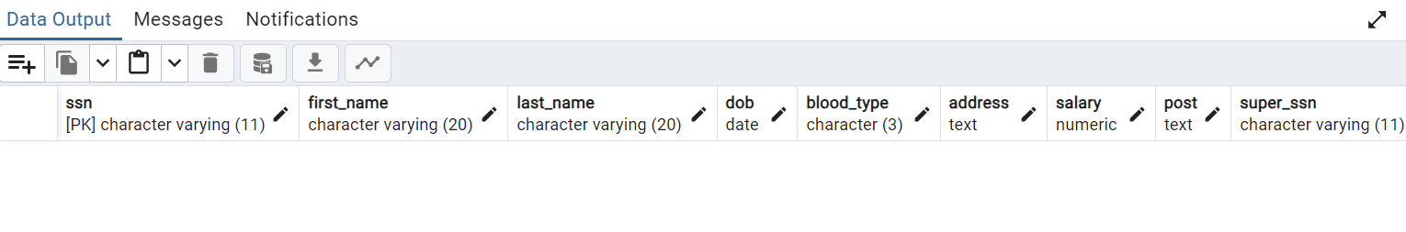

Figure 30: Creation of Staff Relation

**Relation5: Dependents**

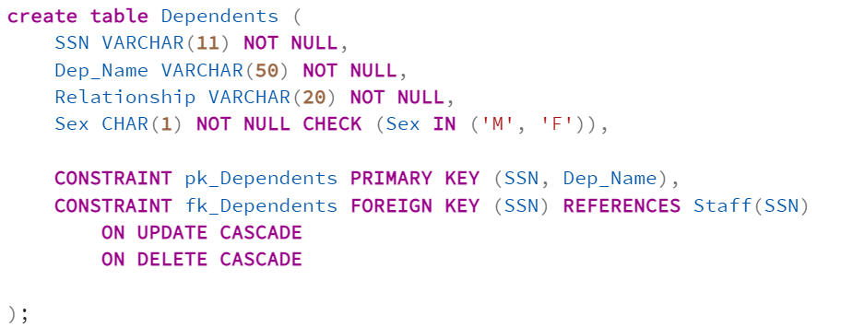

The **Dependents** table stores information about dependents of staff members. It uses a composite primary key (SSN, Dep_Name) to ensure each dependent is uniquely associated with a staff member. The SSN column serves as a foreign key referencing the SSN in the Staff table, maintaining referential integrity with cascading updates and deletions (ON UPDATE CASCADE, ON DELETE CASCADE). The Sex column is restricted to 'M' or 'F' using a CHECK constraint.

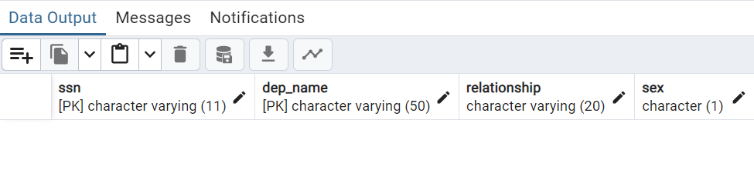

Figure 31: Creation of Dependents Relation

**Relation6: Supplier**

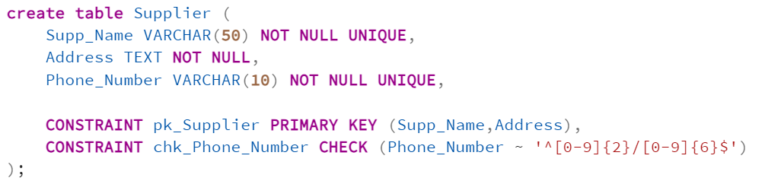

The **Supplier** table stores information about suppliers with Supp_Name and Address forming a composite primary key, ensuring each supplier entry is unique. The Supp_Name and Phone_Number fields are both marked as UNIQUE to prevent duplicate names or phone numbers. A CHECK constraint validates the Phone_Number format, requiring two digits, a slash, and six digits.

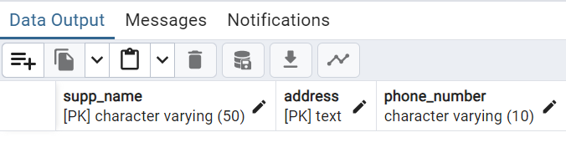

Figure 32: Creation of Supplier Relation

**Relation7: Publisher**

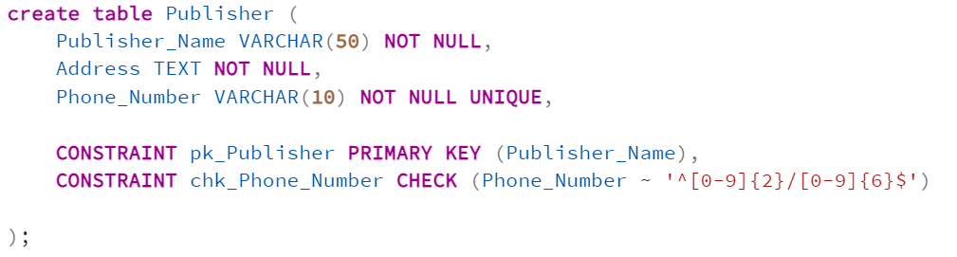

The **Publisher** table stores information about publishers, with Publisher_Name as the primary key to ensure uniqueness. The Phone_Number field is marked as UNIQUE to prevent duplicate phone numbers and must follow a specific pattern validated by a CHECK constraint (two digits, a slash, and six digits). The Address field is mandatory.

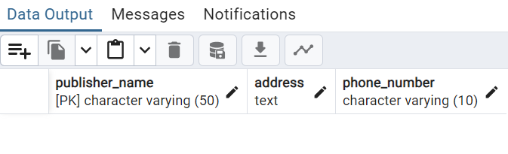

Figure 33: Creation of Publisher Relation

**Relation8: Items**

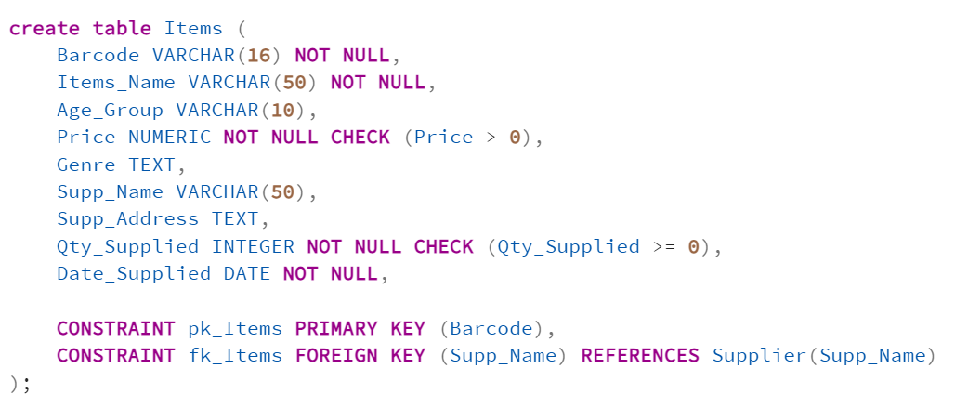

The **Items** table stores information about items with Barcode as the primary key, ensuring uniqueness. Constraints enforce data integrity: Price must be greater than 0, and Qty_Supplied must be zero or higher. The Supp_Name column acts as a foreign key referencing the Supp_Name in the Supplier table. The Date_Supplied is mandatory, and other columns like Items_Name, Age_Group, and Genre capture descriptive details of the items.

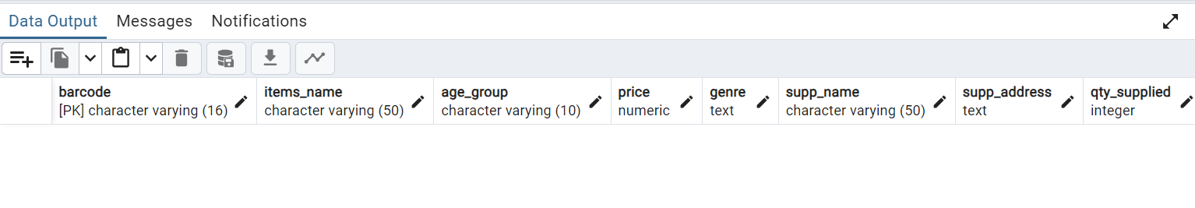

Figure 34: Creation of Items Relation

**Relation9: Books_for_Sale**

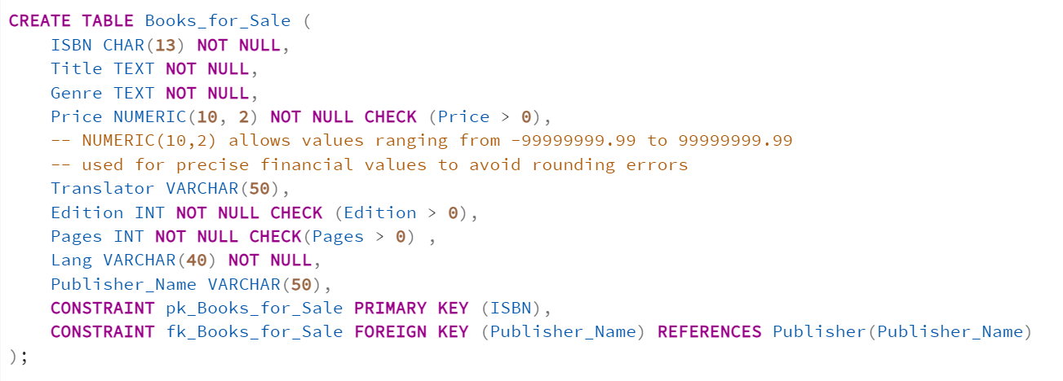

The **Books_for_Sale** table stores details of books with ISBN as the primary key, ensuring uniqueness. Constraints enforce data integrity: Price, Edition, and Pages must all be greater than 0, ensuring valid numeric values. The Publisher_Name column acts as a foreign key referencing the Publisher_Name in the Publisher table. Other columns, such as Title, Genre, Translator, and Lang, capture additional details about each book.

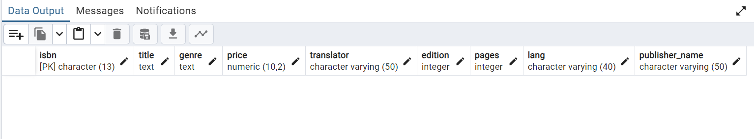

Figure 35: Creation of Books_for_Sale Relation

**Relation10: Books_for_Rent**

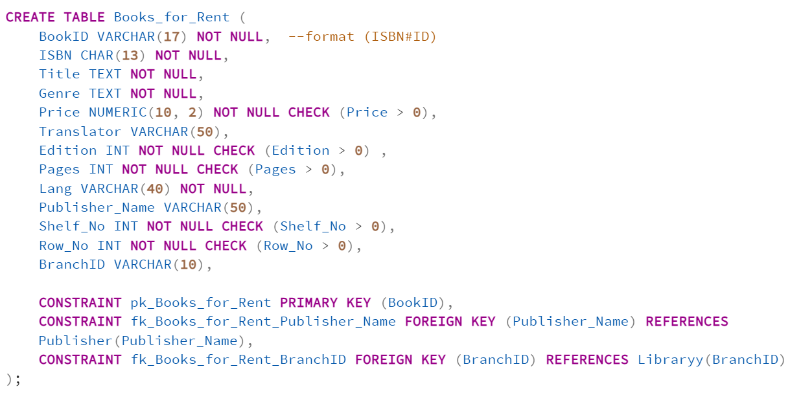

The **Books_for_Rent** table stores details of books available for rent, with BookID as the primary key in the format ISBN#ID to ensure uniqueness. Constraints enforce data validity: Price, Edition, Pages, Shelf_No, and Row_No must all be greater than 0. The Publisher_Name column acts as a foreign key referencing the Publisher table, and BranchID links to the Libraryy table. Other fields like ISBN, Title, Genre, and Lang capture book details.

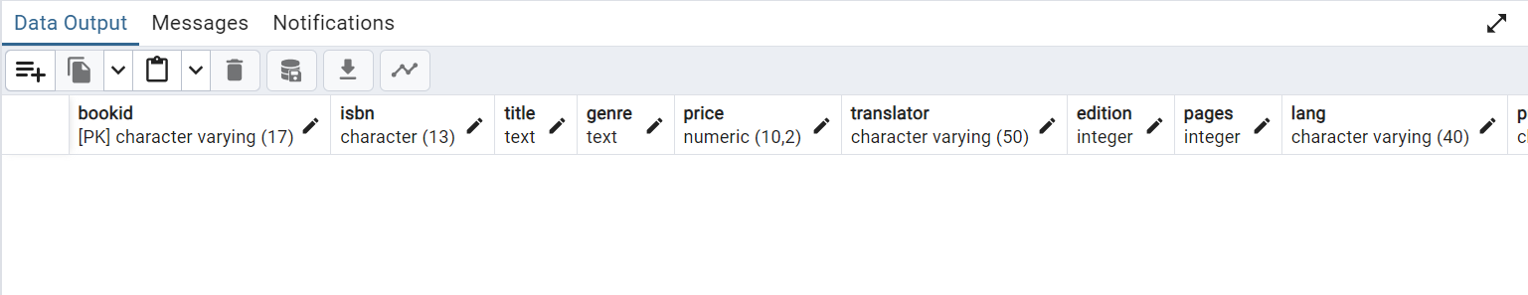

Figure 36: Creation of Books_for_Rent Relation

**Relation11: Authors_BookSale**

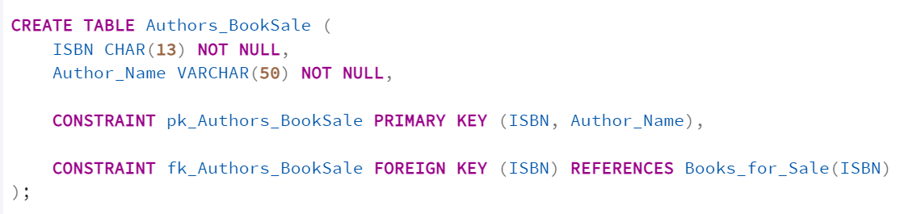

The **Authors_BookSale** table associates authors with books for sale, using a composite primary key (ISBN, Author_Name) to ensure each author-book pair is unique. The ISBN column is a foreign key referencing the ISBN in the Books_for_Sale table.

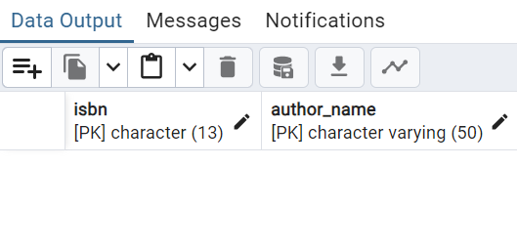

Figure 37: Creation of Authors_BookSale Relation

**Relation12: Authors_BookRent**

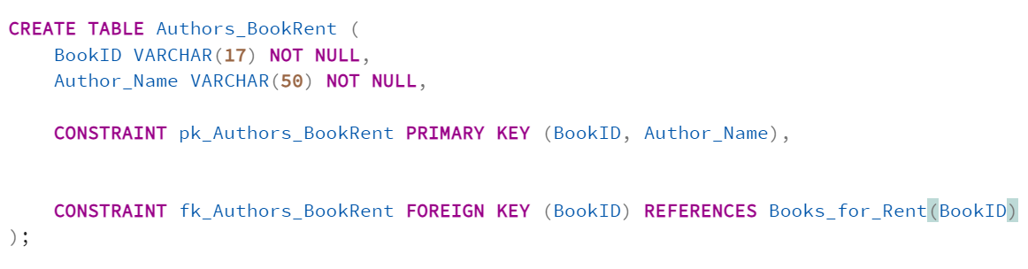

The **Authors_BookRent** table associates authors with books for rent, using a composite primary key (ISBN, Author_Name) to ensure each author-book pair is unique. The ISBN column is a foreign key referencing the ISBN in the Books_for_Rent table.

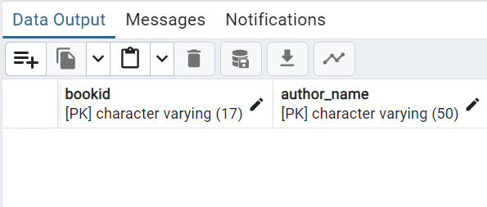

Figure 38: Creation of Authors_BookRent Relation

**Relation13: Stores_Items**

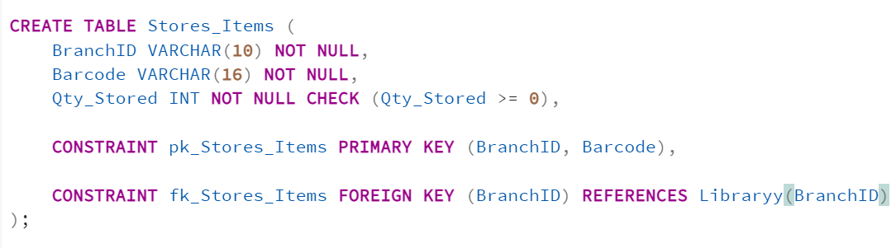

The **Stores_Items** table tracks item storage in branches, with a composite primary key (BranchID, Barcode) ensuring each item in a branch is uniquely identified. The BranchID column is a foreign key referencing the BranchID in the Libraryy table. The Qty_Stored column ensures stored quantities are non-negative using a CHECK constraint.

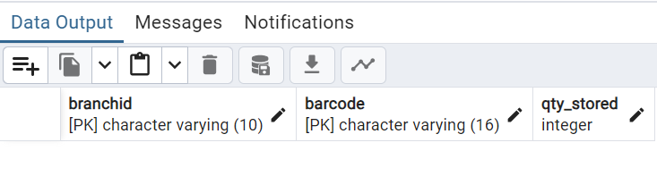

Figure 39: Creation of Stores_Items Relation

**Relation14: Stores_Booksforsale**

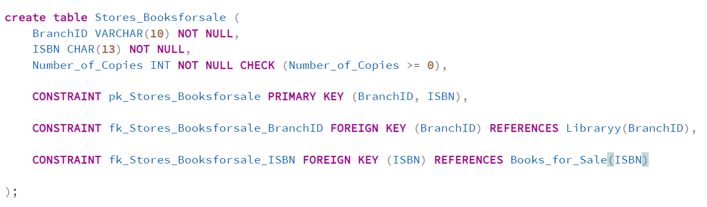

The **Stores_Booksforsale** table tracks books available for sale in specific branches, using a composite primary key (BranchID, ISBN) to ensure unique records. The BranchID column references the Libraryy table, and ISBN references the Books_for_Sale table. The Number_of_Copies column ensures non-negative values using a CHECK constraint.

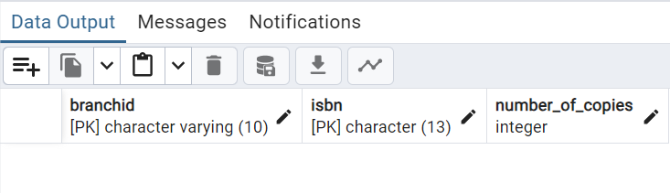

Figure 40: Creation of Stores_BooksforSale Relation

**Relation15: Buys_Books**

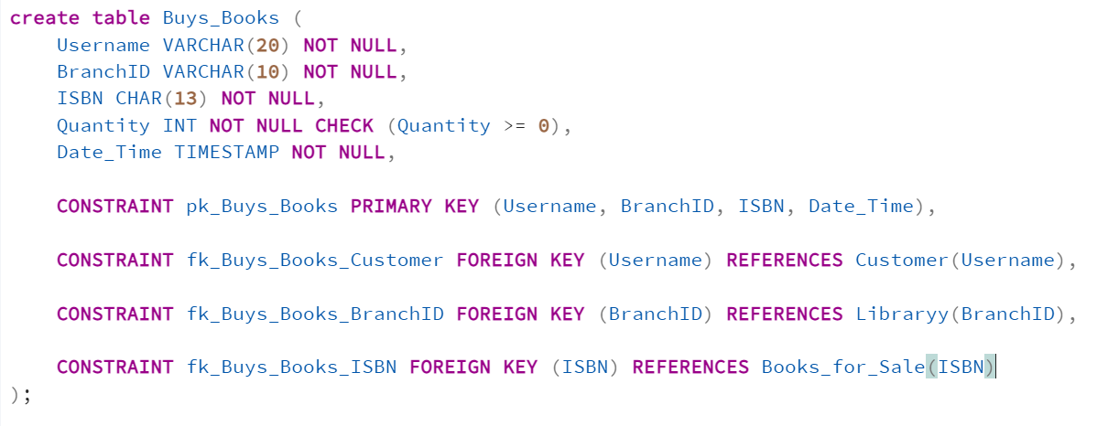

The **Buys_Books** table records book purchase transactions, using a composite primary key (Username, BranchID, ISBN, Date_Time) to identify each purchase uniquely. Foreign keys ensure referential integrity: Username references the Customer table, BranchID references the Libraryy table, and ISBN references the Books_for_Sale table. The Quantity column ensures non-negative values through a CHECK constraint, and Date_Time records the purchase time.

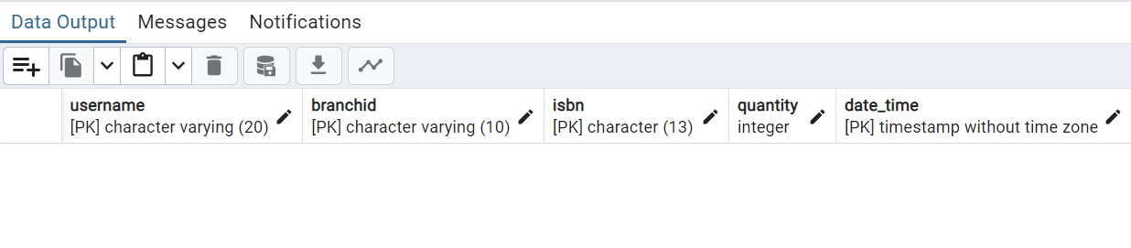

Figure 41: Creation of Buys_Books Relation

**Relation16: Purchases_Items**

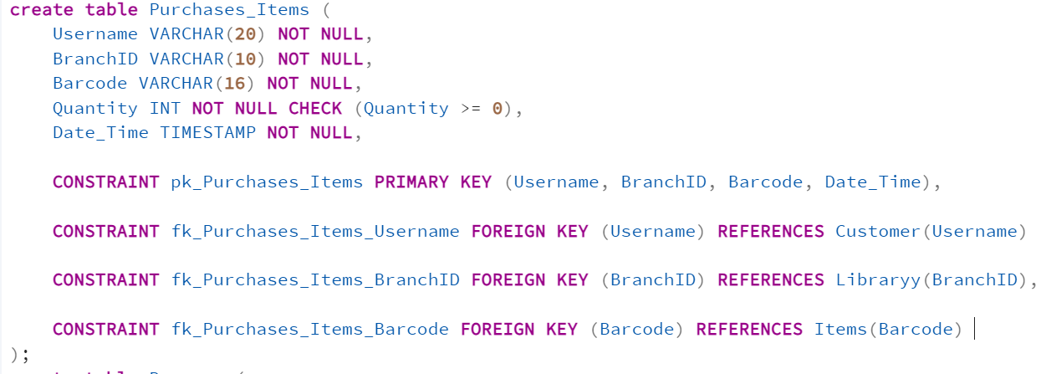

The **Purchases_Items** table records customer purchases of items from specific branches, with a composite primary key (Username, BranchID, Barcode, Date_Time) to uniquely identify each transaction. Foreign keys ensure referential integrity: Username references the Customer table, BranchID references the Libraryy table, and Barcode references the Items table. The Quantity column requires non-negative values through a CHECK constraint, and Date_Time records the purchase timestamp.

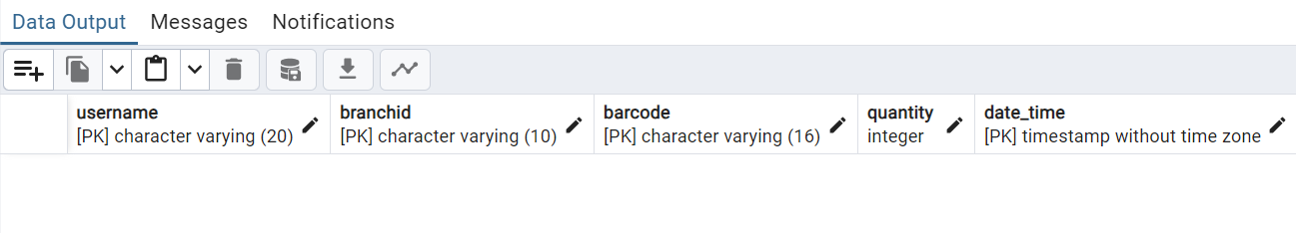

Figure 42: Creation of Purchases_Items Relation

**Relation17: Borrows**

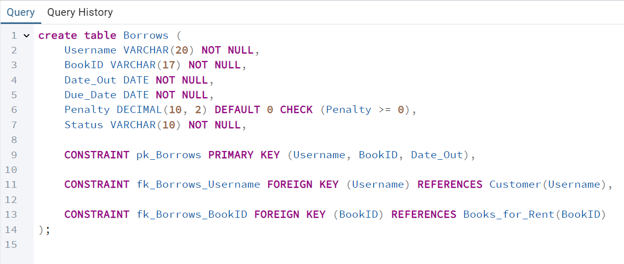

The **Borrows table** tracks book borrowings, using a composite primary key (Username, BookID, Date_Out) to identify each transaction uniquely. Foreign keys ensure referential integrity: Username references the Customer table and BookID references the Books_for_Rent table. The Penalty column records late return penalties, default to 0, and must be non-negative (CHECK Penalty >= 0). Date_Out and Due_Date capture the borrowing and return deadlines, ensuring structured and valid borrowing records, and Status determines whether the book has been returned to the library or not.

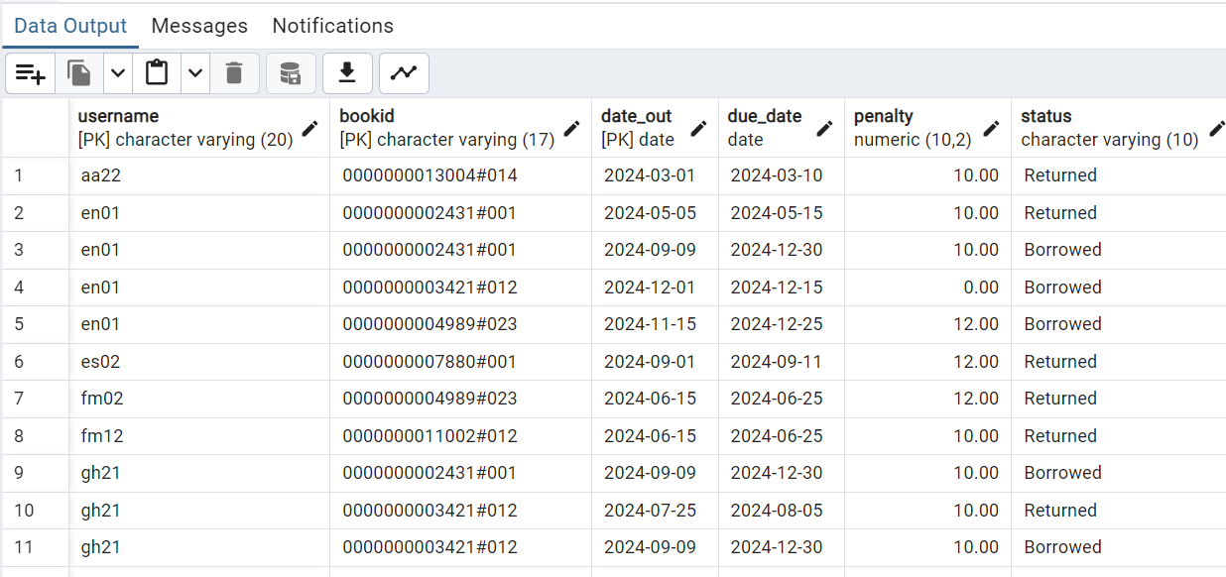

Figure 43: Creation of Borrows Relation

**Relation18: Sale_to_Rent**

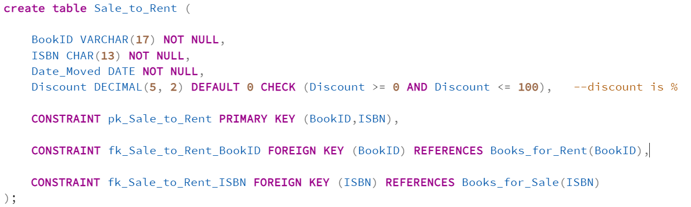

The **Sale_to_Rent** table tracks books transitioned from sale to rent, using a composite primary key (BookID, ISBN) to uniquely identify each record. Foreign keys ensure referential integrity: BookID references the Books_for_Rent table, and ISBN references the Books_for_Sale table. The Date_Moved column records the transition date, while the Discount column applies a discount percentage, defaulting to 0, and is constrained to values between 0 and 100 (CHECK Discount >= 0 AND Discount <= 100).

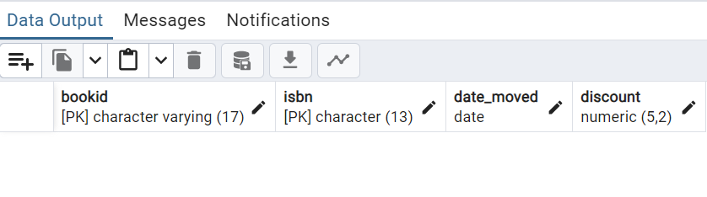

Figure 44: Creation of Sales_to_Rent Relation

**Full Code:**

-- we have 18 tables to create and insert date

CREATE TABLE Authentication_System (

Email VARCHAR(50),

Passcode VARCHAR(20) NOT NULL,

CONSTRAINT pk_Authentication_System PRIMARY KEY (email),

CONSTRAINT chk_email CHECK (

email ~ '^[A-Za-z0-9._%+-]+@[A-Za-z0-9.-]+\.[A-Za-z]{2,}$'

),

CONSTRAINT chk_passcode CHECK (

passcode ~ '^(?=.*[a-z])(?=.*[A-Z])(?=.*[0-9])(?=.*[^a-zA-Z0-9]).{1,}$'

)

--the passcode must contain at least one upper and lower case and 1 number and 1 symbol

--the email should follow the standard format

);

create table Customer (

Username VARCHAR(20),

Phone_Number VARCHAR(10) NOT NULL,

Address TEXT,

Sex CHAR(1) NOT NULL CHECK (Sex IN ('M', 'F')),

First_Name VARCHAR(20) NOT NULL,

Last_Name VARCHAR(20) NOT NULL,

Ct_Email VARCHAR(50) UNIQUE,

CONSTRAINT pk_Customer PRIMARY KEY (Username),

CONSTRAINT fk_Customer FOREIGN KEY (Ct_Email) REFERENCES Authentication_System(Email),

CONSTRAINT chk_Phone_Number CHECK (Phone_Number ~ '^[0-9]{2}/[0-9]{6}$' )

);

create table Libraryy (

BranchID VARCHAR(10) NOT NULL,

Address TEXT NOT NULL,

Phone_Number VARCHAR(10) NOT NULL UNIQUE,

CONSTRAINT pk_Libraryy PRIMARY KEY (BranchID),

CONSTRAINT chk_BranchID CHECK (BranchID ~ '^LIBTECH[0-9]{2}$'),

CONSTRAINT chk_Phone_Number CHECK (Phone_Number ~ '^[0-9]{2}/[0-9]{6}$')

);

create table Staff (

SSN VARCHAR(11),

First_Name VARCHAR(20) NOT NULL,

Last_Name VARCHAR(20) NOT NULL,

DoB DATE,

Blood_Type CHAR(3) NOT NULL CHECK (Blood_Type IN ('A+', 'A-', 'B+', 'B-', 'AB+', 'AB-', 'O+', 'O-')),

Address TEXT NOT NULL,

Salary NUMERIC CHECK (Salary > 0),

Post TEXT NOT NULL,

Super_SSN VARCHAR(11),

St_Email VARCHAR(50) UNIQUE,

BranchID VARCHAR(10),

Hours INTEGER CHECK (Hours >= 0),

CONSTRAINT pk_Staff PRIMARY KEY (SSN),

CONSTRAINT fk_Staff_St_Email FOREIGN KEY (St_Email) REFERENCES Authentication_System(Email),

CONSTRAINT fk_Staff_BranchID FOREIGN KEY (BranchID) REFERENCES Libraryy(BranchID),

CONSTRAINT fk_Staff_Super_SSN FOREIGN KEY (Super_SSN) REFERENCES Staff(SSN)

);

create table Dependents (

SSN VARCHAR(11) NOT NULL,

Dep_Name VARCHAR(50) NOT NULL,

Relationship VARCHAR(20) NOT NULL,

Sex CHAR(1) NOT NULL CHECK (Sex IN ('M', 'F')),

CONSTRAINT pk_Dependents PRIMARY KEY (SSN, Dep_Name),

CONSTRAINT fk_Dependents FOREIGN KEY (SSN) REFERENCES Staff(SSN)

ON UPDATE CASCADE

ON DELETE CASCADE

);

create table Supplier (

Supp_Name VARCHAR(50) NOT NULL UNIQUE,

Address TEXT NOT NULL,

Phone_Number VARCHAR(10) NOT NULL UNIQUE,

CONSTRAINT pk_Supplier PRIMARY KEY (Supp_Name,Address),

CONSTRAINT chk_Phone_Number CHECK (Phone_Number ~ '^[0-9]{2}/[0-9]{6}$')

);

create table Publisher (

Publisher_Name VARCHAR(50) NOT NULL,

Address TEXT NOT NULL,

Phone_Number VARCHAR(10) NOT NULL UNIQUE,

CONSTRAINT pk_Publisher PRIMARY KEY (Publisher_Name),

CONSTRAINT chk_Phone_Number CHECK (Phone_Number ~ '^[0-9]{2}/[0-9]{6}$')

);

create table Items (

Barcode VARCHAR(16) NOT NULL,

Items_Name VARCHAR(50) NOT NULL,

Age_Group VARCHAR(10),

Price NUMERIC NOT NULL CHECK (Price > 0),

Genre TEXT,

Supp_Name VARCHAR(50),

Supp_Address TEXT,

Qty_Supplied INTEGER NOT NULL CHECK (Qty_Supplied >= 0),

Date_Supplied DATE NOT NULL,

CONSTRAINT pk_Items PRIMARY KEY (Barcode),

CONSTRAINT fk_Items FOREIGN KEY (Supp_Name) REFERENCES Supplier(Supp_Name)

);

CREATE TABLE Books_for_Sale (

ISBN CHAR(13) NOT NULL,

Title TEXT NOT NULL,

Genre TEXT NOT NULL,

Price NUMERIC(10, 2) NOT NULL CHECK (Price > 0),

-- NUMERIC(10,2) allows values ranging from -99999999.99 to 99999999.99

-- used for precise financial values to avoid rounding errors

Translator VARCHAR(50),

Edition INT NOT NULL CHECK (Edition > 0),

Pages INT NOT NULL CHECK(Pages > 0) ,

Lang VARCHAR(40) NOT NULL,

Publisher_Name VARCHAR(50),

CONSTRAINT pk_Books_for_Sale PRIMARY KEY (ISBN),

CONSTRAINT fk_Books_for_Sale FOREIGN KEY (Publisher_Name) REFERENCES Publisher(Publisher_Name)

);

CREATE TABLE Books_for_Rent (

BookID VARCHAR(17) NOT NULL, --format (ISBN#ID)

ISBN CHAR(13) NOT NULL,

Title TEXT NOT NULL,

Genre TEXT NOT NULL,

Price NUMERIC(10, 2) NOT NULL CHECK (Price > 0),

Translator VARCHAR(50),

Edition INT NOT NULL CHECK (Edition > 0) ,

Pages INT NOT NULL CHECK (Pages > 0),

Lang VARCHAR(40) NOT NULL,

Publisher_Name VARCHAR(50),

Shelf_No INT NOT NULL CHECK (Shelf_No > 0),

Row_No INT NOT NULL CHECK (Row_No > 0),

BranchID VARCHAR(10),

CONSTRAINT pk_Books_for_Rent PRIMARY KEY (BookID),

CONSTRAINT fk_Books_for_Rent_Publisher_Name FOREIGN KEY (Publisher_Name) REFERENCES Publisher(Publisher_Name) ,

CONSTRAINT fk_Books_for_Rent_BranchID FOREIGN KEY (BranchID) REFERENCES Libraryy(BranchID)

);

CREATE TABLE Authors_BookSale (

ISBN CHAR(13) NOT NULL,

Author_Name VARCHAR(50) NOT NULL,

CONSTRAINT pk_Authors_BookSale PRIMARY KEY (ISBN, Author_Name),

CONSTRAINT fk_Authors_BookSale FOREIGN KEY (ISBN) REFERENCES Books_for_Sale(ISBN)

);

CREATE TABLE Authors_BookRent (

BookID VARCHAR(17) NOT NULL,

Author_Name VARCHAR(50) NOT NULL,

CONSTRAINT pk_Authors_BookRent PRIMARY KEY (BookID, Author_Name),

CONSTRAINT fk_Authors_BookRent FOREIGN KEY (BookID) REFERENCES Books_for_Rent(BookID)

);

CREATE TABLE Stores_Items (

BranchID VARCHAR(10) NOT NULL,

Barcode VARCHAR(16) NOT NULL,

Qty_Stored INT NOT NULL CHECK (Qty_Stored >= 0),

CONSTRAINT pk_Stores_Items PRIMARY KEY (BranchID, Barcode),

CONSTRAINT fk_Stores_Items FOREIGN KEY (BranchID) REFERENCES Libraryy(BranchID)

);

create table Stores_Booksforsale (

BranchID VARCHAR(10) NOT NULL,

ISBN CHAR(13) NOT NULL,

Number_of_Copies INT NOT NULL CHECK (Number_of_Copies >= 0),

CONSTRAINT pk_Stores_Booksforsale PRIMARY KEY (BranchID, ISBN),

CONSTRAINT fk_Stores_Booksforsale_BranchID FOREIGN KEY (BranchID) REFERENCES Libraryy(BranchID),

CONSTRAINT fk_Stores_Booksforsale_ISBN FOREIGN KEY (ISBN) REFERENCES Books_for_Sale(ISBN)

);

create table Buys_Books (

Username VARCHAR(20) NOT NULL,

BranchID VARCHAR(10) NOT NULL,

ISBN CHAR(13) NOT NULL,

Quantity INT NOT NULL CHECK (Quantity >= 0),

Date_Time TIMESTAMP NOT NULL,

CONSTRAINT pk_Buys_Books PRIMARY KEY (Username, BranchID, ISBN, Date_Time),

CONSTRAINT fk_Buys_Books_Customer FOREIGN KEY (Username) REFERENCES Customer(Username),

CONSTRAINT fk_Buys_Books_BranchID FOREIGN KEY (BranchID) REFERENCES Libraryy(BranchID),

CONSTRAINT fk_Buys_Books_ISBN FOREIGN KEY (ISBN) REFERENCES Books_for_Sale(ISBN)

);

create table Purchases_Items (

Username VARCHAR(20) NOT NULL,

BranchID VARCHAR(10) NOT NULL,

Barcode VARCHAR(16) NOT NULL,

Quantity INT NOT NULL CHECK (Quantity >= 0),

Date_Time TIMESTAMP NOT NULL,

CONSTRAINT pk_Purchases_Items PRIMARY KEY (Username, BranchID, Barcode, Date_Time),

CONSTRAINT fk_Purchases_Items_Username FOREIGN KEY (Username) REFERENCES Customer(Username),

CONSTRAINT fk_Purchases_Items_BranchID FOREIGN KEY (BranchID) REFERENCES Libraryy(BranchID),

CONSTRAINT fk_Purchases_Items_Barcode FOREIGN KEY (Barcode) REFERENCES Items(Barcode)

);

create table Borrows (

Username VARCHAR(20) NOT NULL,

BookID VARCHAR(17) NOT NULL,

Date_Out DATE NOT NULL,

Due_Date DATE NOT NULL,

Penalty DECIMAL(10, 2) DEFAULT 0 CHECK (Penalty >= 0),

Status VARCHAR(10) NOT NULL,

CONSTRAINT pk_Borrows PRIMARY KEY (Username, BookID, Date_Out),

CONSTRAINT fk_Borrows_Username FOREIGN KEY (Username) REFERENCES Customer(Username),

CONSTRAINT fk_Borrows_BookID FOREIGN KEY (BookID) REFERENCES Books_for_Rent(BookID)

);

create table Sale_to_Rent (

BookID VARCHAR(17) NOT NULL,

ISBN CHAR(13) NOT NULL,

Date_Moved DATE NOT NULL,

Discount DECIMAL(5, 2) DEFAULT 0 CHECK (Discount >= 0 AND Discount <= 100), --discount is %

CONSTRAINT pk_Sale_to_Rent PRIMARY KEY (BookID,ISBN),

CONSTRAINT fk_Sale_to_Rent_BookID FOREIGN KEY (BookID) REFERENCES Books_for_Rent(BookID),

CONSTRAINT fk_Sale_to_Rent_ISBN FOREIGN KEY (ISBN) REFERENCES Books_for_Sale(ISBN)

);

# **Insertion of Data**

After successfully creating the tables, we inserted meaningful data. Each table contains more than 10 tuples.

**Relation 1: Authentication System:**

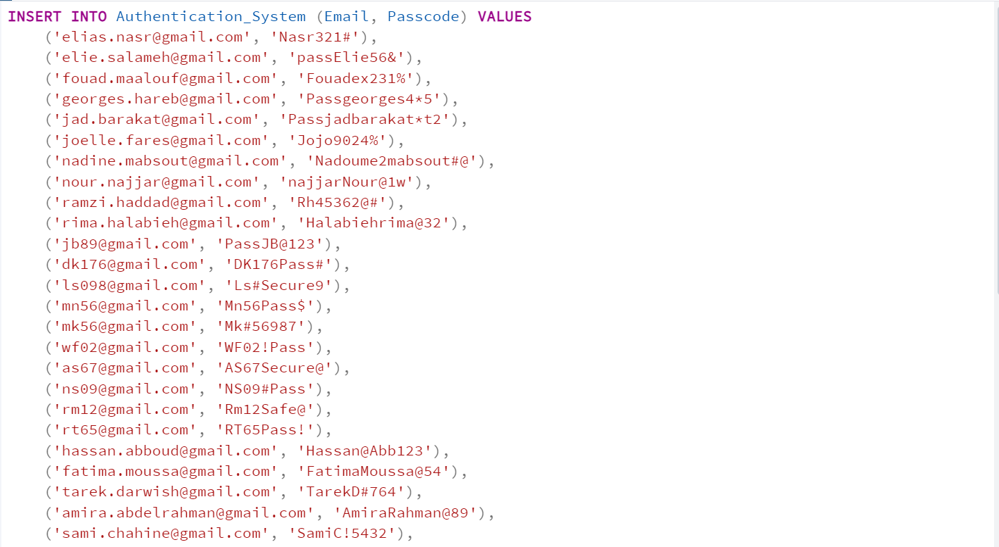

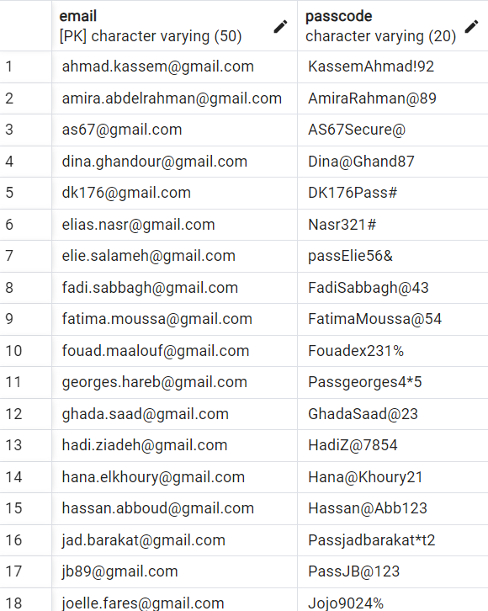

Figure 45: Inserting Data into Authentication_System Relation

**Relation2: Customer**

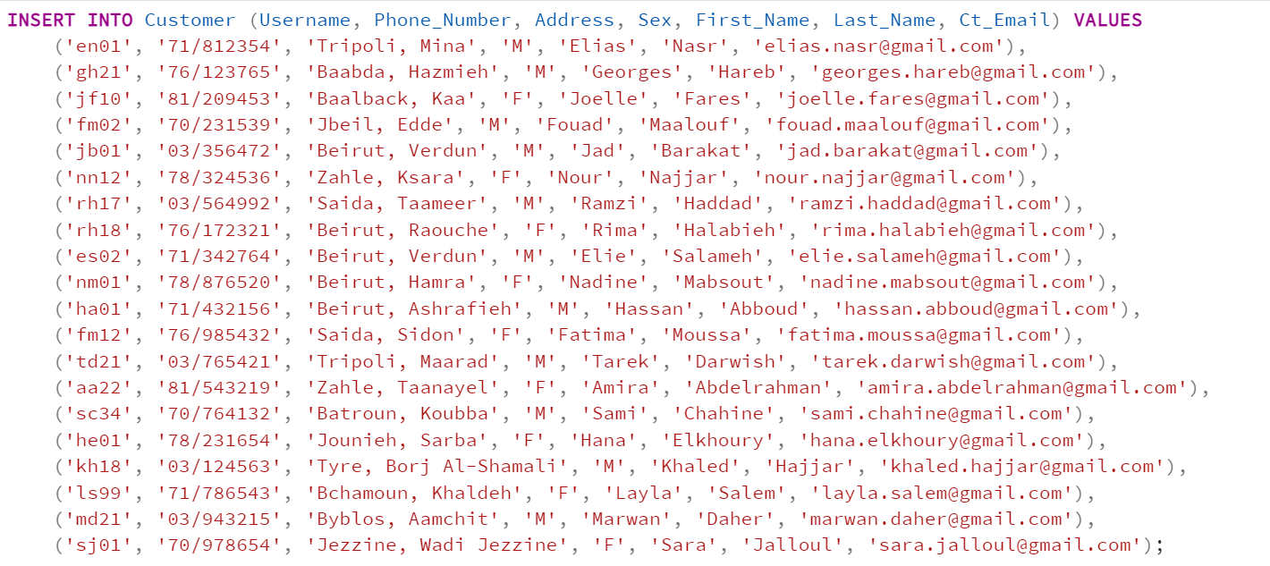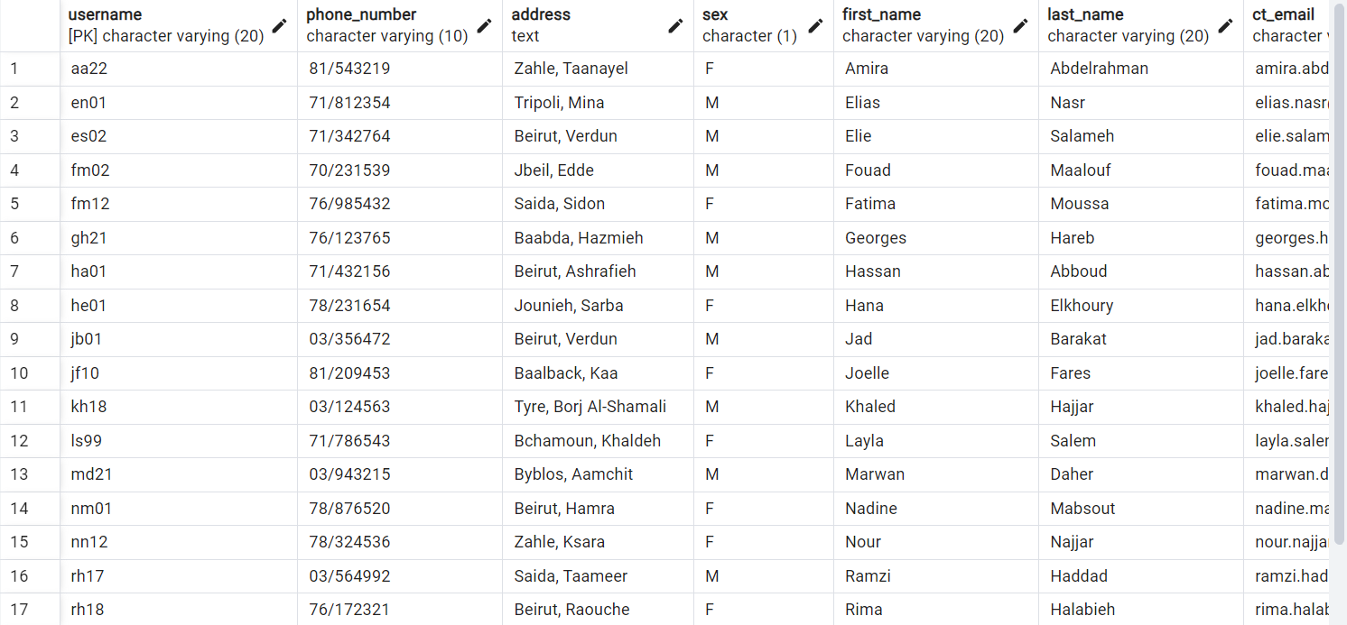

Figure 46: Inserting Data into Customer Relation

**Relation3: Libraryy**

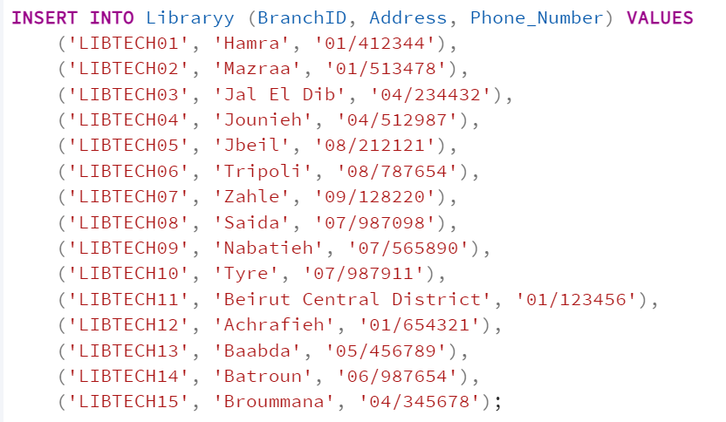

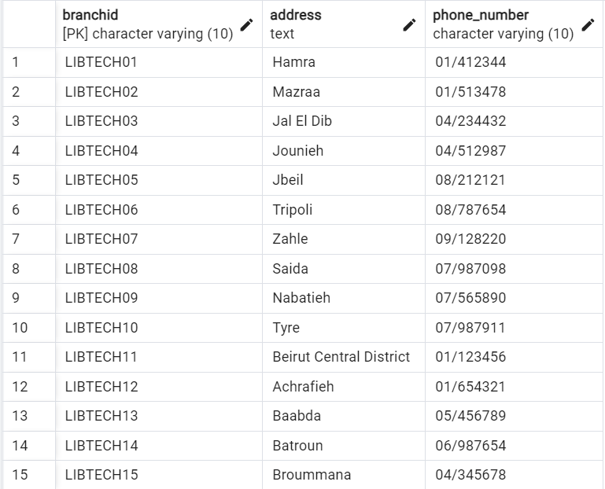

Figure 47: Inserting Data into Libraryy Relation

**Relation4:** **Staff**

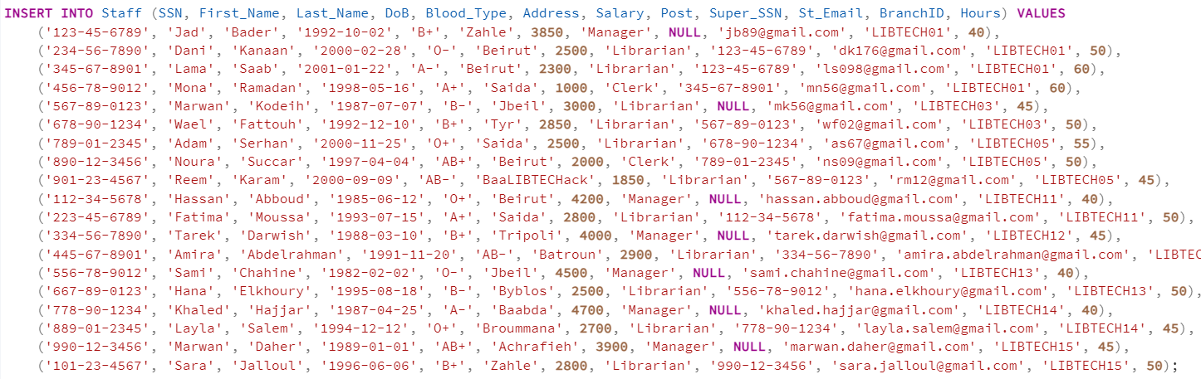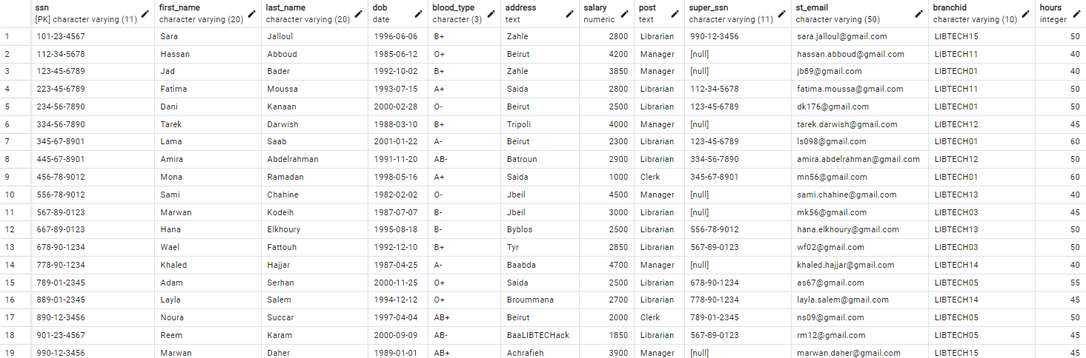

Figure 48: Inserting Data into Staff Relation

**Relation5: Dependents**

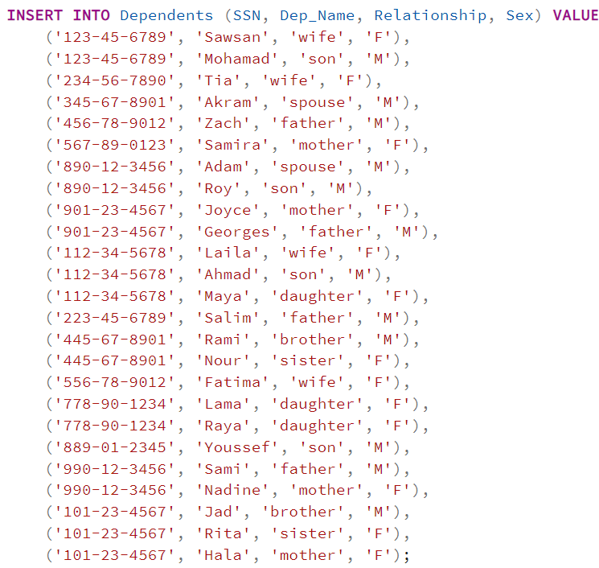

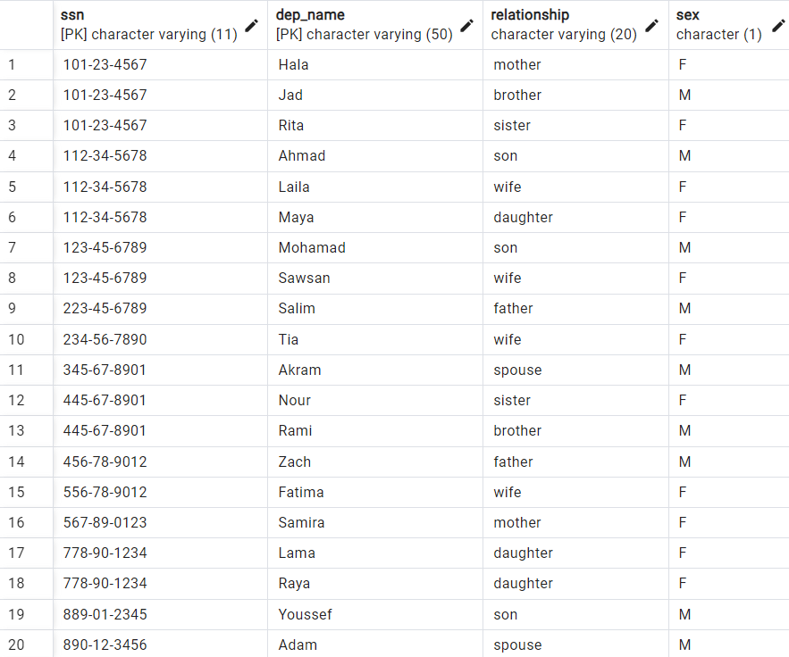

Figure 49: Inserting Data into Dependents Relation

**Relation6: Supplier**

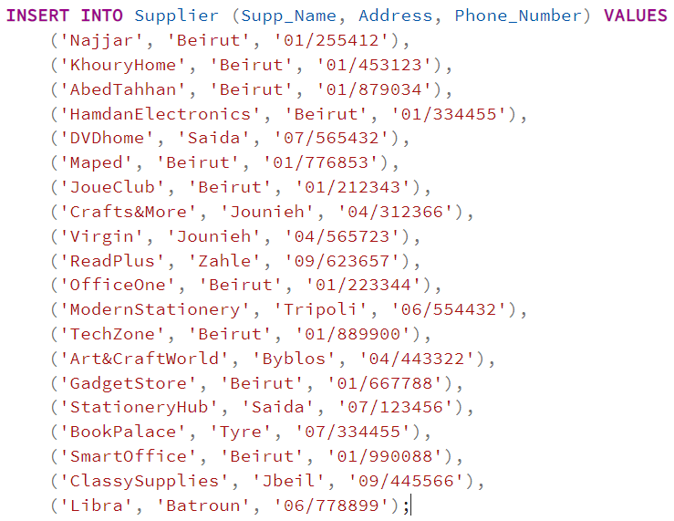

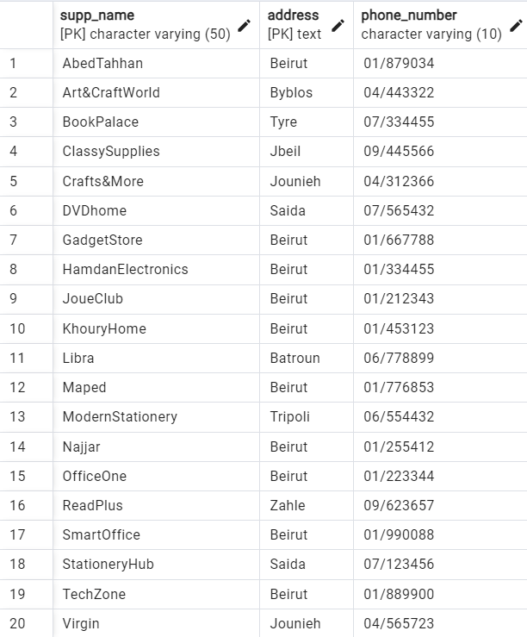

Figure 50: Inserting Data into Supplier Relation

**Relation7: Items**

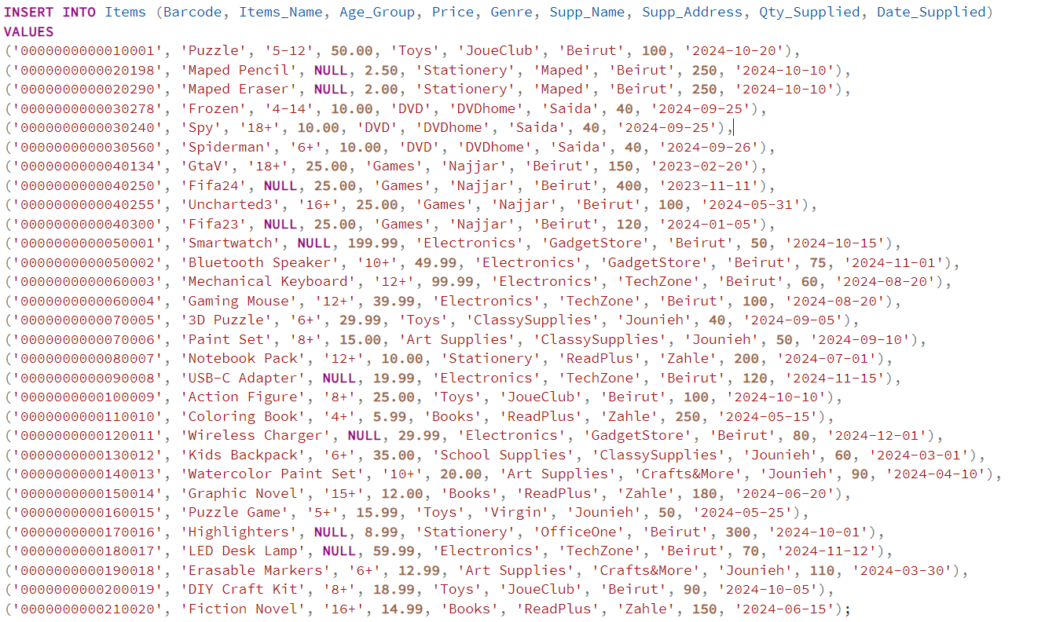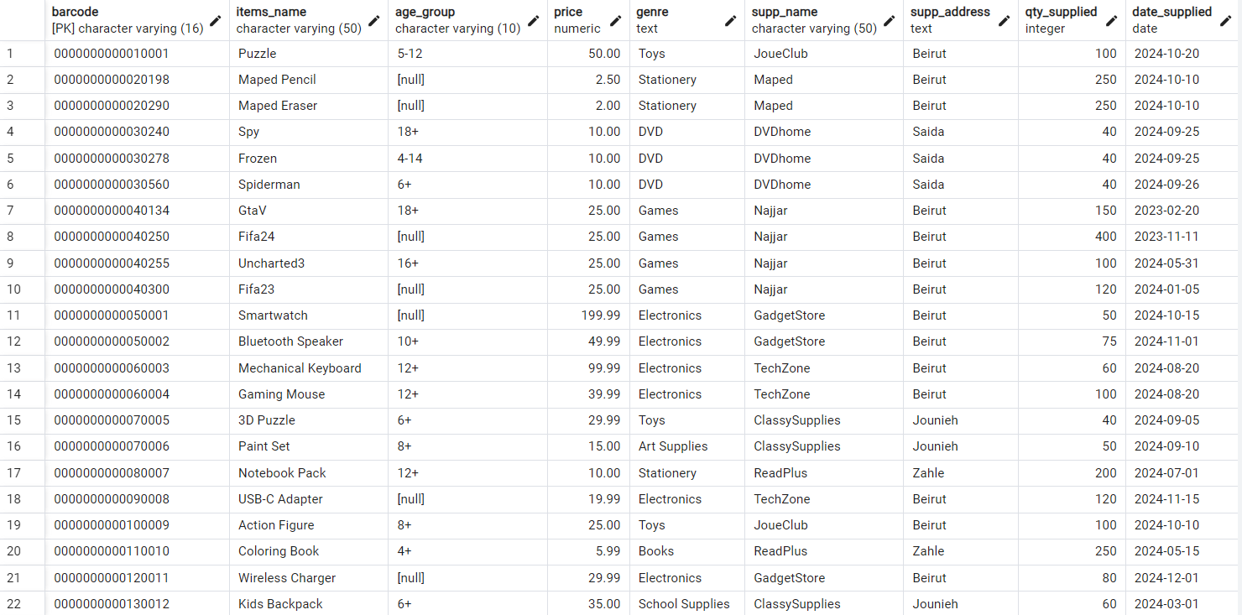

Figure 51: Inserting Data into Items Relation

**Relation8: Publisher**  
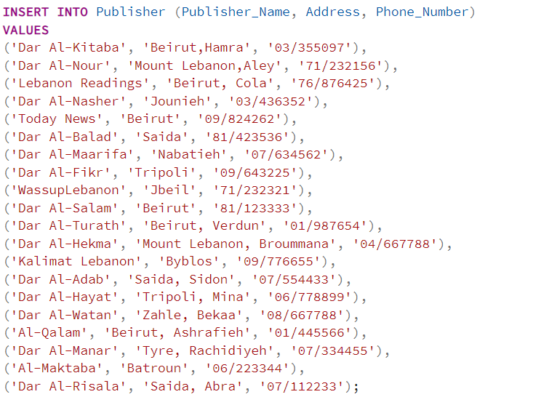

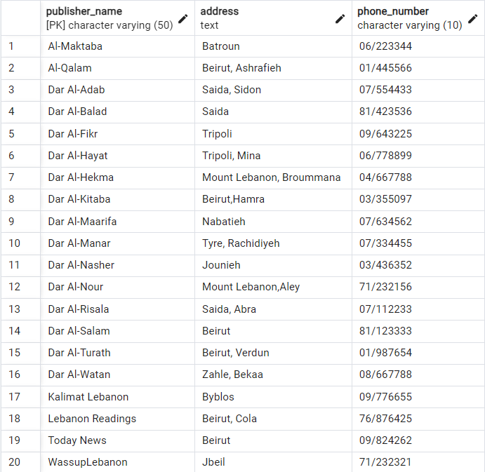

Figure 52: Inserting Data into Publisher Relation

**Relation9: Books_for_Sale**  
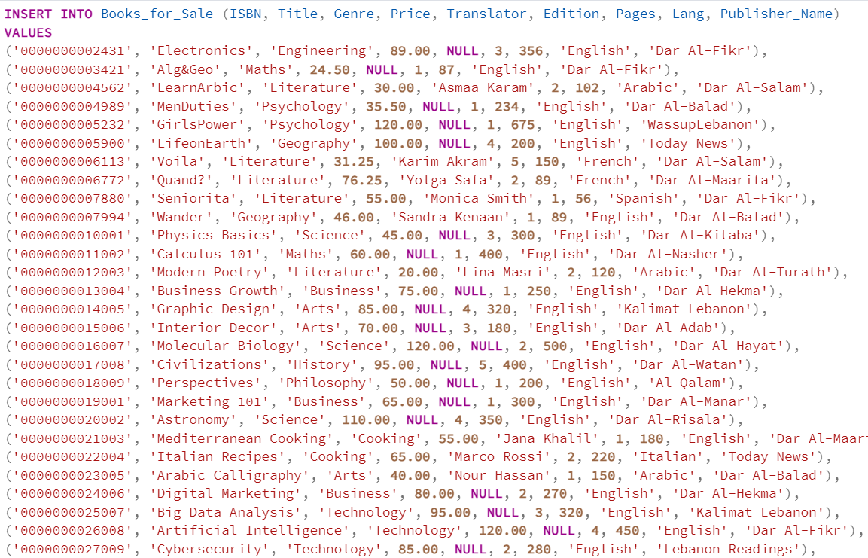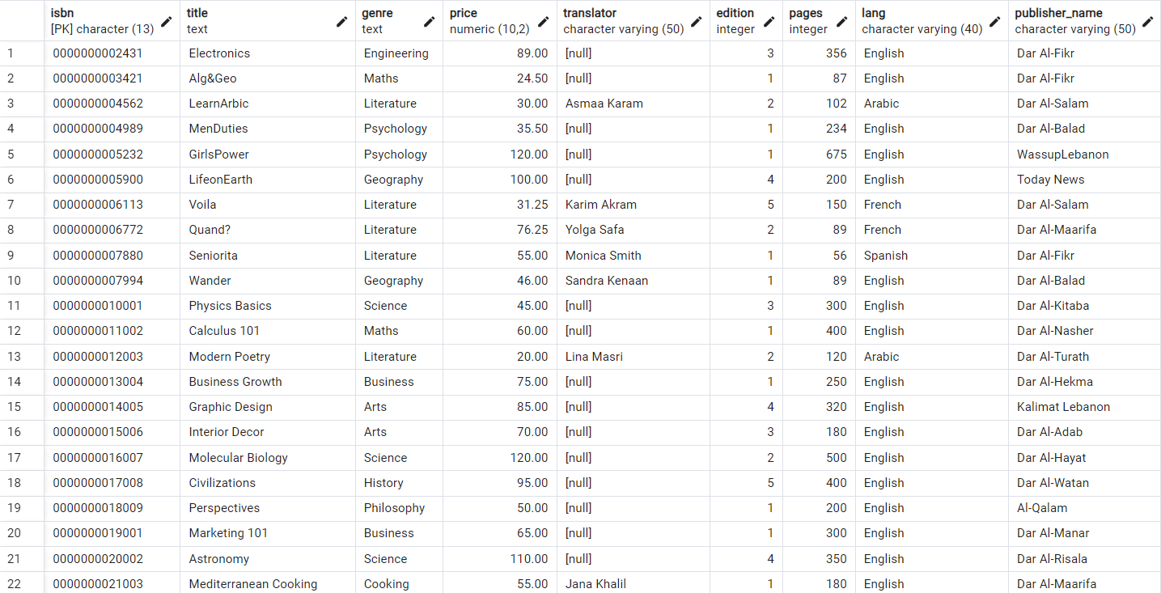

Figure 53: Inserting Data into Books_for_Sale Relation

**Relation10: Books_for_Rent**  
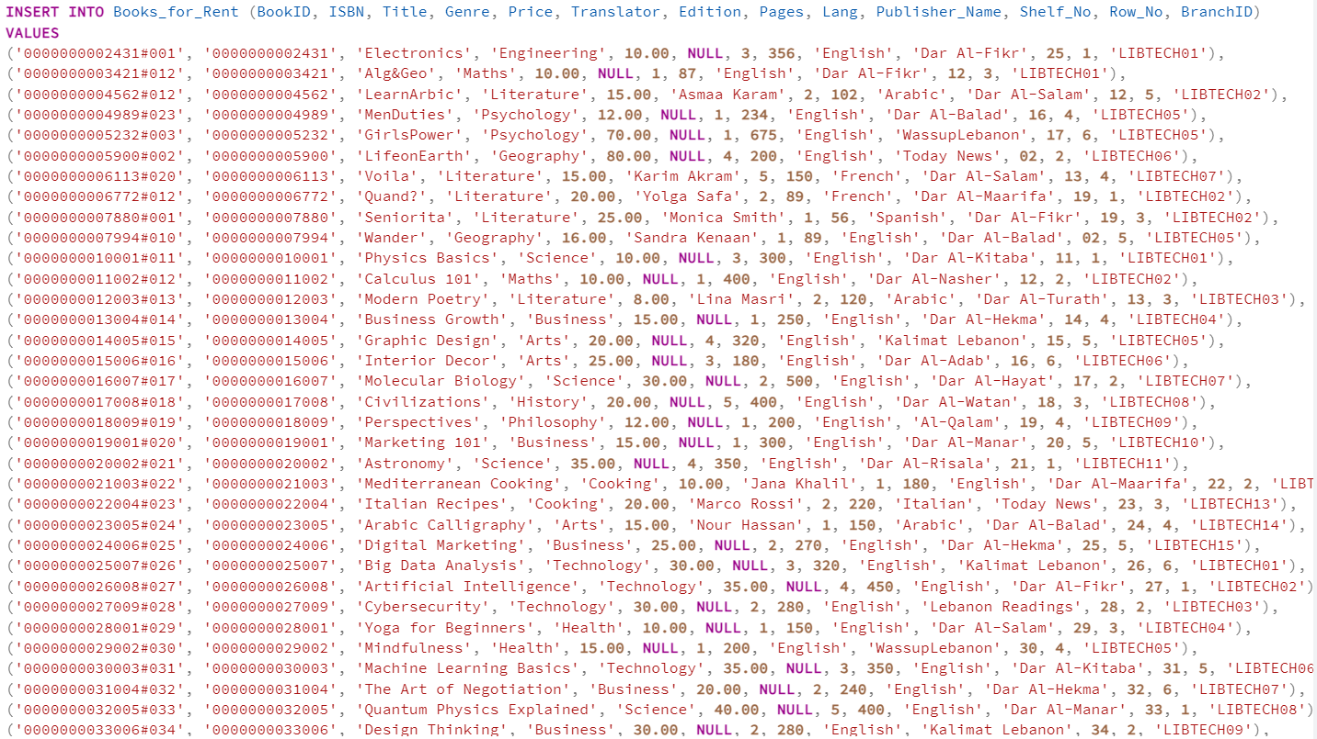

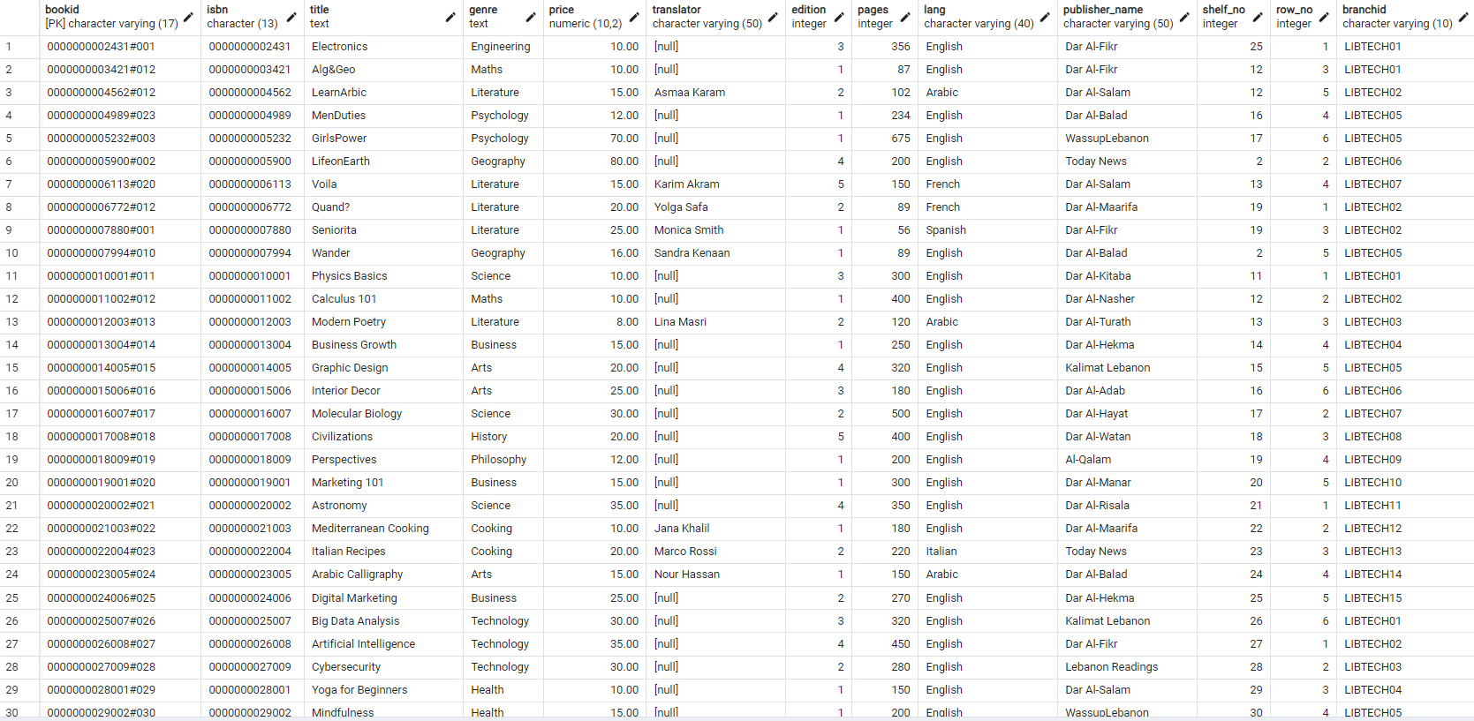

Figure 54: Inserting Data into Books_for_Rent Relation

**Relation11: Authors_booksale**  
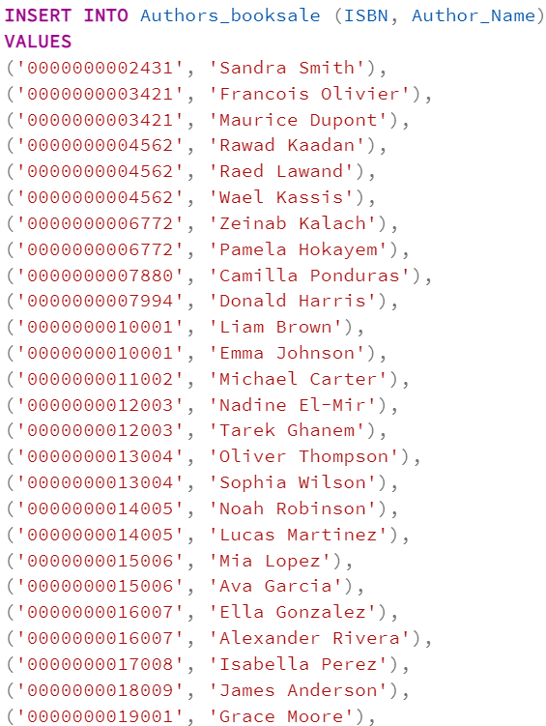

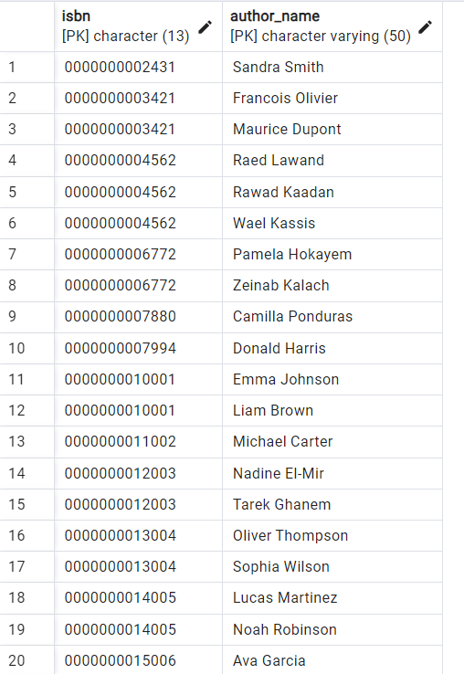

Figure 55: Inserting Data into Authors_booksale Relation

**Relation12: Authors_bookrent**  
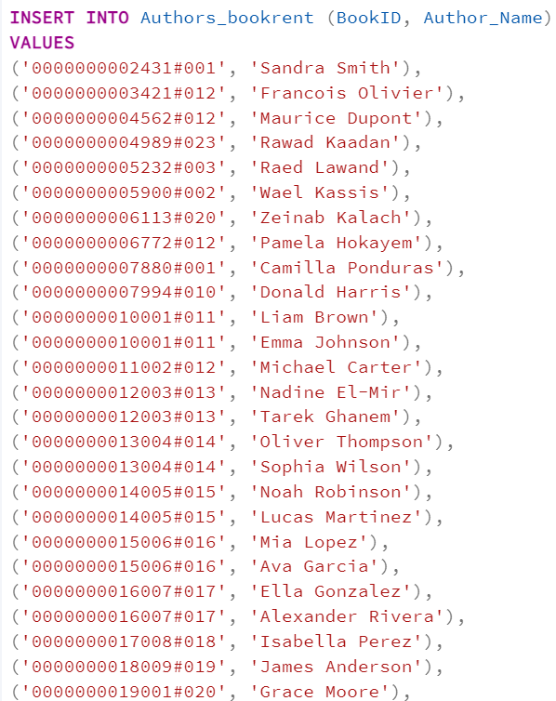

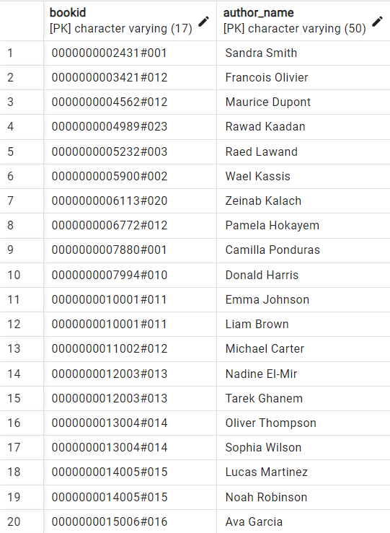

Figure 56: Inserting Data into Authors_bookrent Relation

**Relation13: Stores_Items**  
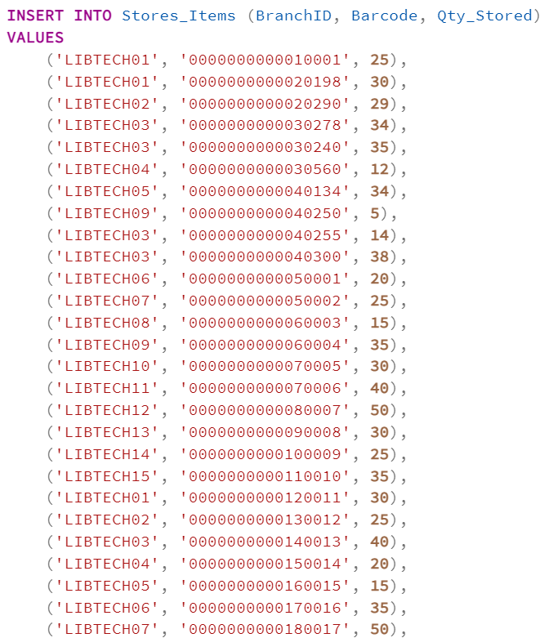

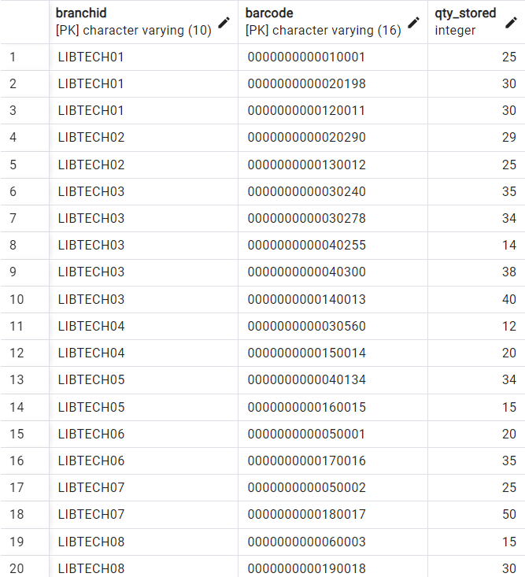

Figure 57: Inserting Data into Stores_Items Relation

**Relation14: Stores_booksforsale**  
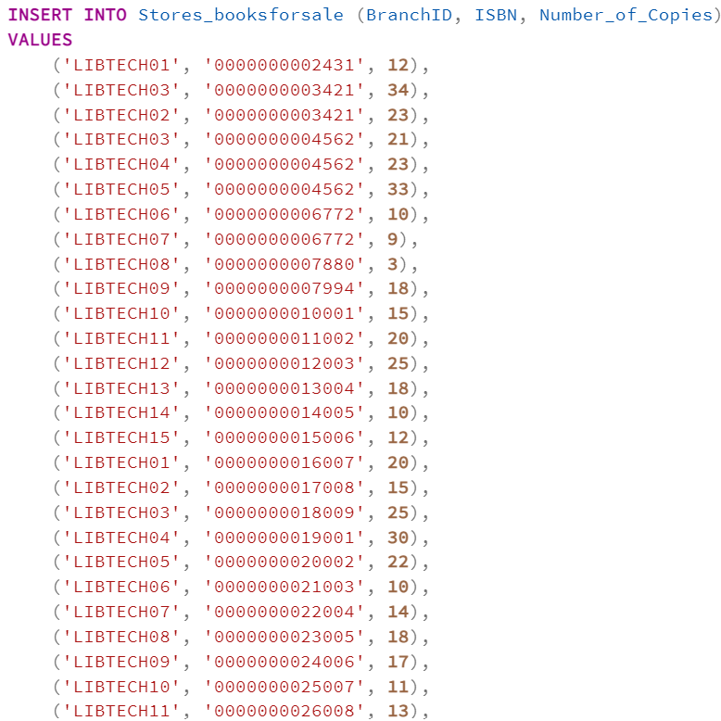

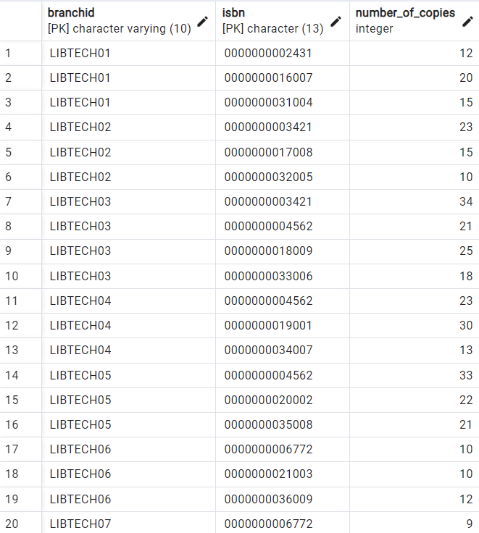

Figure 58: Insertingt Data into Stores_booksforsale Relation

**Relation15: Buys_Books**  
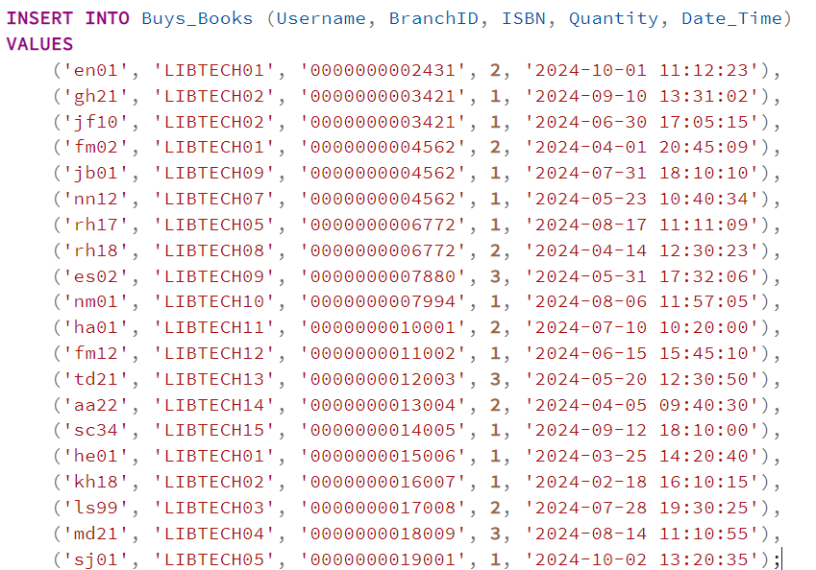

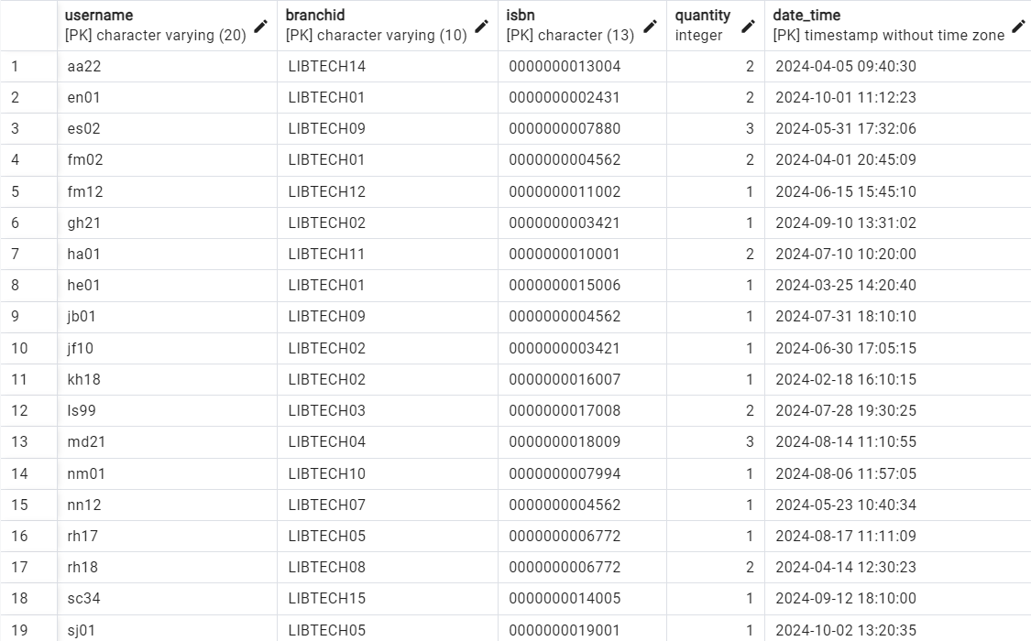

Figure 59: Inserting Data into Buys_Books Relation

**Relation16: Purchases_Items**  
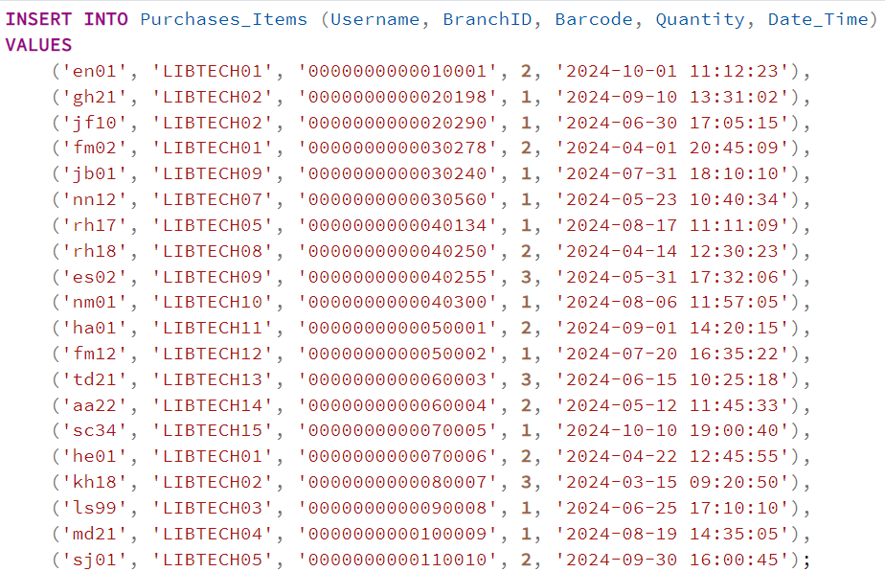

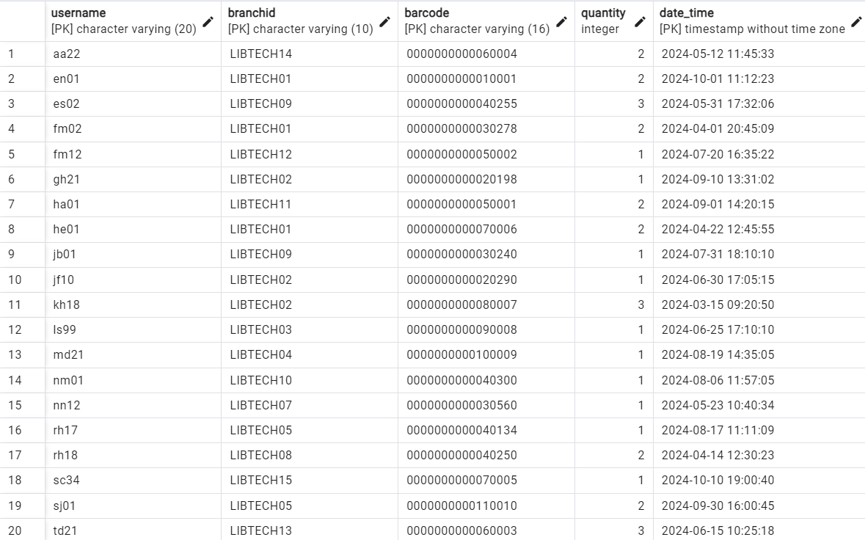

Figure 60: Inserting Data into Purchases_Items Relation

**Relation17: Borrows**  
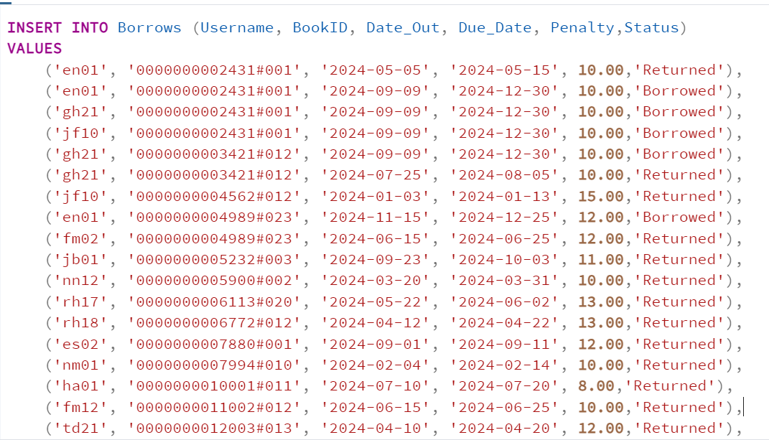



Figure 61: Inserting Data into Borrows Relation

**Relation18: Sale_to_Rent**  
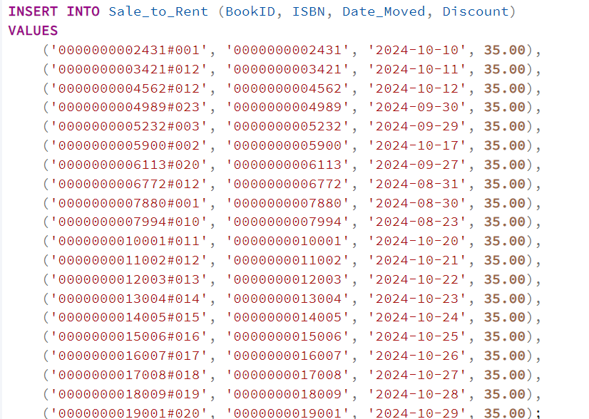

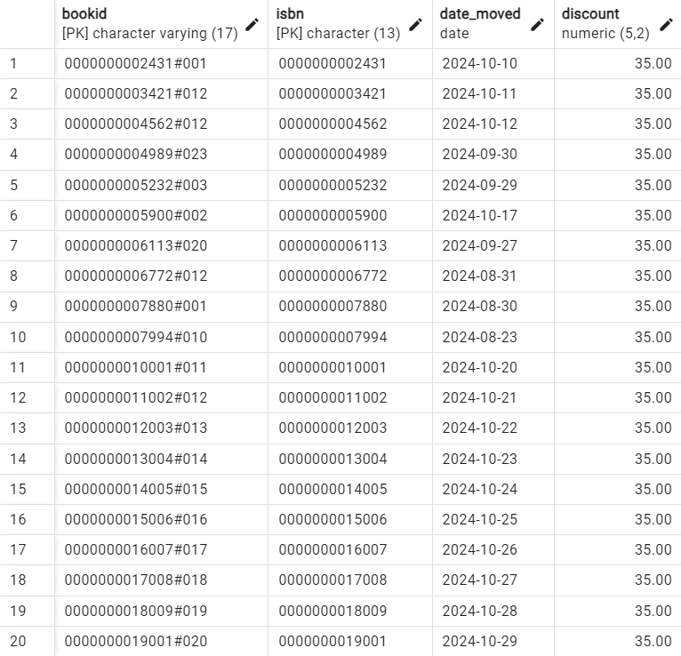

Figure 62: Inserting Data into Sale_to_Rent Relation

**Full Code:**

INSERT INTO Authentication_System (Email, Passcode) VALUES

('elias.nasr@gmail.com', 'Nasr321#'),

('elie.salameh@gmail.com', 'passElie56&'),

('fouad.maalouf@gmail.com', 'Fouadex231%'),

('georges.hareb@gmail.com', 'Passgeorges4*5'),

('jad.barakat@gmail.com', 'Passjadbarakat*t2'),

('joelle.fares@gmail.com', 'Jojo9024%'),

('nadine.mabsout@gmail.com', 'Nadoume2mabsout#@'),

('nour.najjar@gmail.com', 'najjarNour@1w'),

('ramzi.haddad@gmail.com', 'Rh45362@#'),

('rima.halabieh@gmail.com', 'Halabiehrima@32'),

('jb89@gmail.com', 'PassJB@123'),

('dk176@gmail.com', 'DK176Pass#'),

('ls098@gmail.com', 'Ls#Secure9'),

('mn56@gmail.com', 'Mn56Pass$'),

('mk56@gmail.com', 'Mk#56987'),

('wf02@gmail.com', 'WF02!Pass'),

('as67@gmail.com', 'AS67Secure@'),

('ns09@gmail.com', 'NS09#Pass'),

('rm12@gmail.com', 'Rm12Safe@'),

('rt65@gmail.com', 'RT65Pass!'),

('hassan.abboud@gmail.com', 'Hassan@Abb123'),

('fatima.moussa@gmail.com', 'FatimaMoussa@54'),

('tarek.darwish@gmail.com', 'TarekD#764'),

('amira.abdelrahman@gmail.com', 'AmiraRahman@89'),

('sami.chahine@gmail.com', 'SamiC!5432'),

('hana.elkhoury@gmail.com', 'Hana@Khoury21'),

('khaled.hajjar@gmail.com', 'HajjarKhaled#77'),

('layla.salem@gmail.com', 'LaylaS@13#'),

('marwan.daher@gmail.com', 'MarwanDaher@98'),

('sara.jalloul@gmail.com', 'SaraJ!53@2'),

('nizar.issa@gmail.com', 'IssaNizar#68'),

('dina.ghandour@gmail.com', 'Dina@Ghand87'),

('ahmad.kassem@gmail.com', 'KassemAhmad!92'),

('reem.abouzeid@gmail.com', 'ReemAZ@34!'),

('mohammad.farhat@gmail.com', 'Mohammad@Fh43'),

('leila.omari@gmail.com', 'LeilaOmari#66'),

('hadi.ziadeh@gmail.com', 'HadiZ@7854'),

('yasmeen.mirza@gmail.com', 'YasmeenMirza!09'),

('omar.bazzi@gmail.com', 'Omar@Bazzi44'),

('ghada.saad@gmail.com', 'GhadaSaad@23'),

('zainab.abdallah@gmail.com', 'Zainab@Abdallah12'),

('mahmoud.jaber@gmail.com', 'MahmoudJaber#88'),

('karim.ouwayda@gmail.com', 'KarimOuwayda@77'),

('salma.rajab@gmail.com', 'SalmaR@56!'),

('fadi.sabbagh@gmail.com', 'FadiSabbagh@43'),

('rana.daher@gmail.com', 'Rana@Daher99'),

('youssef.nahhas@gmail.com', 'YoussefN!1234');

INSERT INTO Customer (Username, Phone_Number, Address, Sex, First_Name, Last_Name, Ct_Email) VALUES

('en01', '71/812354', 'Tripoli, Mina', 'M', 'Elias', 'Nasr', 'elias.nasr@gmail.com'),

('gh21', '76/123765', 'Baabda, Hazmieh', 'M', 'Georges', 'Hareb', 'georges.hareb@gmail.com'),

('jf10', '81/209453', 'Baalback, Kaa', 'F', 'Joelle', 'Fares', 'joelle.fares@gmail.com'),

('fm02', '70/231539', 'Jbeil, Edde', 'M', 'Fouad', 'Maalouf', 'fouad.maalouf@gmail.com'),

('jb01', '03/356472', 'Beirut, Verdun', 'M', 'Jad', 'Barakat', 'jad.barakat@gmail.com'),

('nn12', '78/324536', 'Zahle, Ksara', 'F', 'Nour', 'Najjar', 'nour.najjar@gmail.com'),

('rh17', '03/564992', 'Saida, Taameer', 'M', 'Ramzi', 'Haddad', 'ramzi.haddad@gmail.com'),

('rh18', '76/172321', 'Beirut, Raouche', 'F', 'Rima', 'Halabieh', 'rima.halabieh@gmail.com'),

('es02', '71/342764', 'Beirut, Verdun', 'M', 'Elie', 'Salameh', 'elie.salameh@gmail.com'),

('nm01', '78/876520', 'Beirut, Hamra', 'F', 'Nadine', 'Mabsout', 'nadine.mabsout@gmail.com'),

('ha01', '71/432156', 'Beirut, Ashrafieh', 'M', 'Hassan', 'Abboud', 'hassan.abboud@gmail.com'),

('fm12', '76/985432', 'Saida, Sidon', 'F', 'Fatima', 'Moussa', 'fatima.moussa@gmail.com'),

('td21', '03/765421', 'Tripoli, Maarad', 'M', 'Tarek', 'Darwish', 'tarek.darwish@gmail.com'),

('aa22', '81/543219', 'Zahle, Taanayel', 'F', 'Amira', 'Abdelrahman', 'amira.abdelrahman@gmail.com'),

('sc34', '70/764132', 'Batroun, Koubba', 'M', 'Sami', 'Chahine', 'sami.chahine@gmail.com'),

('he01', '78/231654', 'Jounieh, Sarba', 'F', 'Hana', 'Elkhoury', 'hana.elkhoury@gmail.com'),

('kh18', '03/124563', 'Tyre, Borj Al-Shamali', 'M', 'Khaled', 'Hajjar', 'khaled.hajjar@gmail.com'),

('ls99', '71/786543', 'Bchamoun, Khaldeh', 'F', 'Layla', 'Salem', 'layla.salem@gmail.com'),

('md21', '03/943215', 'Byblos, Aamchit', 'M', 'Marwan', 'Daher', 'marwan.daher@gmail.com'),

('sj01', '70/978654', 'Jezzine, Wadi Jezzine', 'F', 'Sara', 'Jalloul', 'sara.jalloul@gmail.com');

INSERT INTO Libraryy (BranchID, Address, Phone_Number) VALUES

('LIBTECH01', 'Hamra', '01/412344'),

('LIBTECH02', 'Mazraa', '01/513478'),

('LIBTECH03', 'Jal El Dib', '04/234432'),

('LIBTECH04', 'Jounieh', '04/512987'),

('LIBTECH05', 'Jbeil', '08/212121'),

('LIBTECH06', 'Tripoli', '08/787654'),

('LIBTECH07', 'Zahle', '09/128220'),

('LIBTECH08', 'Saida', '07/987098'),

('LIBTECH09', 'Nabatieh', '07/565890'),

('LIBTECH10', 'Tyre', '07/987911'),

('LIBTECH11', 'Beirut Central District', '01/123456'),

('LIBTECH12', 'Achrafieh', '01/654321'),

('LIBTECH13', 'Baabda', '05/456789'),

('LIBTECH14', 'Batroun', '06/987654'),

('LIBTECH15', 'Broummana', '04/345678');

INSERT INTO Staff (SSN, First_Name, Last_Name, DoB, Blood_Type, Address, Salary, Post, Super_SSN, St_Email, BranchID, Hours) VALUES

('123-45-6789', 'Jad', 'Bader', '1992-10-02', 'B+', 'Zahle', 3850, 'Manager', NULL, 'jb89@gmail.com', 'LIBTECH01', 40),

('234-56-7890', 'Dani', 'Kanaan', '2000-02-28', 'O-', 'Beirut', 2500, 'Librarian', '123-45-6789', 'dk176@gmail.com', 'LIBTECH01', 50),

('345-67-8901', 'Lama', 'Saab', '2001-01-22', 'A-', 'Beirut', 2300, 'Librarian', '123-45-6789', 'ls098@gmail.com', 'LIBTECH01', 60),

('456-78-9012', 'Mona', 'Ramadan', '1998-05-16', 'A+', 'Saida', 1000, 'Clerk', '345-67-8901', 'mn56@gmail.com', 'LIBTECH01', 60),

('567-89-0123', 'Marwan', 'Kodeih', '1987-07-07', 'B-', 'Jbeil', 3000, 'Librarian', NULL, 'mk56@gmail.com', 'LIBTECH03', 45),

('678-90-1234', 'Wael', 'Fattouh', '1992-12-10', 'B+', 'Tyr', 2850, 'Librarian', '567-89-0123', 'wf02@gmail.com', 'LIBTECH03', 50),

('789-01-2345', 'Adam', 'Serhan', '2000-11-25', 'O+', 'Saida', 2500, 'Librarian', '678-90-1234', 'as67@gmail.com', 'LIBTECH05', 55),

('890-12-3456', 'Noura', 'Succar', '1997-04-04', 'AB+', 'Beirut', 2000, 'Clerk', '789-01-2345', 'ns09@gmail.com', 'LIBTECH05', 50),

('901-23-4567', 'Reem', 'Karam', '2000-09-09', 'AB-', 'BaaLIBTECHack', 1850, 'Librarian', '567-89-0123', 'rm12@gmail.com', 'LIBTECH05', 45),

('112-34-5678', 'Hassan', 'Abboud', '1985-06-12', 'O+', 'Beirut', 4200, 'Manager', NULL, 'hassan.abboud@gmail.com', 'LIBTECH11', 40),

('223-45-6789', 'Fatima', 'Moussa', '1993-07-15', 'A+', 'Saida', 2800, 'Librarian', '112-34-5678', 'fatima.moussa@gmail.com', 'LIBTECH11', 50),

('334-56-7890', 'Tarek', 'Darwish', '1988-03-10', 'B+', 'Tripoli', 4000, 'Manager', NULL, 'tarek.darwish@gmail.com', 'LIBTECH12', 45),

('445-67-8901', 'Amira', 'Abdelrahman', '1991-11-20', 'AB-', 'Batroun', 2900, 'Librarian', '334-56-7890', 'amira.abdelrahman@gmail.com', 'LIBTECH12', 50),

('556-78-9012', 'Sami', 'Chahine', '1982-02-02', 'O-', 'Jbeil', 4500, 'Manager', NULL, 'sami.chahine@gmail.com', 'LIBTECH13', 40),

('667-89-0123', 'Hana', 'Elkhoury', '1995-08-18', 'B-', 'Byblos', 2500, 'Librarian', '556-78-9012', 'hana.elkhoury@gmail.com', 'LIBTECH13', 50),

('778-90-1234', 'Khaled', 'Hajjar', '1987-04-25', 'A-', 'Baabda', 4700, 'Manager', NULL, 'khaled.hajjar@gmail.com', 'LIBTECH14', 40),

('889-01-2345', 'Layla', 'Salem', '1994-12-12', 'O+', 'Broummana', 2700, 'Librarian', '778-90-1234', 'layla.salem@gmail.com', 'LIBTECH14', 45),

('990-12-3456', 'Marwan', 'Daher', '1989-01-01', 'AB+', 'Achrafieh', 3900, 'Manager', NULL, 'marwan.daher@gmail.com', 'LIBTECH15', 45),

('101-23-4567', 'Sara', 'Jalloul', '1996-06-06', 'B+', 'Zahle', 2800, 'Librarian', '990-12-3456', 'sara.jalloul@gmail.com', 'LIBTECH15', 50);

INSERT INTO Dependents (SSN, Dep_Name, Relationship, Sex) VALUES

('123-45-6789', 'Sawsan', 'wife', 'F'),

('123-45-6789', 'Mohamad', 'son', 'M'),

('234-56-7890', 'Tia', 'wife', 'F'),

('345-67-8901', 'Akram', 'spouse', 'M'),

('456-78-9012', 'Zach', 'father', 'M'),

('567-89-0123', 'Samira', 'mother', 'F'),

('890-12-3456', 'Adam', 'spouse', 'M'),

('890-12-3456', 'Roy', 'son', 'M'),

('901-23-4567', 'Joyce', 'mother', 'F'),

('901-23-4567', 'Georges', 'father', 'M'),

('112-34-5678', 'Laila', 'wife', 'F'),

('112-34-5678', 'Ahmad', 'son', 'M'),

('112-34-5678', 'Maya', 'daughter', 'F'),

('223-45-6789', 'Salim', 'father', 'M'),

('445-67-8901', 'Rami', 'brother', 'M'),

('445-67-8901', 'Nour', 'sister', 'F'),

('556-78-9012', 'Fatima', 'wife', 'F'),

('778-90-1234', 'Lama', 'daughter', 'F'),

('778-90-1234', 'Raya', 'daughter', 'F'),

('889-01-2345', 'Youssef', 'son', 'M'),

('990-12-3456', 'Sami', 'father', 'M'),

('990-12-3456', 'Nadine', 'mother', 'F'),

('101-23-4567', 'Jad', 'brother', 'M'),

('101-23-4567', 'Rita', 'sister', 'F'),

('101-23-4567', 'Hala', 'mother', 'F');

INSERT INTO Supplier (Supp_Name, Address, Phone_Number) VALUES

('Najjar', 'Beirut', '01/255412'),

('KhouryHome', 'Beirut', '01/453123'),

('AbedTahhan', 'Beirut', '01/879034'),

('HamdanElectronics', 'Beirut', '01/334455'),

('DVDhome', 'Saida', '07/565432'),

('Maped', 'Beirut', '01/776853'),

('JoueClub', 'Beirut', '01/212343'),

('Crafts&More', 'Jounieh', '04/312366'),

('Virgin', 'Jounieh', '04/565723'),

('ReadPlus', 'Zahle', '09/623657'),

('OfficeOne', 'Beirut', '01/223344'),

('ModernStationery', 'Tripoli', '06/554432'),

('TechZone', 'Beirut', '01/889900'),

('Art&CraftWorld', 'Byblos', '04/443322'),

('GadgetStore', 'Beirut', '01/667788'),

('StationeryHub', 'Saida', '07/123456'),

('BookPalace', 'Tyre', '07/334455'),

('SmartOffice', 'Beirut', '01/990088'),

('ClassySupplies', 'Jbeil', '09/445566'),

('Libra', 'Batroun', '06/778899');

INSERT INTO Items (Barcode, Items_Name, Age_Group, Price, Genre, Supp_Name, Supp_Address, Qty_Supplied, Date_Supplied)

VALUES

('0000000000010001', 'Puzzle', '5-12', 50.00, 'Toys', 'JoueClub', 'Beirut', 100, '2024-10-20'),

('0000000000020198', 'Maped Pencil', NULL, 2.50, 'Stationery', 'Maped', 'Beirut', 250, '2024-10-10'),

('0000000000020290', 'Maped Eraser', NULL, 2.00, 'Stationery', 'Maped', 'Beirut', 250, '2024-10-10'),

('0000000000030278', 'Frozen', '4-14', 10.00, 'DVD', 'DVDhome', 'Saida', 40, '2024-09-25'),

('0000000000030240', 'Spy', '18+', 10.00, 'DVD', 'DVDhome', 'Saida', 40, '2024-09-25'),

('0000000000030560', 'Spiderman', '6+', 10.00, 'DVD', 'DVDhome', 'Saida', 40, '2024-09-26'),

('0000000000040134', 'GtaV', '18+', 25.00, 'Games', 'Najjar', 'Beirut', 150, '2023-02-20'),

('0000000000040250', 'Fifa24', NULL, 25.00, 'Games', 'Najjar', 'Beirut', 400, '2023-11-11'),

('0000000000040255', 'Uncharted3', '16+', 25.00, 'Games', 'Najjar', 'Beirut', 100, '2024-05-31'),

('0000000000040300', 'Fifa23', NULL, 25.00, 'Games', 'Najjar', 'Beirut', 120, '2024-01-05'),

('0000000000050001', 'Smartwatch', NULL, 199.99, 'Electronics', 'GadgetStore', 'Beirut', 50, '2024-10-15'),

('0000000000050002', 'Bluetooth Speaker', '10+', 49.99, 'Electronics', 'GadgetStore', 'Beirut', 75, '2024-11-01'),

('0000000000060003', 'Mechanical Keyboard', '12+', 99.99, 'Electronics', 'TechZone', 'Beirut', 60, '2024-08-20'),

('0000000000060004', 'Gaming Mouse', '12+', 39.99, 'Electronics', 'TechZone', 'Beirut', 100, '2024-08-20'),

('0000000000070005', '3D Puzzle', '6+', 29.99, 'Toys', 'ClassySupplies', 'Jounieh', 40, '2024-09-05'),

('0000000000070006', 'Paint Set', '8+', 15.00, 'Art Supplies', 'ClassySupplies', 'Jounieh', 50, '2024-09-10'),

('0000000000080007', 'Notebook Pack', '12+', 10.00, 'Stationery', 'ReadPlus', 'Zahle', 200, '2024-07-01'),

('0000000000090008', 'USB-C Adapter', NULL, 19.99, 'Electronics', 'TechZone', 'Beirut', 120, '2024-11-15'),

('0000000000100009', 'Action Figure', '8+', 25.00, 'Toys', 'JoueClub', 'Beirut', 100, '2024-10-10'),

('0000000000110010', 'Coloring Book', '4+', 5.99, 'Books', 'ReadPlus', 'Zahle', 250, '2024-05-15'),

('0000000000120011', 'Wireless Charger', NULL, 29.99, 'Electronics', 'GadgetStore', 'Beirut', 80, '2024-12-01'),

('0000000000130012', 'Kids Backpack', '6+', 35.00, 'School Supplies', 'ClassySupplies', 'Jounieh', 60, '2024-03-01'),

('0000000000140013', 'Watercolor Paint Set', '10+', 20.00, 'Art Supplies', 'Crafts&More', 'Jounieh', 90, '2024-04-10'),

('0000000000150014', 'Graphic Novel', '15+', 12.00, 'Books', 'ReadPlus', 'Zahle', 180, '2024-06-20'),

('0000000000160015', 'Puzzle Game', '5+', 15.99, 'Toys', 'Virgin', 'Jounieh', 50, '2024-05-25'),

('0000000000170016', 'Highlighters', NULL, 8.99, 'Stationery', 'OfficeOne', 'Beirut', 300, '2024-10-01'),

('0000000000180017', 'LED Desk Lamp', NULL, 59.99, 'Electronics', 'TechZone', 'Beirut', 70, '2024-11-12'),

('0000000000190018', 'Erasable Markers', '6+', 12.99, 'Art Supplies', 'Crafts&More', 'Jounieh', 110, '2024-03-30'),

('0000000000200019', 'DIY Craft Kit', '8+', 18.99, 'Toys', 'JoueClub', 'Beirut', 90, '2024-10-05'),

('0000000000210020', 'Fiction Novel', '16+', 14.99, 'Books', 'ReadPlus', 'Zahle', 150, '2024-06-15');

INSERT INTO Publisher (Publisher_Name, Address, Phone_Number)

VALUES

('Dar Al-Kitaba', 'Beirut,Hamra', '03/355097'),

('Dar Al-Nour', 'Mount Lebanon,Aley', '71/232156'),

('Lebanon Readings', 'Beirut, Cola', '76/876425'),

('Dar Al-Nasher', 'Jounieh', '03/436352'),

('Today News', 'Beirut', '09/824262'),

('Dar Al-Balad', 'Saida', '81/423536'),

('Dar Al-Maarifa', 'Nabatieh', '07/634562'),

('Dar Al-Fikr', 'Tripoli', '09/643225'),

('WassupLebanon', 'Jbeil', '71/232321'),

('Dar Al-Salam', 'Beirut', '81/123333'),

('Dar Al-Turath', 'Beirut, Verdun', '01/987654'),

('Dar Al-Hekma', 'Mount Lebanon, Broummana', '04/667788'),

('Kalimat Lebanon', 'Byblos', '09/776655'),

('Dar Al-Adab', 'Saida, Sidon', '07/554433'),

('Dar Al-Hayat', 'Tripoli, Mina', '06/778899'),

('Dar Al-Watan', 'Zahle, Bekaa', '08/667788'),

('Al-Qalam', 'Beirut, Ashrafieh', '01/445566'),

('Dar Al-Manar', 'Tyre, Rachidiyeh', '07/334455'),

('Al-Maktaba', 'Batroun', '06/223344'),

('Dar Al-Risala', 'Saida, Abra', '07/112233');

INSERT INTO Books_for_Sale (ISBN, Title, Genre, Price, Translator, Edition, Pages, Lang, Publisher_Name)

VALUES

('0000000002431', 'Electronics', 'Engineering', 89.00, NULL, 3, 356, 'English', 'Dar Al-Fikr'),

('0000000003421', 'Alg&Geo', 'Maths', 24.50, NULL, 1, 87, 'English', 'Dar Al-Fikr'),

('0000000004562', 'LearnArbic', 'Literature', 30.00, 'Asmaa Karam', 2, 102, 'Arabic', 'Dar Al-Salam'),

('0000000004989', 'MenDuties', 'Psychology', 35.50, NULL, 1, 234, 'English', 'Dar Al-Balad'),

('0000000005232', 'GirlsPower', 'Psychology', 120.00, NULL, 1, 675, 'English', 'WassupLebanon'),

('0000000005900', 'LifeonEarth', 'Geography', 100.00, NULL, 4, 200, 'English', 'Today News'),

('0000000006113', 'Voila', 'Literature', 31.25, 'Karim Akram', 5, 150, 'French', 'Dar Al-Salam'),

('0000000006772', 'Quand?', 'Literature', 76.25, 'Yolga Safa', 2, 89, 'French', 'Dar Al-Maarifa'),

('0000000007880', 'Seniorita', 'Literature', 55.00, 'Monica Smith', 1, 56, 'Spanish', 'Dar Al-Fikr'),

('0000000007994', 'Wander', 'Geography', 46.00, 'Sandra Kenaan', 1, 89, 'English', 'Dar Al-Balad'),

('0000000010001', 'Physics Basics', 'Science', 45.00, NULL, 3, 300, 'English', 'Dar Al-Kitaba'),

('0000000011002', 'Calculus 101', 'Maths', 60.00, NULL, 1, 400, 'English', 'Dar Al-Nasher'),

('0000000012003', 'Modern Poetry', 'Literature', 20.00, 'Lina Masri', 2, 120, 'Arabic', 'Dar Al-Turath'),

('0000000013004', 'Business Growth', 'Business', 75.00, NULL, 1, 250, 'English', 'Dar Al-Hekma'),

('0000000014005', 'Graphic Design', 'Arts', 85.00, NULL, 4, 320, 'English', 'Kalimat Lebanon'),

('0000000015006', 'Interior Decor', 'Arts', 70.00, NULL, 3, 180, 'English', 'Dar Al-Adab'),

('0000000016007', 'Molecular Biology', 'Science', 120.00, NULL, 2, 500, 'English', 'Dar Al-Hayat'),

('0000000017008', 'Civilizations', 'History', 95.00, NULL, 5, 400, 'English', 'Dar Al-Watan'),

('0000000018009', 'Perspectives', 'Philosophy', 50.00, NULL, 1, 200, 'English', 'Al-Qalam'),

('0000000019001', 'Marketing 101', 'Business', 65.00, NULL, 1, 300, 'English', 'Dar Al-Manar'),

('0000000020002', 'Astronomy', 'Science', 110.00, NULL, 4, 350, 'English', 'Dar Al-Risala'),

('0000000021003', 'Mediterranean Cooking', 'Cooking', 55.00, 'Jana Khalil', 1, 180, 'English', 'Dar Al-Maarifa'),

('0000000022004', 'Italian Recipes', 'Cooking', 65.00, 'Marco Rossi', 2, 220, 'Italian', 'Today News'),

('0000000023005', 'Arabic Calligraphy', 'Arts', 40.00, 'Nour Hassan', 1, 150, 'Arabic', 'Dar Al-Balad'),

('0000000024006', 'Digital Marketing', 'Business', 80.00, NULL, 2, 270, 'English', 'Dar Al-Hekma'),

('0000000025007', 'Big Data Analysis', 'Technology', 95.00, NULL, 3, 320, 'English', 'Kalimat Lebanon'),

('0000000026008', 'Artificial Intelligence', 'Technology', 120.00, NULL, 4, 450, 'English', 'Dar Al-Fikr'),

('0000000027009', 'Cybersecurity', 'Technology', 85.00, NULL, 2, 280, 'English', 'Lebanon Readings'),

('0000000028001', 'Yoga for Beginners', 'Health', 30.00, NULL, 1, 150, 'English', 'Dar Al-Salam'),

('0000000029002', 'Mindfulness', 'Health', 40.00, NULL, 1, 200, 'English', 'WassupLebanon'),

('0000000030003', 'Machine Learning Basics', 'Technology', 125.00, NULL, 3, 350, 'English', 'Dar Al-Kitaba'),

('0000000031004', 'The Art of Negotiation', 'Business', 75.00, NULL, 2, 240, 'English', 'Dar Al-Hekma'),

('0000000032005', 'Quantum Physics Explained', 'Science', 130.00, NULL, 5, 400, 'English', 'Dar Al-Manar'),

('0000000033006', 'Design Thinking', 'Business', 85.00, NULL, 2, 280, 'English', 'Kalimat Lebanon'),

('0000000034007', 'Ancient Cultures', 'History', 90.00, NULL, 3, 320, 'English', 'Dar Al-Risala'),

('0000000035008', 'Data Science Advanced', 'Technology', 115.00, NULL, 4, 420, 'English', 'Lebanon Readings'),

('0000000036009', 'Cooking for Kids', 'Cooking', 45.00, 'Nadia Abed', 1, 120, 'English', 'Dar Al-Maarifa'),

('0000000037001', 'World Mythologies', 'History', 99.00, NULL, 4, 350, 'English', 'Today News');

INSERT INTO Books_for_Rent (BookID, ISBN, Title, Genre, Price, Translator, Edition, Pages, Lang, Publisher_Name, Shelf_No, Row_No, BranchID)

VALUES

('0000000002431#001', '0000000002431', 'Electronics', 'Engineering', 10.00, NULL, 3, 356, 'English', 'Dar Al-Fikr', 25, 1, 'LIBTECH01'),

('0000000003421#012', '0000000003421', 'Alg&Geo', 'Maths', 10.00, NULL, 1, 87, 'English', 'Dar Al-Fikr', 12, 3, 'LIBTECH01'),

('0000000004562#012', '0000000004562', 'LearnArbic', 'Literature', 15.00, 'Asmaa Karam', 2, 102, 'Arabic', 'Dar Al-Salam', 12, 5, 'LIBTECH02'),

('0000000004989#023', '0000000004989', 'MenDuties', 'Psychology', 12.00, NULL, 1, 234, 'English', 'Dar Al-Balad', 16, 4, 'LIBTECH05'),

('0000000005232#003', '0000000005232', 'GirlsPower', 'Psychology', 70.00, NULL, 1, 675, 'English', 'WassupLebanon', 17, 6, 'LIBTECH05'),

('0000000005900#002', '0000000005900', 'LifeonEarth', 'Geography', 80.00, NULL, 4, 200, 'English', 'Today News', 02, 2, 'LIBTECH06'),

('0000000006113#020', '0000000006113', 'Voila', 'Literature', 15.00, 'Karim Akram', 5, 150, 'French', 'Dar Al-Salam', 13, 4, 'LIBTECH07'),

('0000000006772#012', '0000000006772', 'Quand?', 'Literature', 20.00, 'Yolga Safa', 2, 89, 'French', 'Dar Al-Maarifa', 19, 1, 'LIBTECH02'),

('0000000007880#001', '0000000007880', 'Seniorita', 'Literature', 25.00, 'Monica Smith', 1, 56, 'Spanish', 'Dar Al-Fikr', 19, 3, 'LIBTECH02'),

('0000000007994#010', '0000000007994', 'Wander', 'Geography', 16.00, 'Sandra Kenaan', 1, 89, 'English', 'Dar Al-Balad', 02, 5, 'LIBTECH05'),

('0000000010001#011', '0000000010001', 'Physics Basics', 'Science', 10.00, NULL, 3, 300, 'English', 'Dar Al-Kitaba', 11, 1, 'LIBTECH01'),

('0000000011002#012', '0000000011002', 'Calculus 101', 'Maths', 10.00, NULL, 1, 400, 'English', 'Dar Al-Nasher', 12, 2, 'LIBTECH02'),

('0000000012003#013', '0000000012003', 'Modern Poetry', 'Literature', 8.00, 'Lina Masri', 2, 120, 'Arabic', 'Dar Al-Turath', 13, 3, 'LIBTECH03'),

('0000000013004#014', '0000000013004', 'Business Growth', 'Business', 15.00, NULL, 1, 250, 'English', 'Dar Al-Hekma', 14, 4, 'LIBTECH04'),

('0000000014005#015', '0000000014005', 'Graphic Design', 'Arts', 20.00, NULL, 4, 320, 'English', 'Kalimat Lebanon', 15, 5, 'LIBTECH05'),

('0000000015006#016', '0000000015006', 'Interior Decor', 'Arts', 25.00, NULL, 3, 180, 'English', 'Dar Al-Adab', 16, 6, 'LIBTECH06'),

('0000000016007#017', '0000000016007', 'Molecular Biology', 'Science', 30.00, NULL, 2, 500, 'English', 'Dar Al-Hayat', 17, 2, 'LIBTECH07'),

('0000000017008#018', '0000000017008', 'Civilizations', 'History', 20.00, NULL, 5, 400, 'English', 'Dar Al-Watan', 18, 3, 'LIBTECH08'),

('0000000018009#019', '0000000018009', 'Perspectives', 'Philosophy', 12.00, NULL, 1, 200, 'English', 'Al-Qalam', 19, 4, 'LIBTECH09'),

('0000000019001#020', '0000000019001', 'Marketing 101', 'Business', 15.00, NULL, 1, 300, 'English', 'Dar Al-Manar', 20, 5, 'LIBTECH10'),

('0000000020002#021', '0000000020002', 'Astronomy', 'Science', 35.00, NULL, 4, 350, 'English', 'Dar Al-Risala', 21, 1, 'LIBTECH11'),

('0000000021003#022', '0000000021003', 'Mediterranean Cooking', 'Cooking', 10.00, 'Jana Khalil', 1, 180, 'English', 'Dar Al-Maarifa', 22, 2, 'LIBTECH12'),

('0000000022004#023', '0000000022004', 'Italian Recipes', 'Cooking', 20.00, 'Marco Rossi', 2, 220, 'Italian', 'Today News', 23, 3, 'LIBTECH13'),

('0000000023005#024', '0000000023005', 'Arabic Calligraphy', 'Arts', 15.00, 'Nour Hassan', 1, 150, 'Arabic', 'Dar Al-Balad', 24, 4, 'LIBTECH14'),

('0000000024006#025', '0000000024006', 'Digital Marketing', 'Business', 25.00, NULL, 2, 270, 'English', 'Dar Al-Hekma', 25, 5, 'LIBTECH15'),

('0000000025007#026', '0000000025007', 'Big Data Analysis', 'Technology', 30.00, NULL, 3, 320, 'English', 'Kalimat Lebanon', 26, 6, 'LIBTECH01'),

('0000000026008#027', '0000000026008', 'Artificial Intelligence', 'Technology', 35.00, NULL, 4, 450, 'English', 'Dar Al-Fikr', 27, 1, 'LIBTECH02'),

('0000000027009#028', '0000000027009', 'Cybersecurity', 'Technology', 30.00, NULL, 2, 280, 'English', 'Lebanon Readings', 28, 2, 'LIBTECH03'),

('0000000028001#029', '0000000028001', 'Yoga for Beginners', 'Health', 10.00, NULL, 1, 150, 'English', 'Dar Al-Salam', 29, 3, 'LIBTECH04'),

('0000000029002#030', '0000000029002', 'Mindfulness', 'Health', 15.00, NULL, 1, 200, 'English', 'WassupLebanon', 30, 4, 'LIBTECH05'),

('0000000030003#031', '0000000030003', 'Machine Learning Basics', 'Technology', 35.00, NULL, 3, 350, 'English', 'Dar Al-Kitaba', 31, 5, 'LIBTECH06'),

('0000000031004#032', '0000000031004', 'The Art of Negotiation', 'Business', 20.00, NULL, 2, 240, 'English', 'Dar Al-Hekma', 32, 6, 'LIBTECH07'),

('0000000032005#033', '0000000032005', 'Quantum Physics Explained', 'Science', 40.00, NULL, 5, 400, 'English', 'Dar Al-Manar', 33, 1, 'LIBTECH08'),

('0000000033006#034', '0000000033006', 'Design Thinking', 'Business', 30.00, NULL, 2, 280, 'English', 'Kalimat Lebanon', 34, 2, 'LIBTECH09'),

('0000000034007#035', '0000000034007', 'Ancient Cultures', 'History', 35.00, NULL, 3, 320, 'English', 'Dar Al-Risala', 35, 3, 'LIBTECH10'),

('0000000035008#036', '0000000035008', 'Data Science Advanced', 'Technology', 40.00, NULL, 4, 420, 'English', 'Lebanon Readings', 36, 4, 'LIBTECH11'),

('0000000036009#037', '0000000036009', 'Cooking for Kids', 'Cooking', 20.00, 'Nadia Abed', 1, 120, 'English', 'Dar Al-Maarifa', 37, 5, 'LIBTECH12'),

('0000000037001#038', '0000000037001', 'World Mythologies', 'History', 40.00, NULL, 4, 350, 'English', 'Today News', 38, 6, 'LIBTECH13');

INSERT INTO Authors_booksale (ISBN, Author_Name)

VALUES

('0000000002431', 'Sandra Smith'),

('0000000003421', 'Francois Olivier'),

('0000000003421', 'Maurice Dupont'),

('0000000004562', 'Rawad Kaadan'),

('0000000004562', 'Raed Lawand'),

('0000000004562', 'Wael Kassis'),

('0000000006772', 'Zeinab Kalach'),

('0000000006772', 'Pamela Hokayem'),

('0000000007880', 'Camilla Ponduras'),

('0000000007994', 'Donald Harris'),

('0000000010001', 'Liam Brown'),

('0000000010001', 'Emma Johnson'),

('0000000011002', 'Michael Carter'),

('0000000012003', 'Nadine El-Mir'),

('0000000012003', 'Tarek Ghanem'),

('0000000013004', 'Oliver Thompson'),

('0000000013004', 'Sophia Wilson'),

('0000000014005', 'Noah Robinson'),

('0000000014005', 'Lucas Martinez'),

('0000000015006', 'Mia Lopez'),

('0000000015006', 'Ava Garcia'),

('0000000016007', 'Ella Gonzalez'),

('0000000016007', 'Alexander Rivera'),

('0000000017008', 'Isabella Perez'),

('0000000018009', 'James Anderson'),

('0000000019001', 'Grace Moore'),

('0000000020002', 'Benjamin Clark'),

('0000000021003', 'Charlotte Young'),

('0000000022004', 'Abdullah Hassan'),

('0000000023005', 'Sara Ahmed'),

('0000000024006', 'Fatima Hussein');

INSERT INTO Authors_bookrent (BookID, Author_Name)

VALUES

('0000000002431#001', 'Sandra Smith'),

('0000000003421#012', 'Francois Olivier'),

('0000000004562#012', 'Maurice Dupont'),

('0000000004989#023', 'Rawad Kaadan'),

('0000000005232#003', 'Raed Lawand'),

('0000000005900#002', 'Wael Kassis'),

('0000000006113#020', 'Zeinab Kalach'),

('0000000006772#012', 'Pamela Hokayem'),

('0000000007880#001', 'Camilla Ponduras'),

('0000000007994#010', 'Donald Harris'),

('0000000010001#011', 'Liam Brown'),

('0000000010001#011', 'Emma Johnson'),

('0000000011002#012', 'Michael Carter'),

('0000000012003#013', 'Nadine El-Mir'),

('0000000012003#013', 'Tarek Ghanem'),

('0000000013004#014', 'Oliver Thompson'),

('0000000013004#014', 'Sophia Wilson'),

('0000000014005#015', 'Noah Robinson'),

('0000000014005#015', 'Lucas Martinez'),

('0000000015006#016', 'Mia Lopez'),

('0000000015006#016', 'Ava Garcia'),

('0000000016007#017', 'Ella Gonzalez'),

('0000000016007#017', 'Alexander Rivera'),

('0000000017008#018', 'Isabella Perez'),

('0000000018009#019', 'James Anderson'),

('0000000019001#020', 'Grace Moore'),

('0000000020002#021', 'Benjamin Clark'),

('0000000021003#022', 'Charlotte Young'),

('0000000022004#023', 'Abdullah Hassan'),

('0000000023005#024', 'Sara Ahmed'),

('0000000024006#025', 'Fatima Hussein');

INSERT INTO Stores_Items (BranchID, Barcode, Qty_Stored)

VALUES

('LIBTECH01', '0000000000010001', 25),

('LIBTECH01', '0000000000020198', 30),

('LIBTECH02', '0000000000020290', 29),

('LIBTECH03', '0000000000030278', 34),

('LIBTECH03', '0000000000030240', 35),

('LIBTECH04', '0000000000030560', 12),

('LIBTECH05', '0000000000040134', 34),

('LIBTECH09', '0000000000040250', 5),

('LIBTECH03', '0000000000040255', 14),

('LIBTECH03', '0000000000040300', 38),

('LIBTECH06', '0000000000050001', 20),

('LIBTECH07', '0000000000050002', 25),

('LIBTECH08', '0000000000060003', 15),

('LIBTECH09', '0000000000060004', 35),

('LIBTECH10', '0000000000070005', 30),

('LIBTECH11', '0000000000070006', 40),

('LIBTECH12', '0000000000080007', 50),

('LIBTECH13', '0000000000090008', 30),

('LIBTECH14', '0000000000100009', 25),

('LIBTECH15', '0000000000110010', 35),

('LIBTECH01', '0000000000120011', 30),

('LIBTECH02', '0000000000130012', 25),

('LIBTECH03', '0000000000140013', 40),

('LIBTECH04', '0000000000150014', 20),

('LIBTECH05', '0000000000160015', 15),

('LIBTECH06', '0000000000170016', 35),

('LIBTECH07', '0000000000180017', 50),

('LIBTECH08', '0000000000190018', 30),

('LIBTECH09', '0000000000200019', 20),

('LIBTECH10', '0000000000210020', 40);

INSERT INTO Stores_booksforsale (BranchID, ISBN, Number_of_Copies)

VALUES

('LIBTECH01', '0000000002431', 12),

('LIBTECH03', '0000000003421', 34),

('LIBTECH02', '0000000003421', 23),

('LIBTECH03', '0000000004562', 21),

('LIBTECH04', '0000000004562', 23),

('LIBTECH05', '0000000004562', 33),

('LIBTECH06', '0000000006772', 10),

('LIBTECH07', '0000000006772', 9),

('LIBTECH08', '0000000007880', 3),

('LIBTECH09', '0000000007994', 18),

('LIBTECH10', '0000000010001', 15),

('LIBTECH11', '0000000011002', 20),

('LIBTECH12', '0000000012003', 25),

('LIBTECH13', '0000000013004', 18),

('LIBTECH14', '0000000014005', 10),

('LIBTECH15', '0000000015006', 12),

('LIBTECH01', '0000000016007', 20),

('LIBTECH02', '0000000017008', 15),

('LIBTECH03', '0000000018009', 25),

('LIBTECH04', '0000000019001', 30),

('LIBTECH05', '0000000020002', 22),

('LIBTECH06', '0000000021003', 10),

('LIBTECH07', '0000000022004', 14),

('LIBTECH08', '0000000023005', 18),

('LIBTECH09', '0000000024006', 17),

('LIBTECH10', '0000000025007', 11),

('LIBTECH11', '0000000026008', 13),

('LIBTECH12', '0000000027009', 19),

('LIBTECH13', '0000000028001', 20),

('LIBTECH14', '0000000029002', 16),

('LIBTECH15', '0000000030003', 8),

('LIBTECH01', '0000000031004', 15),

('LIBTECH02', '0000000032005', 10),

('LIBTECH03', '0000000033006', 18),

('LIBTECH04', '0000000034007', 13),

('LIBTECH05', '0000000035008', 21),

('LIBTECH06', '0000000036009', 12),

('LIBTECH07', '0000000037001', 14);

INSERT INTO Buys_Books (Username, BranchID, ISBN, Quantity, Date_Time)

VALUES

('en01', 'LIBTECH01', '0000000002431', 2, '2024-10-01 11:12:23'),

('gh21', 'LIBTECH02', '0000000003421', 1, '2024-09-10 13:31:02'),

('jf10', 'LIBTECH02', '0000000003421', 1, '2024-06-30 17:05:15'),

('fm02', 'LIBTECH01', '0000000004562', 2, '2024-04-01 20:45:09'),

('jb01', 'LIBTECH09', '0000000004562', 1, '2024-07-31 18:10:10'),

('nn12', 'LIBTECH07', '0000000004562', 1, '2024-05-23 10:40:34'),

('rh17', 'LIBTECH05', '0000000006772', 1, '2024-08-17 11:11:09'),

('rh18', 'LIBTECH08', '0000000006772', 2, '2024-04-14 12:30:23'),

('es02', 'LIBTECH09', '0000000007880', 3, '2024-05-31 17:32:06'),

('nm01', 'LIBTECH10', '0000000007994', 1, '2024-08-06 11:57:05'),

('ha01', 'LIBTECH11', '0000000010001', 2, '2024-07-10 10:20:00'),

('fm12', 'LIBTECH12', '0000000011002', 1, '2024-06-15 15:45:10'),

('td21', 'LIBTECH13', '0000000012003', 3, '2024-05-20 12:30:50'),

('aa22', 'LIBTECH14', '0000000013004', 2, '2024-04-05 09:40:30'),

('sc34', 'LIBTECH15', '0000000014005', 1, '2024-09-12 18:10:00'),

('he01', 'LIBTECH01', '0000000015006', 1, '2024-03-25 14:20:40'),

('kh18', 'LIBTECH02', '0000000016007', 1, '2024-02-18 16:10:15'),

('ls99', 'LIBTECH03', '0000000017008', 2, '2024-07-28 19:30:25'),

('md21', 'LIBTECH04', '0000000018009', 3, '2024-08-14 11:10:55'),

('sj01', 'LIBTECH05', '0000000019001', 1, '2024-10-02 13:20:35');

INSERT INTO Borrows (Username, BookID, Date_Out, Due_Date, Penalty, Status)

VALUES

('en01', '0000000002431#001', '2024-05-05', '2024-05-15', 10.00,'Returned'),

('en01', '0000000002431#001', '2024-09-09', '2024-12-30', 10.00,'Borrowed'),

('gh21', '0000000002431#001', '2024-09-09', '2024-12-30', 10.00,'Borrowed'),

('jf10', '0000000002431#001', '2024-09-09', '2024-12-30', 10.00,'Borrowed'),

('gh21', '0000000003421#012', '2024-09-09', '2024-12-30', 10.00,'Borrowed'),

('gh21', '0000000003421#012', '2024-07-25', '2024-08-05', 10.00,'Returned'),

('jf10', '0000000004562#012', '2024-01-03', '2024-01-13', 15.00,'Returned'),

('en01', '0000000004989#023', '2024-11-15', '2024-12-25', 12.00,'Borrowed'),

('fm02', '0000000004989#023', '2024-06-15', '2024-06-25', 12.00,'Returned'),

('jb01', '0000000005232#003', '2024-09-23', '2024-10-03', 11.00,'Returned'),

('nn12', '0000000005900#002', '2024-03-20', '2024-03-31', 10.00,'Returned'),

('rh17', '0000000006113#020', '2024-05-22', '2024-06-02', 13.00,'Returned'),

('rh18', '0000000006772#012', '2024-04-12', '2024-04-22', 13.00,'Returned'),

('es02', '0000000007880#001', '2024-09-01', '2024-09-11', 12.00,'Returned'),

('nm01', '0000000007994#010', '2024-02-04', '2024-02-14', 10.00,'Returned'),

('ha01', '0000000010001#011', '2024-07-10', '2024-07-20', 8.00,'Returned'),

('fm12', '0000000011002#012', '2024-06-15', '2024-06-25', 10.00,'Returned'),

('td21', '0000000012003#013', '2024-04-10', '2024-04-20', 12.00,'Returned'),

('aa22', '0000000013004#014', '2024-03-01', '2024-03-10', 10.00,'Returned'),

('sc34', '0000000014005#015', '2024-02-12', '2024-02-22', 9.00,'Returned'),

('he01', '0000000015006#016', '2024-09-30', '2024-10-10', 15.00,'Returned'),

('kh18', '0000000016007#017', '2024-01-01', '2024-01-10', 14.00,'Returned'),

('ls99', '0000000017008#018', '2024-03-15', '2024-03-25', 11.00,'Returned'),

('md21', '0000000018009#019', '2024-04-25', '2024-05-05', 8.00,'Returned'),

('sj01', '0000000019001#020', '2024-05-10', '2024-05-20', 10.00,'Returned');

INSERT INTO Sale_to_Rent (BookID, ISBN, Date_Moved, Discount)

VALUES

('0000000002431#001', '0000000002431', '2024-10-10', 35.00),

('0000000003421#012', '0000000003421', '2024-10-11', 35.00),

('0000000004562#012', '0000000004562', '2024-10-12', 35.00),

('0000000004989#023', '0000000004989', '2024-09-30', 35.00),

('0000000005232#003', '0000000005232', '2024-09-29', 35.00),

('0000000005900#002', '0000000005900', '2024-10-17', 35.00),

('0000000006113#020', '0000000006113', '2024-09-27', 35.00),

('0000000006772#012', '0000000006772', '2024-08-31', 35.00),

('0000000007880#001', '0000000007880', '2024-08-30', 35.00),

('0000000007994#010', '0000000007994', '2024-08-23', 35.00),

('0000000010001#011', '0000000010001', '2024-10-20', 35.00),

('0000000011002#012', '0000000011002', '2024-10-21', 35.00),

('0000000012003#013', '0000000012003', '2024-10-22', 35.00),

('0000000013004#014', '0000000013004', '2024-10-23', 35.00),

('0000000014005#015', '0000000014005', '2024-10-24', 35.00),

('0000000015006#016', '0000000015006', '2024-10-25', 35.00),

('0000000016007#017', '0000000016007', '2024-10-26', 35.00),

('0000000017008#018', '0000000017008', '2024-10-27', 35.00),

('0000000018009#019', '0000000018009', '2024-10-28', 35.00),

('0000000019001#020', '0000000019001', '2024-10-29', 35.00);

# **Complex Transactions**

After successfully creating and inserting the data into our tables, we have developed twelve complex transactions that are interesting and pertinent to our database. Those transactions have real meaning in our mini world (i.e., the library), and follow the needs of the stakeholders.

**Q1: Identify Top 5 Borrowed Books in the Last Year**

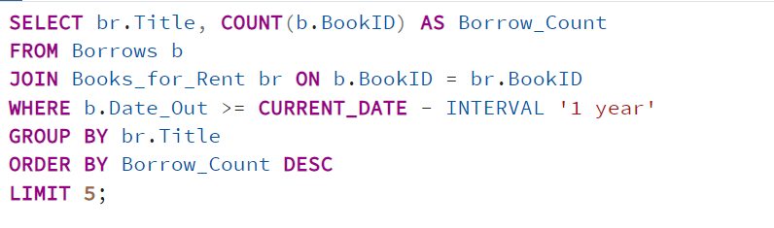

Explanation:

This query aims to identify the **top 5 most borrowed books** from the library in the past year. The Borrows table is joined with the Books_for_Rent table on the BookID field to get the titles of the borrowed books. The WHERE clause filters the records to only include books borrowed within the last year (b.Date_Out >= CURRENT_DATE - INTERVAL '1 year'). The COUNT(b.BookID) function counts the total number of times each book was borrowed. The results are grouped by the Title of the books to get the borrow count for each unique title. The results are sorted in descending order of the borrow count (ORDER BY Borrow_Count DESC) and limited to the top 5 entries.

Scenario:

LibTech wants to know which books are most popular among readers. They run a query to find the top 5 most borrowed books in the past year. The results show titles like *Electronics* and *MenDuties* leading the list, helping the library decide which books to feature in promotions and restock in larger quantities.

.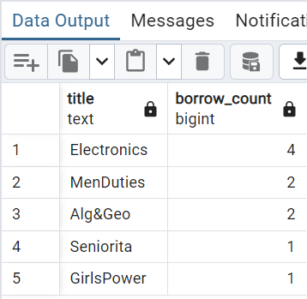

Figure 63: Complex Transcation: Top 5 Borrowed Books

The output shows the top 5 most borrowed books in the past year along with the count of times each book was borrowed.

Code:

SELECT br.Title, COUNT(b.BookID) AS Borrow_Count

FROM Borrows b

JOIN Books_for_Rent br ON b.BookID = br.BookID

WHERE b.Date_Out >= CURRENT_DATE - INTERVAL '1 year'

GROUP BY br.Title

ORDER BY Borrow_Count DESC

LIMIT 5;

**Q2: List Customers Who Have Unreturned Books Past Due Date**

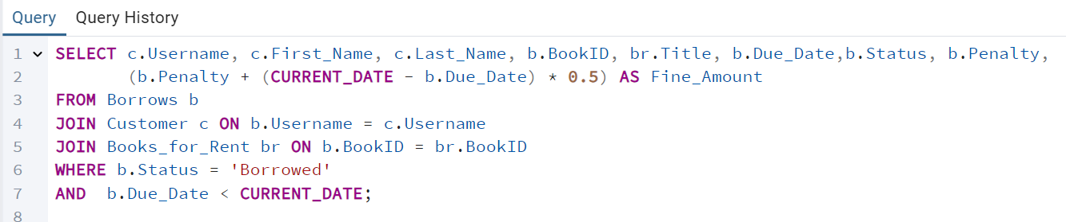

Explanation:

This query is designed to identify customers who have overdue books that have not yet been returned. The Borrows table is joined with the Customer and Books_for_Rent tables using the Username and BookID fields, respectively, to retrieve customer and book information. The WHERE clause filters records to include only those where the Due_Date is in the past (b.Due_Date < CURRENT_DATE) and the Status of the book is ‘borrowed’ which mean that it hasn’t been returned yet. The query calculates the fine amount for each overdue book based on a rate of **$**0.5 per day past the due date using the formula (Penalty + (CURRENT_DATE - b.Due_Date) * 0.5). The query retrieves details such as the customer's username, first and last name, the BookID, the book's title, the due date, and the calculated fine.

Scenario:

LibTech identifies customers who have not returned books past their due dates by running a query. This helps them contact these customers and remind them to return the overdue books, ensuring smoother inventory management and availability for other patrons.

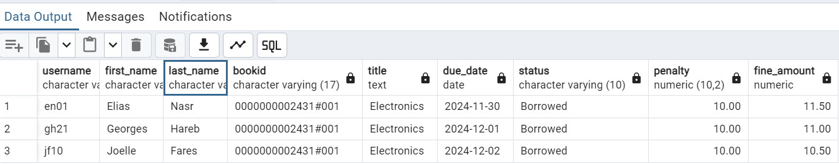

Figure 64: Complex Transaction 2: Customers with Unreturned Books

The output shows a list of customers who have overdue books along with the details of the books and the fines they owe.

Code:

SELECT c.Username, c.First_Name, c.Last_Name, b.BookID, br.Title, b.Due_Date,b.Status, b.Penalty,

(b.Penalty + (CURRENT_DATE - b.Due_Date) * 0.5) AS Fine_Amount

FROM Borrows b

JOIN Customer c ON b.Username = c.Username

JOIN Books_for_Rent br ON b.BookID = br.BookID

WHERE b.Status = ‘Borrowed’

AND b.Due_Date < CURRENT_DATE;

**Q3: Branch with the Highest Number of Rentals**

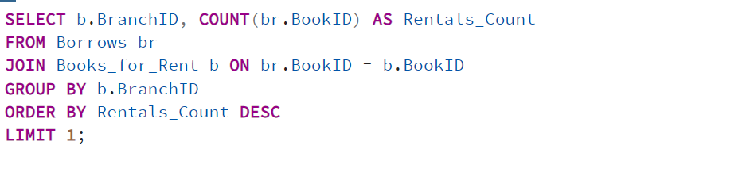Explanation:

This query is designed to identify the branch with the highest number of book rentals. The Borrows table is joined with the Books_for_Rent table using the BookID field to associate rentals with specific branches. The COUNT(br.BookID) function calculates the total number of books rented out by each branch. The results are grouped by BranchID to get the rental count for each branch. The query sorts the results in descending order by the Rentals_Count and limits the output to only one record to get the branch with the highest number of rentals.

Scenario:

LibTech analyzes its branches to determine which has the most book rentals. The results show that LibTech01 leads in rentals, helping the management focus resources and popular titles at this location to meet demand better.

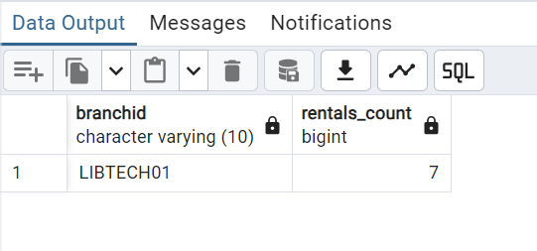

Figure 65: Complex Transaction 3: Branch with High Number of Rentals

The output shows that the branch with the highest number of rentals is **LIBTECH05**, with a total of four rentals.

Code:

SELECT b.BranchID, COUNT(br.BookID) AS Rentals_Count

FROM Borrows br

JOIN Books_for_Rent b ON br.BookID = b.BookID

GROUP BY b.BranchID

ORDER BY Rentals_Count DESC

LIMIT 1;

**Q4: Retrieve the Total Amount Each Customer Has Spent on Book Purchases and Item Purchases, and the Most Frequently Visited Branch**

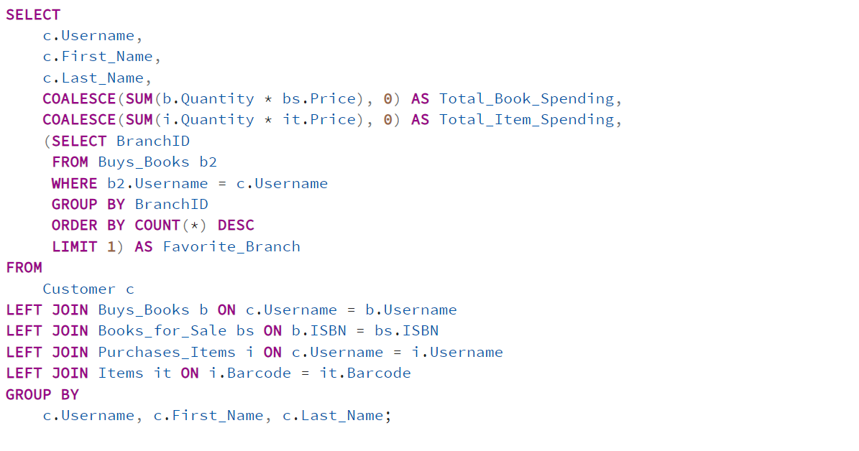

Explanation:

This query is designed to provide an overview of each customer's spending on book and item purchases, as well as identifying his/her most frequently visited branch. The SUM(b.Quantity * bs.Price) calculates the total amount each customer has spent on purchased books. If a customer has not bought any books, the COALESCE function sets the value to zero. The SUM(i.Quantity * it.Price) calculates the total amount each customer has spent on items. If a customer has not bought any items, the COALESCE function sets the value to zero. A subquery identifies the branch where the customer made the most purchases (Buys_Books). It counts the number of purchases made by the customer at each branch, then selects the branch with the highest count. The query uses LEFT JOIN to ensure that customers who have not made any purchases are still included in the results with zero values for the spending. The results are grouped by the customer's username, first name, and last name to aggregate the total spending.

Scenario:

LibTech tracks customer spending on book and item purchases along with their most frequently visited branch. For example, the query reveals that Rima Haabieh spent $152.5 on books and $50 on items, primarily visiting LibTech01 branch. This helps the library understand customer preferences and tailor services for better engagement..

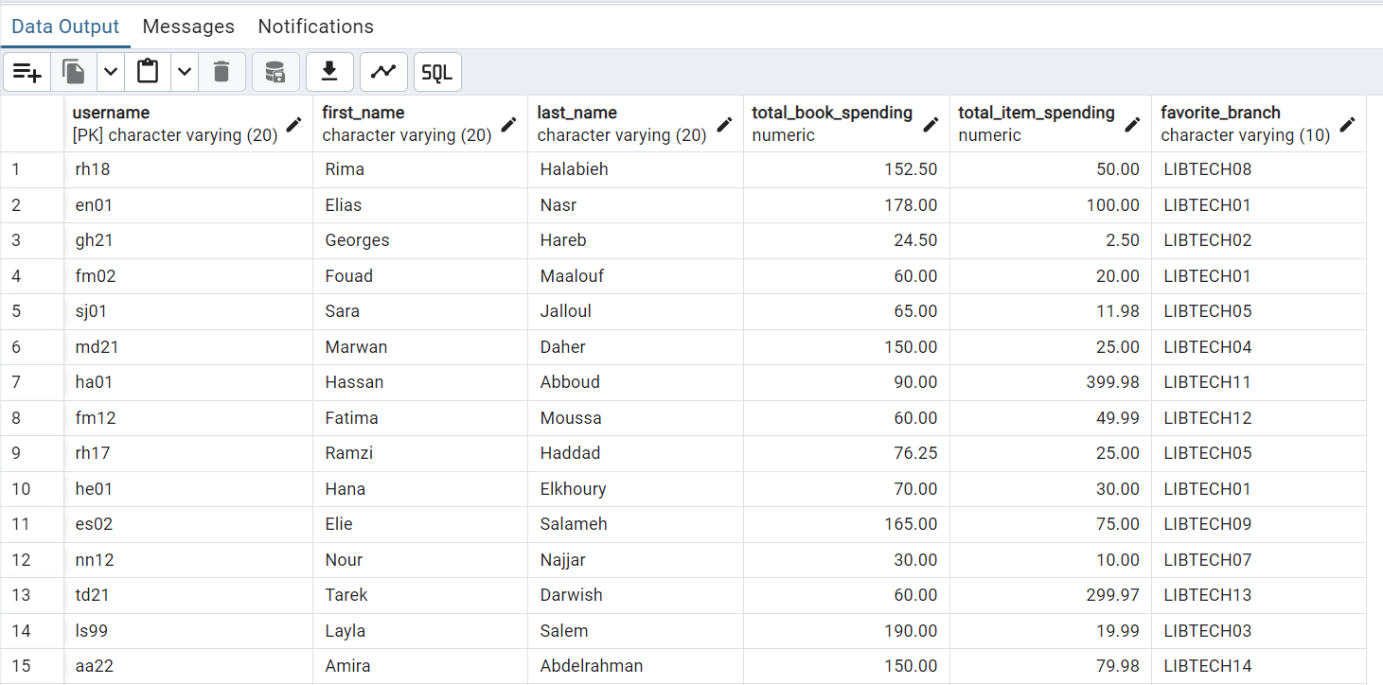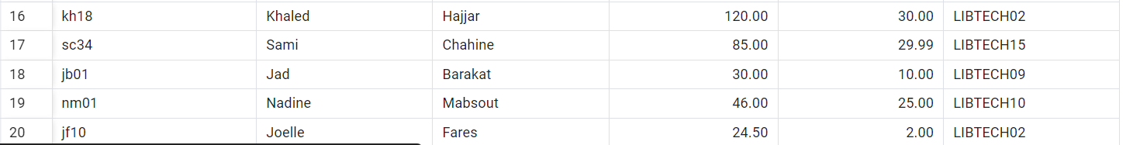

Figure 66: Compelx Transaction 4: Customer with Total Spendings and most Visited Branch

The output shows each customer's total spending on books and other items, along with the branch he/she most frequently purchase books from.

Code:

SELECT

c.Username,

c.First_Name,

c.Last_Name,

COALESCE(SUM(b.Quantity * bs.Price), 0) AS Total_Book_Spending,

COALESCE(SUM(i.Quantity * it.Price), 0) AS Total_Item_Spending,

(SELECT BranchID

FROM Buys_Books b2

WHERE b2.Username = c.Username

GROUP BY BranchID

ORDER BY COUNT(*) DESC

LIMIT 1) AS Favorite_Branch

FROM

Customer c

LEFT JOIN Buys_Books b ON c.Username = b.Username

LEFT JOIN Books_for_Sale bs ON b.ISBN = bs.ISBN

LEFT JOIN Purchases_Items i ON c.Username = i.Username

LEFT JOIN Items it ON i.Barcode = it.Barcode

GROUP BY

c.Username, c.First_Name, c.Last_Name;

**Q5: Categorize Customers into Segments (High, Medium, Low Spenders) Based on Their Total Spending**

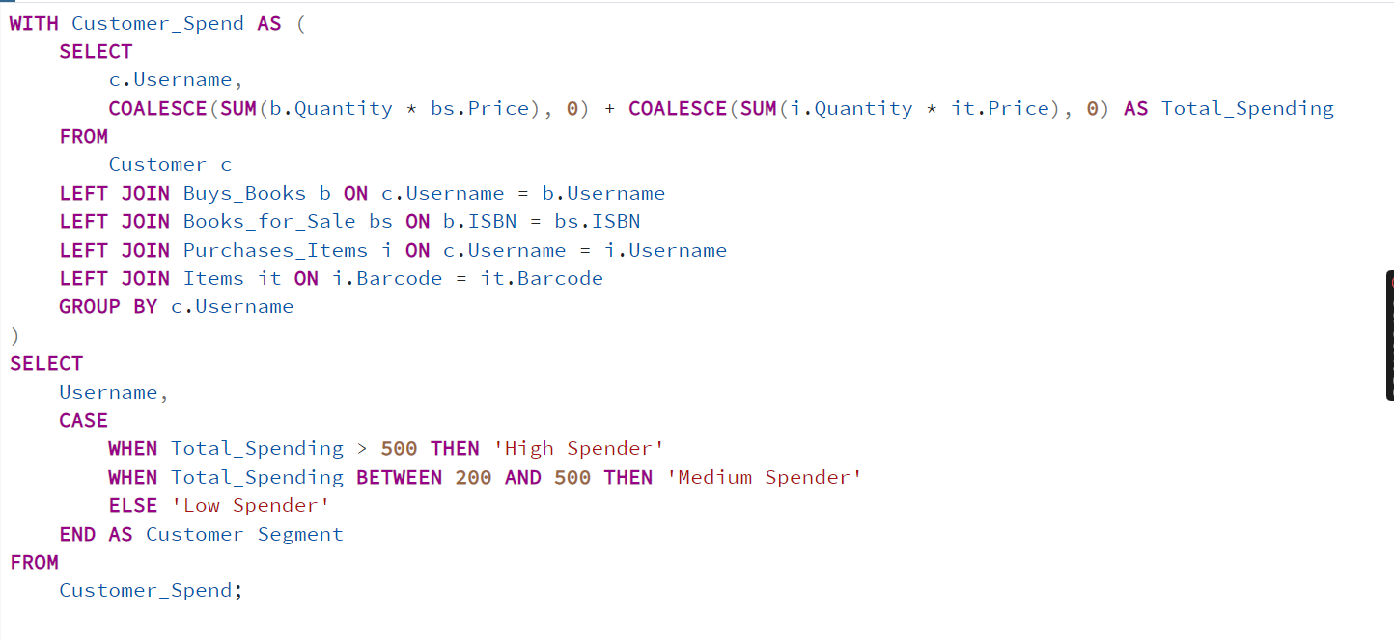

Explanation:

This query is used to categorize customers into different spending segments based on their total purchases, combining both book and item spending. Customer_Spend calculates the total amount each customer has spent on book and item purchases. COALESCE is used to ensure that customers who have not made any purchases have a total spending of zero. The LEFT JOIN is used to include all customers, even those who have not made any purchases.

The outer query assigns a spending category (High Spender, Medium Spender, Low Spender) based on the total amount calculated. Customers who spent more than $500 are classified as High Spenders. Customers who spent between $200 and $500 are classified as Medium Spenders. Customers who spent less than $200 are classified as Low Spenders.

Scenario:

LibTech categorizes its customers into spending segments based on their total purchases. For instance, a query reveals that rh18 is a medium spender, and gh21 is a low spender. This segmentation helps the library design targeted promotions and loyalty programs for different customer groups.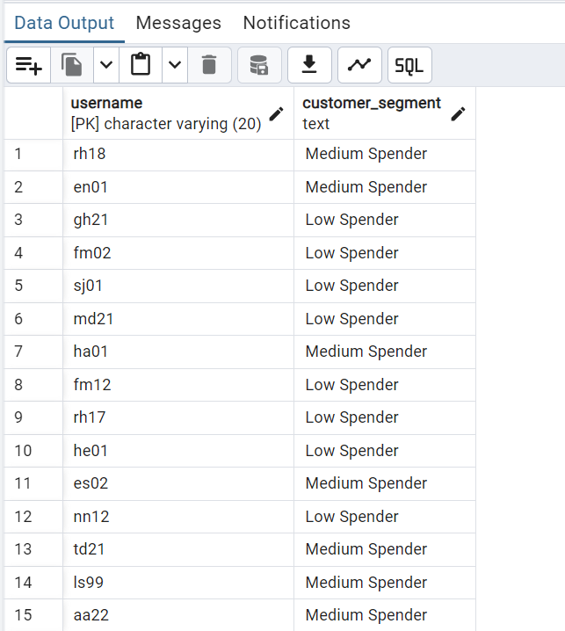

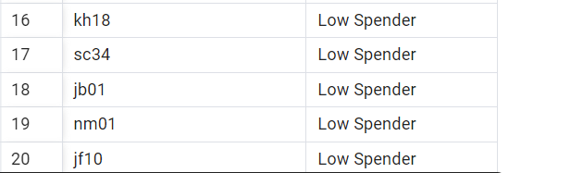

Figure 67: Complex Transaction 5: Categorization of Customers

The output categorizes each customer based on the total spending.

Code:

WITH Customer_Spend AS (

SELECT

c.Username,

COALESCE(SUM(b.Quantity * bs.Price), 0) + COALESCE(SUM(i.Quantity * it.Price), 0) AS Total_Spending

FROM

Customer c

LEFT JOIN Buys_Books b ON c.Username = b.Username

LEFT JOIN Books_for_Sale bs ON b.ISBN = bs.ISBN

LEFT JOIN Purchases_Items i ON c.Username = i.Username

LEFT JOIN Items it ON i.Barcode = it.Barcode

GROUP BY c.Username

)

SELECT

Username,

CASE

WHEN Total_Spending > 500 THEN 'High Spender'

WHEN Total_Spending BETWEEN 200 AND 500 THEN 'Medium Spender'

ELSE 'Low Spender'

END AS Customer_Segment

FROM

Customer_Spend;

**Q6: Find the Top 5 Suppliers Who Generated the Most Revenue from Their Items**

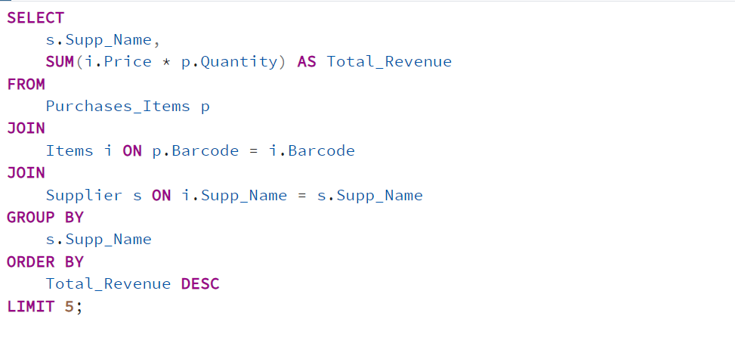

Explanation:

This query is used to identify the **top 5 suppliers** who have generated the most revenue from the items they supplied. It calculates the total revenue each supplier has earned from customers' purchases. The Purchases_Items table is joined with the Items table on the Barcode field to get the item details. The Items table is then joined with the Supplier table using the Supp_Name field to get the supplier information. For each purchase, the query multiplies the Price of the item by the Quantity purchased to calculate the revenue generated. The SUM(i.Price * p.Quantity) function aggregates the total revenue generated by each supplier. The results are grouped by Supp_Name to calculate the total revenue per supplier. The results are then sorted in descending order by Total_Revenue, with only the top 5 suppliers being displayed (LIMIT 5).

Scenario:

LibTech analyzes supplier performance to find the top 5 suppliers generating the most revenue from their items. The query reveals that *GadgetStore* and *TechZone* lead the list. This insight helps the library strengthen relationships with these suppliers and prioritize their products to boost profitability.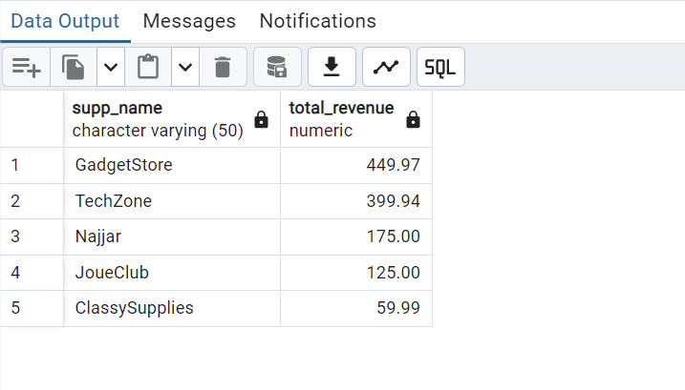

Figure 68: Complex Transaction 6: Top 5 Suppliers

The output shows the top five suppliers who have generated the most revenue from items purchased by customers.

Code:

SELECT

s.Supp_Name,

SUM(i.Price * p.Quantity) AS Total_Revenue

FROM

Purchases_Items p

JOIN

Items i ON p.Barcode = i.Barcode

JOIN

Supplier s ON i.Supp_Name = s.Supp_Name

GROUP BY

s.Supp_Name

ORDER BY

Total_Revenue DESC

LIMIT 5;

**Q7: List All Customers Who Bought Books or Items More Than Once from a Single Library Branch**

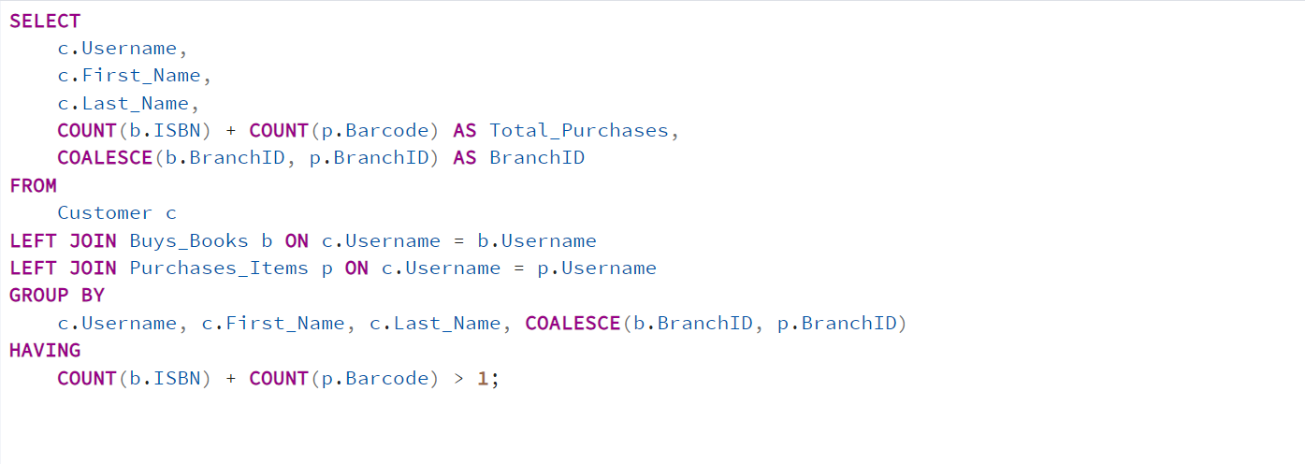

Explanation:

This query is designed to list customers who have made multiple purchases (books or items) from the same branch. It combines data from book purchases and item purchases to identify customers who have shopped more than once from a single branch. The Buys_Books table is joined with the Customer table on the Username field to get details of book purchases. The Purchases_Items table is also joined with the Customer table on the Username field to get details of item purchases. The COUNT(b.ISBN) + COUNT(p.Barcode) calculates the total number of book and item purchases made by each customer. The results are grouped by customer (Username, First_Name, Last_Name) and the branch (BranchID) where the purchases were made. The HAVING clause filters the results to include only customers who have made more than one purchase (> 1) at the same branch. The COALESCE(b.BranchID, p.BranchID) function is used to get the BranchID from either the book purchases or item purchases table.

Scenario:

LibTech identifies customers who made multiple purchases of books or items from the same branch. For example, a query shows that Elias Nasr frequently shops at LibTech01 branch. This information helps the library recognize loyal customers and create branch-specific rewards programs to encourage repeat visits.

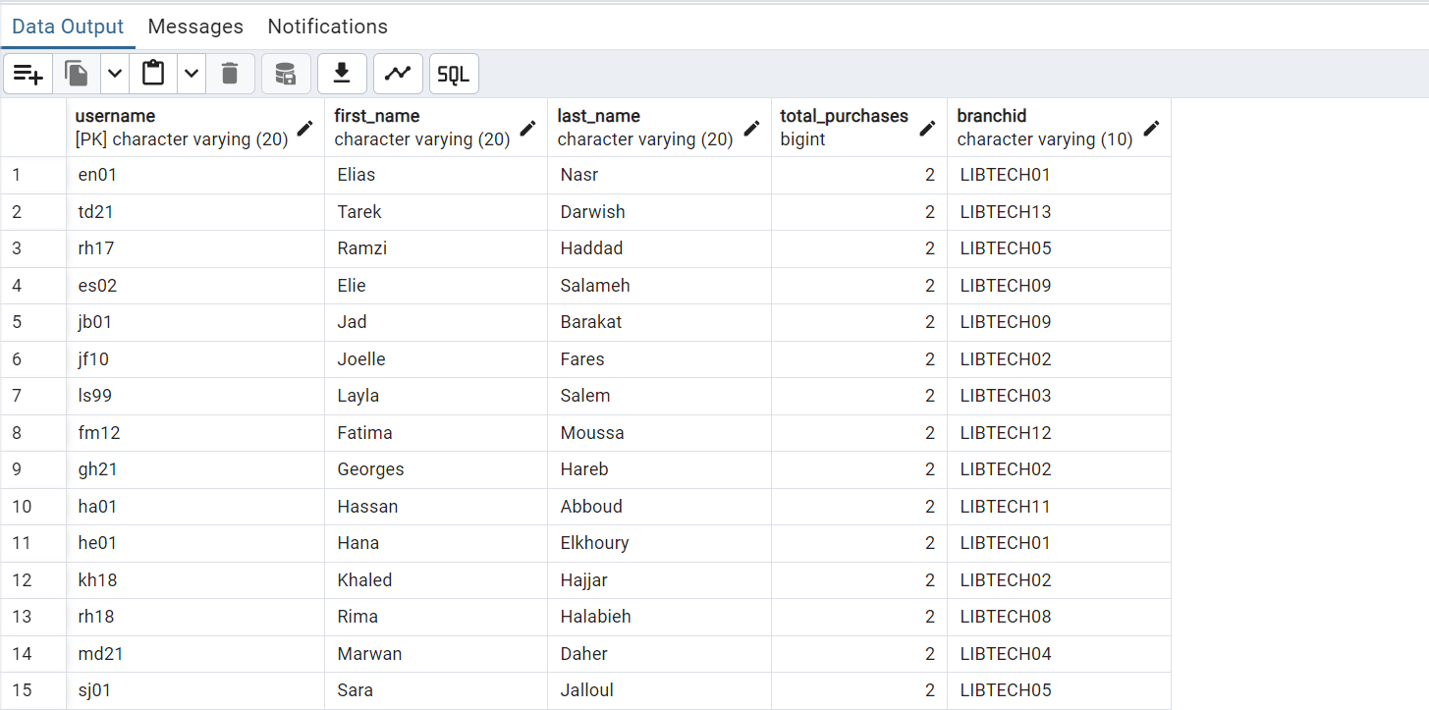

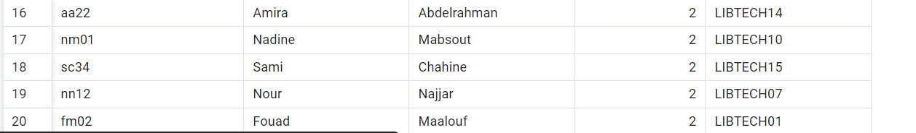

Figure 69: Complex Transaction 7: Customers Purchasing more than one time from a Branch

The output lists customers who have made multiple purchases from the same branch.

Code:

SELECT c.Username, c.First_Name, c.Last_Name, COUNT(b.ISBN) + COUNT(p.Barcode) AS Total_Purchases, b.BranchID

FROM Customer c

LEFT JOIN Buys_Books b ON c.Username = b.Username

LEFT JOIN Purchases_Items p ON c.Username = p.Username

GROUP BY c.Username, c.First_Name, c.Last_Name, b.BranchID

HAVING COUNT(b.ISBN) + COUNT(p.Barcode) > 1;

**Q8: Retrieve Staff Who Manage Libraries with the Highest Number of Items**

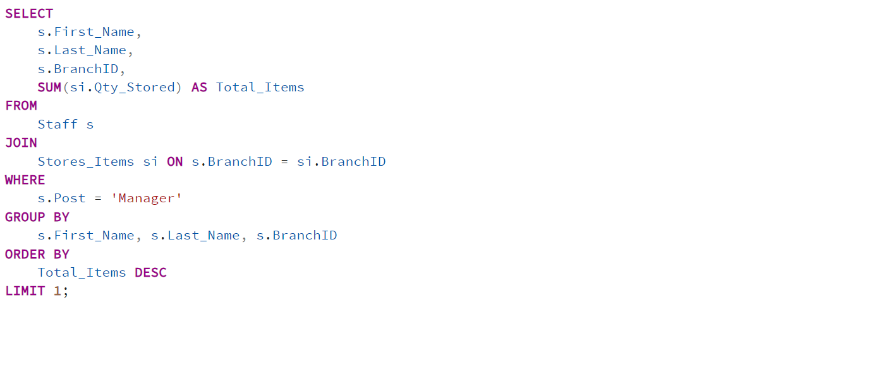

Explanation:

This query is used to identify the manager of the library branch that holds the highest total quantity of items. The Staff table is joined with the Stores_Items table using the BranchID field to get the total quantity of items stored in each branch. The WHERE clause filters the results to include only those staff members whose Post is set to 'Manager'. The SUM(si.Qty_Stored) function calculates the total number of items stored in each branch managed by a specific manager. The results are grouped by the manager's name (First_Name, Last_Name) and the BranchID to aggregate the total item count for each branch they manage. The results are sorted in descending order based on Total_Items and limited to the top result (LIMIT 1), displaying only the branch with the highest total number of items.

Scenario:

LibTech identifies staff managing branches with the highest number of items. A query shows that Jad, managing the main branch, oversees the largest inventory. This helps LibTech allocate resources and staff efficiently to support high-demand locations..

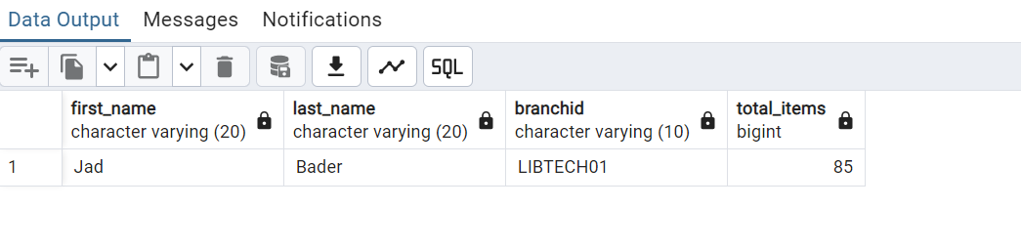

Figure 70: Complex Transaction 8: Staff Managing Highest Number of Items

The output indicates that Jad Bader, the manager of branch LIBTECH01, oversees the branch with the highest total inventory of 85 items. This highlights LIBTECH01 as the branch with the largest stock, managed effectively by Jad.

Code:

SELECT s.First_Name, s.Last_Name, s.BranchID, SUM(si.Qty_Stored) AS Total_Items

FROM Staff s

JOIN Stores_Items si ON s.BranchID = si.BranchID

WHERE s.Post = 'Manager'

GROUP BY s.First_Name, s.Last_Name, s.BranchID

ORDER BY Total_Items DESC

LIMIT 1;

**Q9: Library Branches That Are Running Low on Inventory**

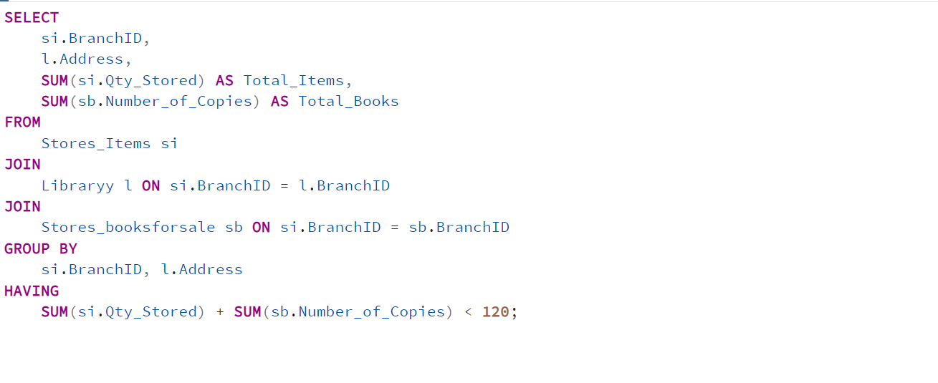

Explanation:

This query identifies library branches with low inventory levels, allowing the library management to prioritize restocking efforts. It combines data from items and books stored in each branch to determine which branches have critically low inventory levels. The Stores_Items table is joined with the Libraryy table to get branch details and with the Stores_booksforsale table to get the total number of books stored. The SUM(si.Qty_Stored) function calculates the total quantity of non-book items stored at each branch. The SUM(sb.Number_of_Copies) function calculates the total number of books available for sale at each branch. The results are grouped by BranchID and Address to aggregate the total inventory for each branch. The HAVING clause filters branches where the combined total of items and books is less than 120.

Scenario:

LibTech analyzes its branches to identify those running low on inventory. A query reveals that Baabda branch has a significantly reduced stock. This allows LibTech to prioritize restocking efforts and ensure all branches maintain sufficient inventory levels to meet customer demands..

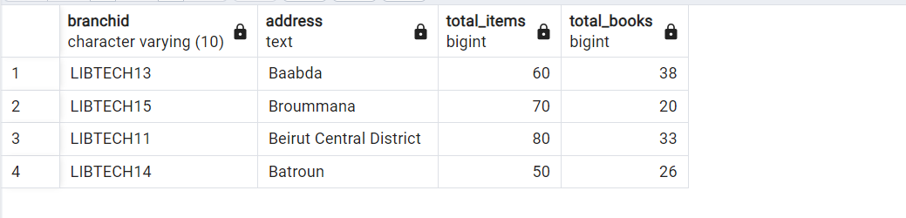

Figure 71: Complex Transaction 9: Library Branches Low on Inventory

The output shows the branches that are running low on inventory.

Code:

SELECT si.BranchID, l.Address, SUM(si.Qty_Stored) AS Total_Items, SUM(sb.Number_of_Copies) AS Total_Books

FROM Stores_Items si

JOIN Libraryy l ON si.BranchID = l.BranchID

JOIN Stores_booksforsale sb ON si.BranchID = sb.BranchID

GROUP BY si.BranchID, l.Address

HAVING SUM(si.Qty_Stored) + SUM(sb.Number_of_Copies) < 120;

**Q10: Total Revenue from Book and Item Sales by Library Branch**

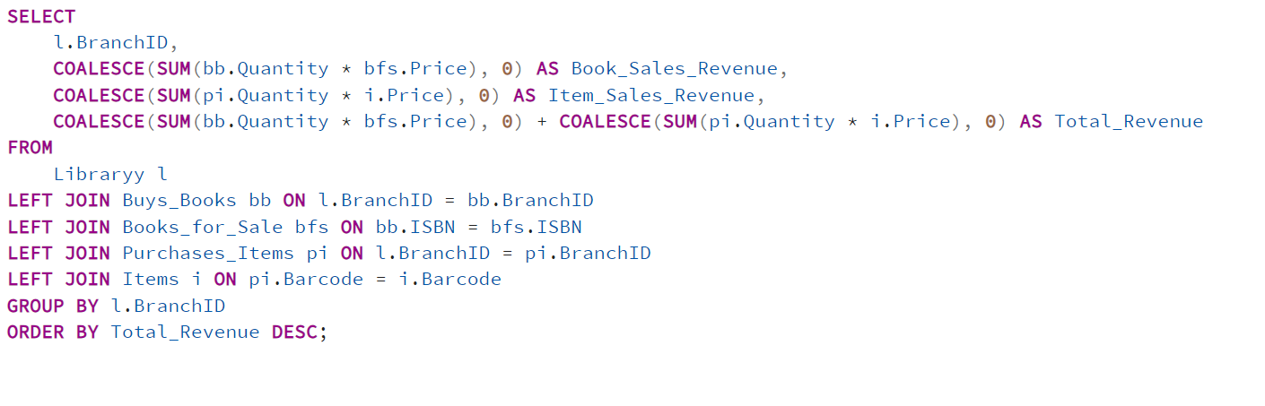

Explanation:

This query calculates the total revenue generated from book and item sales for each library branch, providing a comprehensive overview of each branch’s financial performance. The Libraryy table is joined with Buys_Books to get book sales, and with Purchases_Items to get item sales. The Books_for_Sale and Items tables are joined to retrieve the prices of books and items, respectively.

The SUM(bb.Quantity * bfs.Price) calculates the revenue generated from book sales. The SUM(pi.Quantity * i.Price) calculates the revenue generated from item sales. The COALESCE function ensures that if no purchases were made, the revenue is set to 0. The total revenue is computed as the sum of book sales revenue and item sales revenue for each branch. The results are grouped by BranchID to aggregate the total revenue for each branch. The results are sorted in descending order of Total_Revenue to list the branches with the highest revenue at the top.

Scenario:

LibTech calculates the total revenue from book and item sales for each branch. The query shows that LibTech01 branch generates the highest revenue, followed by the LibTech02 branch. This helps LibTech evaluate branch performance and plan targeted sales strategies to boost overall profitability.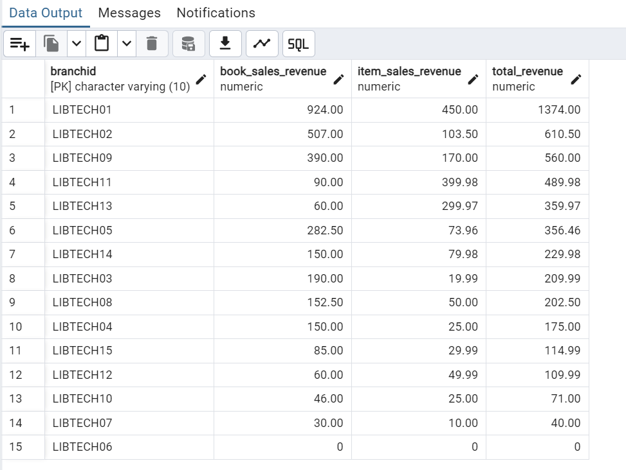

Figure 72: Complex Transaction 10: Total Revenue from Sales by Library Branch

The output provides the total revenue generated by each library branch from both book and item sales.

Code:

SELECT

l.BranchID,

COALESCE(SUM(bb.Quantity * bfs.Price), 0) AS Book_Sales_Revenue,

COALESCE(SUM(pi.Quantity * i.Price), 0) AS Item_Sales_Revenue,

COALESCE(SUM(bb.Quantity * bfs.Price), 0) + COALESCE(SUM(pi.Quantity * i.Price), 0) AS Total_Revenue

FROM

Libraryy l

LEFT JOIN Buys_Books bb ON l.BranchID = bb.BranchID

LEFT JOIN Books_for_Sale bfs ON bb.ISBN = bfs.ISBN

LEFT JOIN Purchases_Items pi ON l.BranchID = pi.BranchID

LEFT JOIN Items i ON pi.Barcode = i.Barcode

GROUP BY l.BranchID

ORDER BY Total_Revenue DESC;

**Q11: Customers Who Borrowed and Bought the Same Book Title**

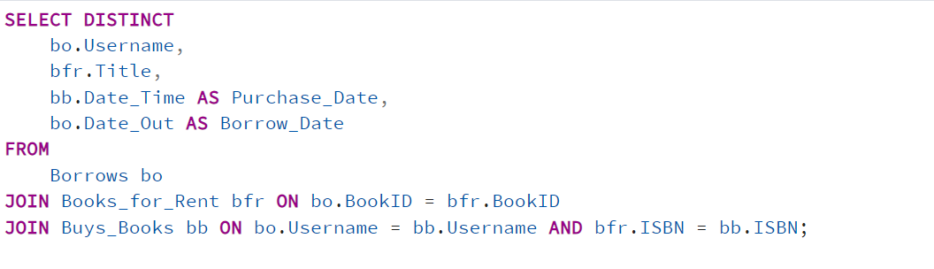Explanation:

This query identifies customers who both borrowed and purchased the same book title. It provides insights into customer behavior, particularly those who decided to buy a book after borrowing it. The Borrows table is joined with the Books_for_Rent table using BookID to get the title of the borrowed book. The Buys_Books table is then joined on Username and ISBN to check if the same customer has purchased the same book. The SELECT DISTINCT statement ensures that each record is unique, preventing duplicate entries if a customer borrowed and purchased the same book multiple times. The query retrieves the customer's username, the title of the book, the date they purchased it (Purchase_Date), and the date they borrowed it (Borrow_Date).

Scenario:

LibTech identifies customers who both borrowed and purchased the same book title. For example, a query shows that aa22 borrowed *Business Growth* before deciding to buy it. This insight helps LibTech understand customer preferences and consider offering purchase discounts on borrowed books to encourage sales.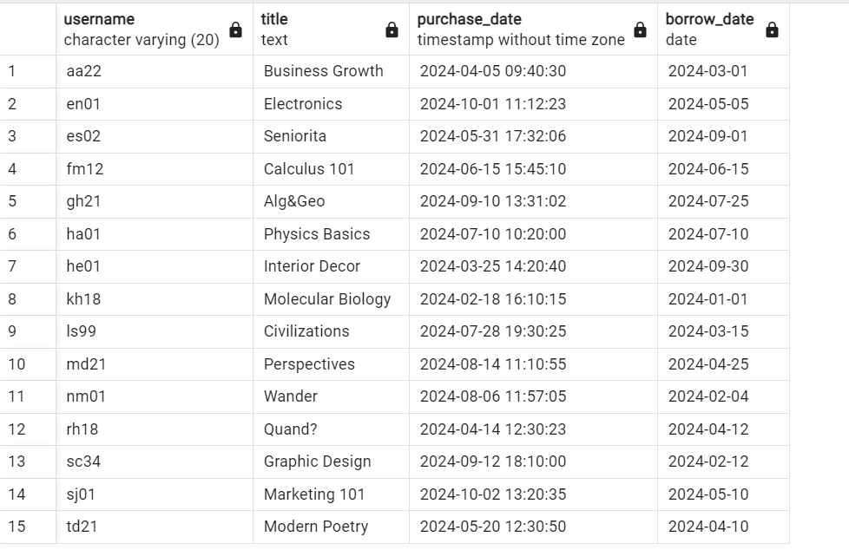

Figure 73: Complex Transaction 11: Customers Borrowing and Selling Same Book Title

The output shows customers who have both borrowed and bought the same book.

Code:

SELECT DISTINCT

bo.Username,

bfr.Title,

bb.Date_Time AS Purchase_Date,

bo.Date_Out AS Borrow_Date

FROM

Borrows bo

JOIN Books_for_Rent bfr ON bo.BookID = bfr.BookID

JOIN Buys_Books bb ON bo.Username = bb.Username AND bfr.ISBN = bb.ISBN;

**Q12: Librarians Working the Most Hours Across All Branches**

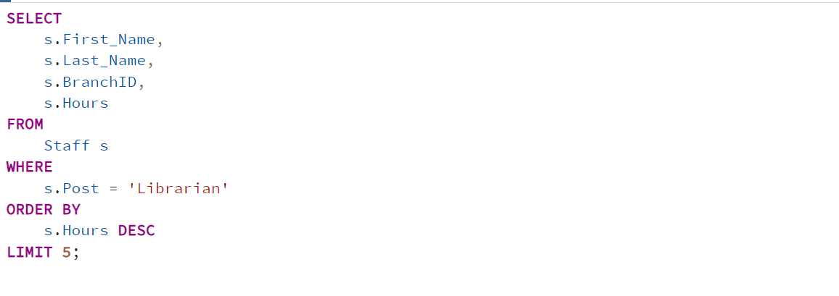

Explanation:

This query is used to identify the top 5 librarians who work the most hours across all library branches. The WHERE clause is used to filter the Staff table to include only those with the Post set to 'Librarian'. The query sorts the results in descending order by the Hours column to identify librarians who work the most hours. The LIMIT 5 clause restricts the output to the top five librarians with the highest working hours.

Scenario:

LibTech tracks librarian work hours across all branches to identify those working the most. A query reveals that Lama Saab logged the highest hours, primarily covering shifts at LibTech01 branch. This helps LibTech recognize dedicated staff and optimize scheduling to balance workloads.

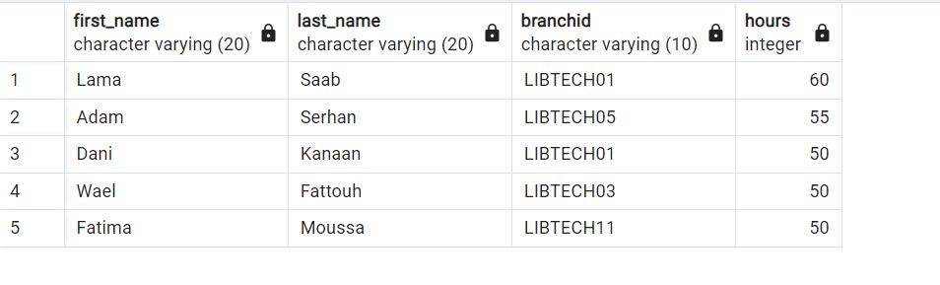

Figure 74: Librarians Working Most Hours across all Branches

The output shows the top 5 librarians who work the most hours.

Code:

SELECT s.First_Name, s.Last_Name, s.BranchID, s.Hours

FROM Staff s

WHERE s.Post = 'Librarian'

ORDER BY s.Hours DESC

LIMIT 5;

# **Views / Triggers / Functions / Procedures**

We have successfully implemented the following views, triggers, functions, and procedures.

**View: Supplier Supply Summary (Triple S)**

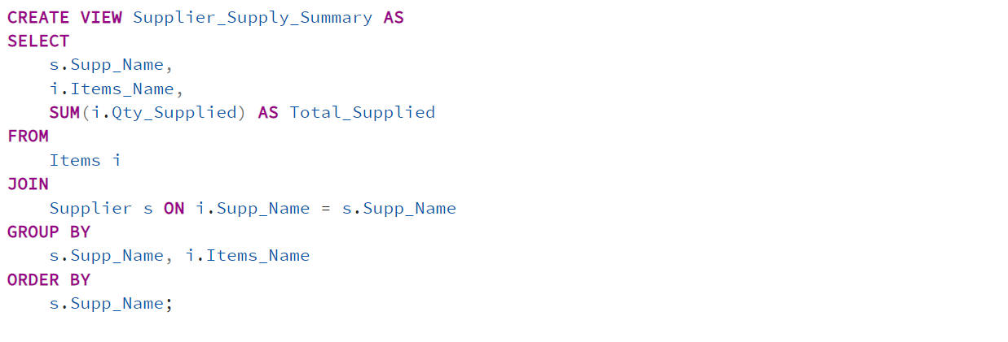

Explanation:

This view provides a summary of items supplied by each supplier along with the total quantity supplied. It helps the library track which suppliers are providing the most items, giving insights into supplier reliability and inventory sources.

The Items table is joined with the Supplier table using the Supp_Name field to link items with their respective suppliers. The SUM(i.Qty_Supplied) function calculates the total quantity of each item supplied by each supplier. The results are grouped by Supp_Name and Items_Name to aggregate the total quantity for each supplier-item combination. The output is sorted alphabetically by Supp_Name for easier reference.

Importance:

This view provides a quick and comprehensive summary of the inventory supplied by each supplier. It helps the library understand which suppliers contribute the most to its inventory, allowing management to prioritize orders and strengthen relationships with reliable suppliers. By using this view, the library can monitor supplier performance over time, identify supply trends, and optimize procurement processes to ensure that high-demand items are adequately stocked. Additionally, the view simplifies reporting and provides a ready reference for managing supplier contracts and negotiations.

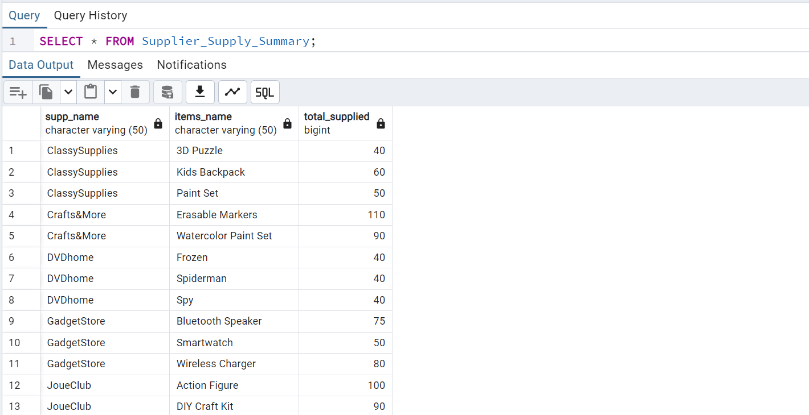

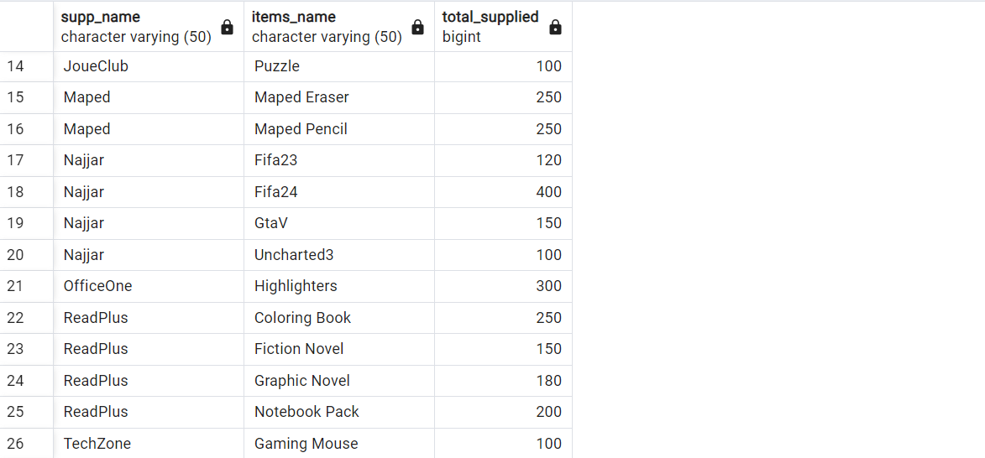

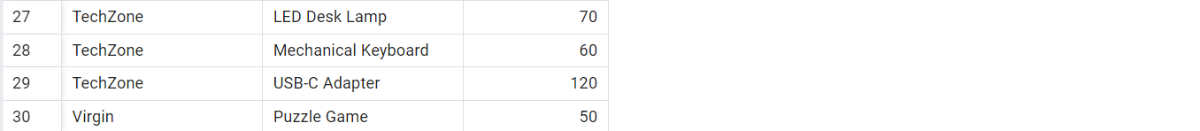

Figure 75: View 1: Supplier Supply Summary

The output of this view provides a summary of the total quantities of various items supplied by each supplier.

Code:

CREATE VIEW Supplier_Supply_Summary AS

SELECT

s.Supp_Name,

i.Items_Name,

SUM(i.Qty_Supplied) AS Total_Supplied

FROM

Items i

JOIN

Supplier s ON i.Supp_Name = s.Supp_Name

GROUP BY

s.Supp_Name, i.Items_Name

ORDER BY

s.Supp_Name;

SELECT * FROM Supplier_Supply_Summary;

**Trigger 1: Automatically Update the Quantity of Books for Sale After a Purchase**

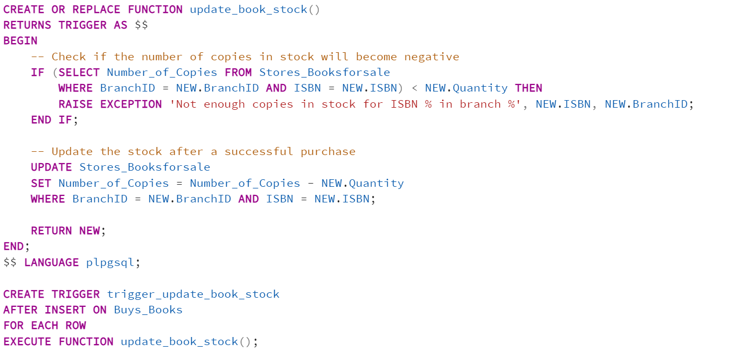

Explanation:

This trigger ensures that the inventory for books for sale is automatically updated whenever a new purchase is made. It prevents negative stock levels and keeps the inventory accurate in real-time. The function checks if there are enough copies in stock before processing a purchase. If the available stock (Number_of_Copies) is less than the quantity being purchased (NEW.Quantity), it raises an exception to prevent the purchase. If there are enough copies, the function updates the stock by deducting the purchased quantity from the Stores_Booksforsale table. The trigger is set to run after an INSERT operation on the Buys_Books table. For each new purchase, it calls the update_book_stock() function to adjust the stock levels automatically.

Importance:

This trigger is essential for managing inventory in real-time, ensuring that the library does not oversell books that are out of stock. By automatically adjusting the stock levels after each purchase, the library can maintain accurate inventory records, reduce the risk of stockouts, and enhance customer satisfaction by ensuring that items listed as available are truly in stock. Additionally, the trigger prevents sales that would result in negative stock, helping the library avoid customer complaints.

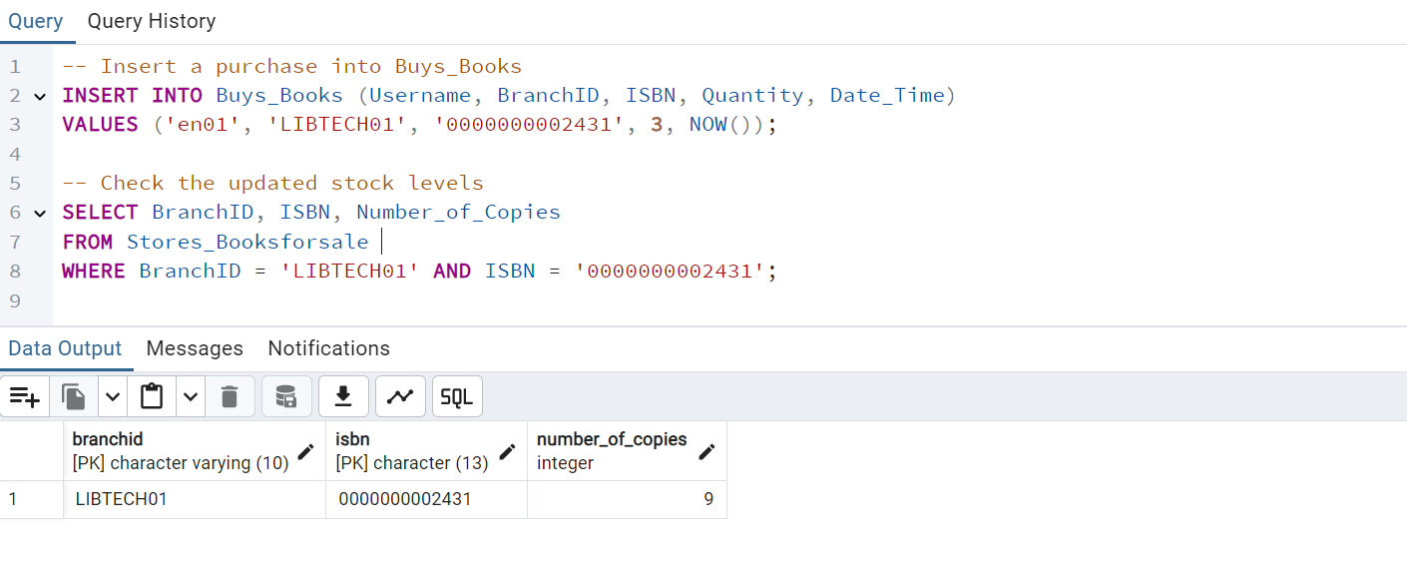

Figure 76: Trigger 1: Updating Quantity after a Purchase

The trigger automatically reduced the stock for the book with ISBN '0000000002431' in branch 'LIBTECH01' by three copies after the purchase. The updated stock shows nine copies remaining, reflecting the purchase made by the customer.

If the branch did not have enough copies in stock, the trigger would have raised an exception, preventing the purchase and keeping the stock unchanged.

Code:

CREATE OR REPLACE FUNCTION update_book_stock()

RETURNS TRIGGER AS $$

BEGIN

-- Check if the number of copies in stock will become negative

IF (SELECT Number_of_Copies FROM Stores_Booksforsale

WHERE BranchID = NEW.BranchID AND ISBN = NEW.ISBN) < NEW.Quantity THEN

RAISE EXCEPTION 'Not enough copies in stock for ISBN % in branch %', NEW.ISBN, NEW.BranchID;

END IF;

-- Update the stock after a successful purchase

UPDATE Stores_Booksforsale

SET Number_of_Copies = Number_of_Copies - NEW.Quantity

WHERE BranchID = NEW.BranchID AND ISBN = NEW.ISBN;

RETURN NEW;

END;

$$ LANGUAGE plpgsql;

CREATE TRIGGER trigger_update_book_stock

AFTER INSERT ON Buys_Books

FOR EACH ROW

EXECUTE FUNCTION update_book_stock();

-- Insert a purchase into Buys_Books

INSERT INTO Buys_Books (Username, BranchID, ISBN, Quantity, Date_Time)

VALUES ('en01', 'LIBTECH01', '0000000002431', 3, NOW());

-- Check the updated stock levels

SELECT BranchID, ISBN, Number_of_Copies

FROM Stores_Booksforsale

WHERE BranchID = 'LIBTECH01' AND ISBN = '0000000002431';

**Trigger 2: Prevent a User from Borrowing a New Book if There are unreturned books**

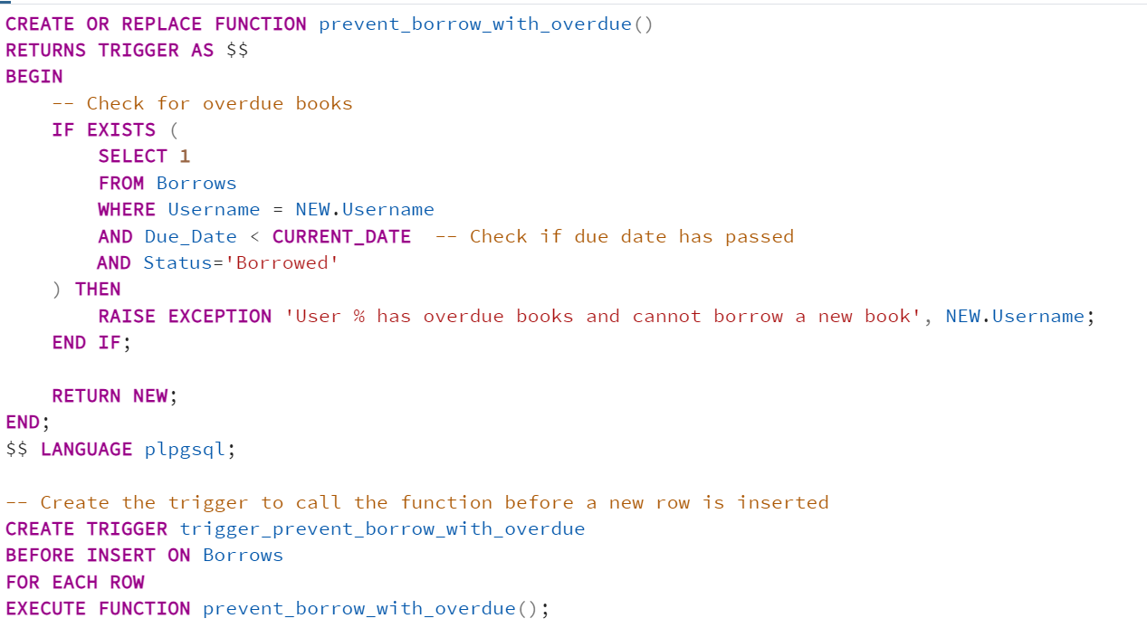

Explanation:

This trigger ensures that customers with outstanding penalties are not allowed to borrow new books until their dues are settled. It helps enforce the library’s borrowing policy by preventing further borrowing privileges until penalties are cleared. The function checks if the customer (NEW.Username) has any outstanding penalties in the Borrows table. If the due_date has passed, the function raises an exception to block the new borrowing transaction. The trigger is set to run before an INSERT operation on the Borrows table. Before a new borrowing record is inserted, it checks if the user has any returned book. If they do, the borrowing attempt is rejected.

Importance:

This trigger is crucial for enforcing borrowing policies and ensuring that customers return books on time. By preventing users with unreturned books from borrowing additional books, the library can encourage timely returns. This helps reduce overdue items, improves the availability of books for other customers, and ensures the library's resources are managed efficiently.

Code:

CREATE OR REPLACE FUNCTION prevent_borrow_with_overdue()

RETURNS TRIGGER AS $$

BEGIN

-- Check for overdue books

IF EXISTS (

SELECT 1

FROM Borrows

WHERE Username = NEW.Username

AND Due_Date < CURRENT_DATE -- Check if due date has passed

AND Status = ‘Borrowed’

) THEN

RAISE EXCEPTION 'User % has overdue books and cannot borrow a new book', NEW.Username;

END IF;

RETURN NEW;

END;

$$ LANGUAGE plpgsql;

-- Create the trigger to call the function before a new row is inserted

CREATE TRIGGER trigger_prevent_borrow_with_overdue

BEFORE INSERT ON Borrows

FOR EACH ROW

EXECUTE FUNCTION prevent_borrow_with_overdue();

INSERT INTO Borrows (Username, BookID, Date_Out, Due_Date, Penalty,Status)

VALUES ('en01', '0000000003421#012', '2024-12-01', '2024-12-15', 0,’Borrowed’);

**Function 1: Check Book Availability in a Given Branch**

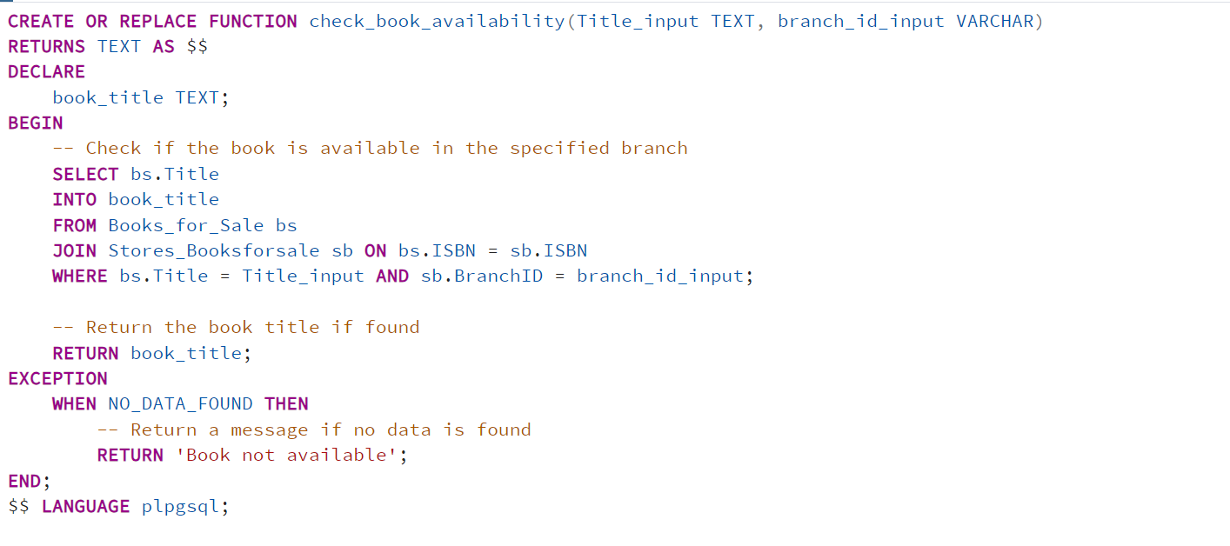

Explanation:

This function checks whether a specific book (based on its **title**) is available in a given library branch. If the book is found, it returns the book title; otherwise, it returns a message indicating that the book is not available.

The function uses a SELECT query to check if the book with the specified title is available in the given branch. If a matching record is found, it returns the title of the book. If the book is not found (NO_DATA_FOUND), the function catches the exception and returns the message 'Book not available'.

Importance:

This function helps streamline the process of checking book availability for both library staff and customers. By automating the search process, it saves time and improves customer service, ensuring customers get quick responses on book availability.

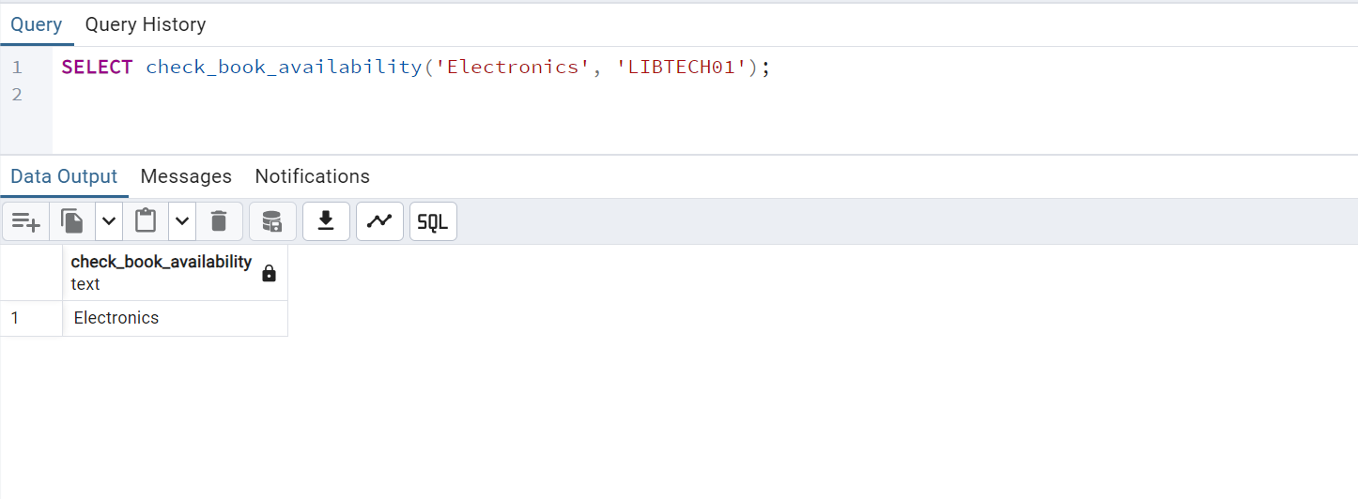

Figure 77: Function 1: Book Availability in a Branch

Since the book titled 'Electronics' is available in branch 'LIBTECH01', the function returns the book title.

Code:

CREATE OR REPLACE FUNCTION check_book_availability(Title_input TEXT, branch_id_input VARCHAR)

RETURNS TEXT AS $$

DECLARE

book_title TEXT;

BEGIN

SELECT bs.Title

INTO book_title

FROM Books_for_Sale bs

JOIN Stores_Booksforsale sb ON bs.ISBN = sb.ISBN

WHERE bs.Title = Title_input AND sb.BranchID = branch_id_input;

RETURN book_title; -- Returns the title if the book is available

EXCEPTION

WHEN NO_DATA_FOUND THEN

RETURN 'Book not available';

END;

$$ LANGUAGE plpgsql;

Example usage:

SELECT check_book_availability('Electronics', 'LIBTECH01');

**Function 2: Calculate Total Inventory Value for a Branch**

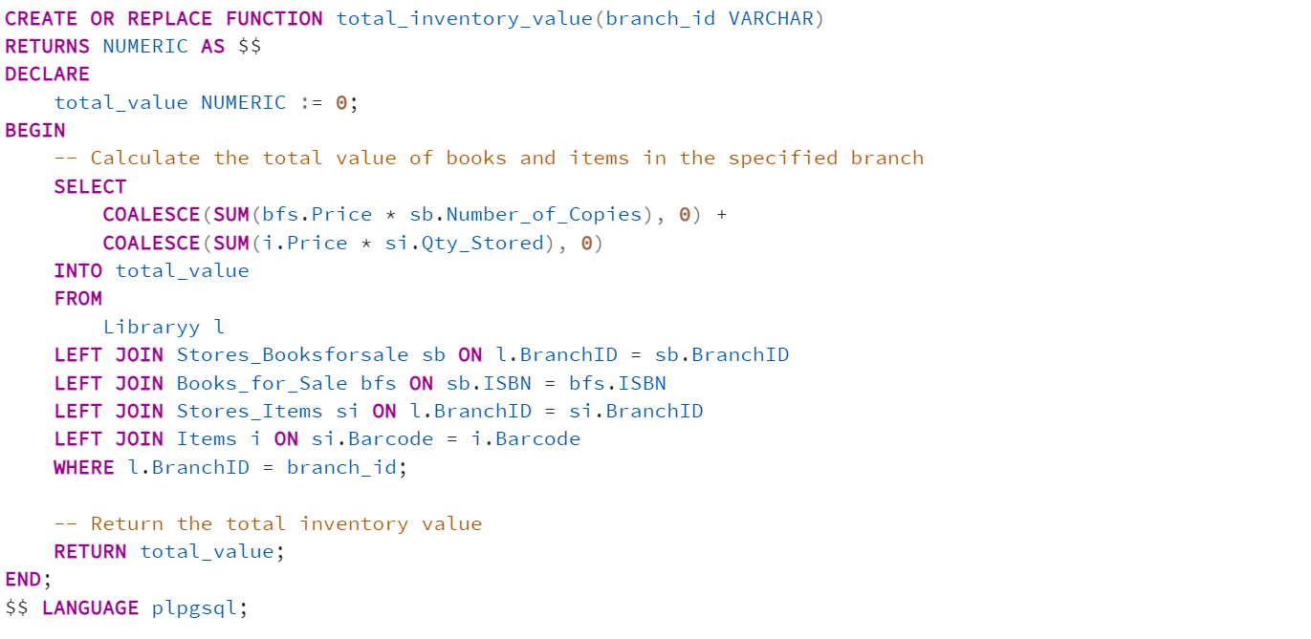

Explanation:

This function calculates the total inventory value for a specific library branch. It sums the value of all books and items stored in the branch, providing a clear overview of the branch’s assets. The SELECT statement calculates the sum of the value of all books (Books_for_Sale) and other items (Items) stored in the specified branch. The calculation is done by multiplying the price of each book by the number of copies (bfs.Price * sb.Number_of_Copies) and the price of each item by its stored quantity (i.Price * si.Qty_Stored). The COALESCE function ensures that if no books or items are found, the sum defaults to 0, preventing null values from affecting the calculation. The function returns the total inventory value as a numeric value.

Importance:

This function is essential for efficiently managing the library’s resources. By calculating the total inventory value of a branch, the library can make informed decisions regarding budgeting, resource allocation, and stock management. It allows for better financial planning and helps identify branches with excess or insufficient inventory. Additionally, this function can be used during audits to verify the value of assets, ensuring that the library maintains accurate financial records.

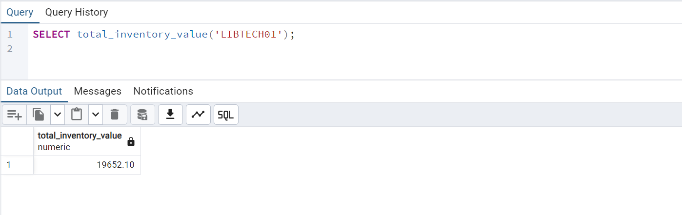

Figure 78: Function 2: Total Inventory Value for a Branch

The total value of books and items in branch **'**LIBTECH01**'** is $19652.10; this value is returned by the function.

The function provides a quick snapshot of the branch’s inventory value, helping the library assess the worth of its current stock.

Code:

CREATE OR REPLACE FUNCTION total_inventory_value(branch_id VARCHAR)

RETURNS NUMERIC AS $$

DECLARE

total_value NUMERIC := 0;

BEGIN

SELECT

COALESCE(SUM(bfs.Price * sb.Number_of_Copies), 0) +

COALESCE(SUM(i.Price * si.Qty_Stored), 0)

INTO total_value

FROM

Libraryy l

LEFT JOIN Stores_Booksforsale sb ON l.BranchID = sb.BranchID

LEFT JOIN Books_for_Sale bfs ON sb.ISBN = bfs.ISBN

LEFT JOIN Stores_Items si ON l.BranchID = si.BranchID

LEFT JOIN Items i ON si.Barcode = i.Barcode

WHERE l.BranchID = branch_id;

RETURN total_value;

END;

$$ LANGUAGE plpgsql;

-- Example usage:

SELECT total_inventory_value('LIBTECH01');

**Stored Procedure: Transfer Book Stock Between Branches**

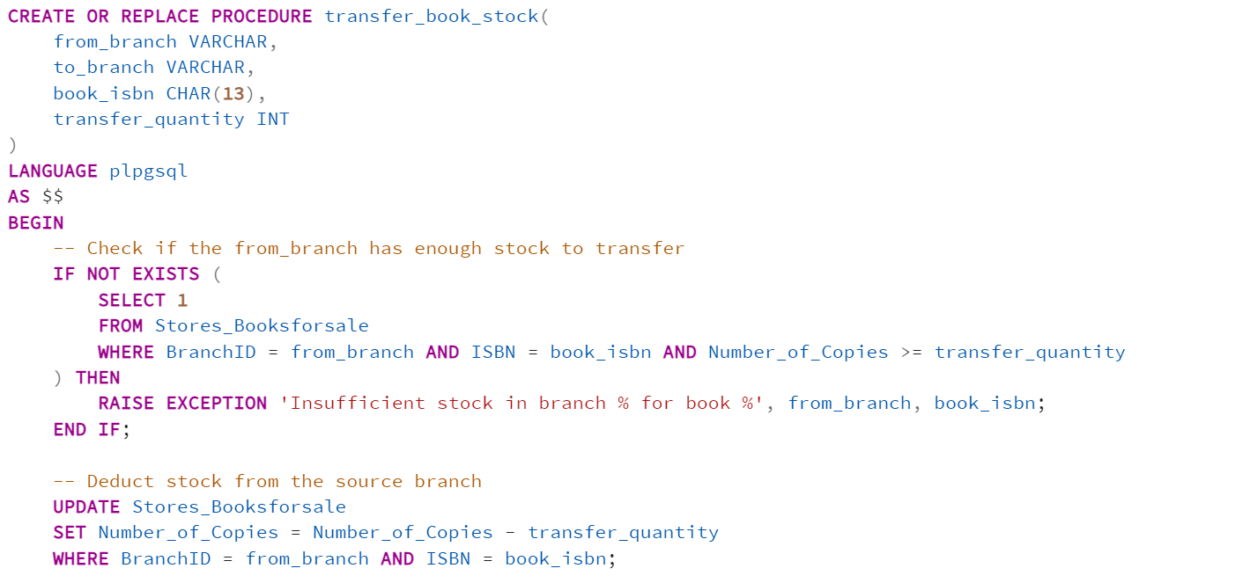

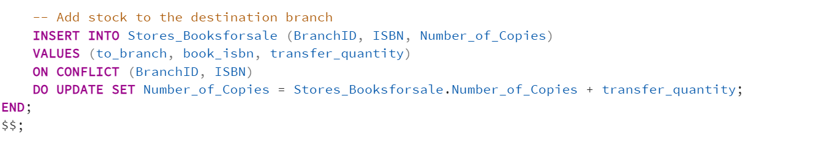

Explanation:

This stored procedure handles the transfer of book stock between two library branches. It ensures that books can be moved from one branch to another while maintaining accurate stock levels.

The procedure first checks if the source branch (from_branch) has enough copies of the specified book (book_isbn) to transfer. If the available stock is less than the transfer quantity, it raises an exception and stops the transfer. If the stock check is successful, the procedure deducts the specified quantity from the source branch. It then adds the same quantity to the destination branch. If the book already exists in the destination branch, it updates the existing quantity. Otherwise, it inserts a new record.

Importance:

This stored procedure automates the process of moving stock between branches, ensuring that books are efficiently redistributed based on demand. It prevents manual errors and maintains accurate inventory levels across branches. This is particularly useful for optimizing stock levels, ensuring that popular books are available where they are most needed, and helping branches avoid shortages.

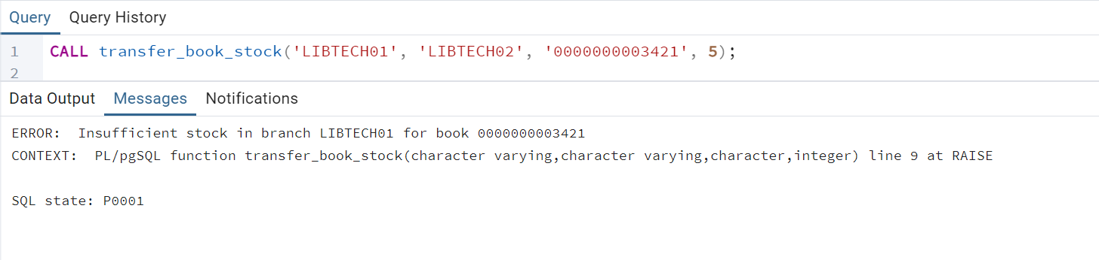

Figure 79: Stored Procedure: Transfer Books among Branches

If the transfer quantity exceeded the available stock in the source branch, the procedure would have raised an error.

Code:

CREATE OR REPLACE PROCEDURE transfer_book_stock(

from_branch VARCHAR,

to_branch VARCHAR,

book_isbn CHAR(13), -- Renamed parameter to avoid conflict

transfer_quantity INT

)

LANGUAGE plpgsql

AS $$

BEGIN

-- Check if the from_branch has enough stock

IF NOT EXISTS (

SELECT 1

FROM Stores_Booksforsale

WHERE BranchID = from_branch AND ISBN = book_isbn AND Number_of_Copies >= transfer_quantity

) THEN

RAISE EXCEPTION 'Insufficient stock in branch % for book %', from_branch, book_isbn;

END IF;

-- Deduct stock from from_branch

UPDATE Stores_Booksforsale

SET Number_of_Copies = Number_of_Copies - transfer_quantity

WHERE BranchID = from_branch AND ISBN = book_isbn;

-- Add stock to to_branch

INSERT INTO Stores_Booksforsale (BranchID, ISBN, Number_of_Copies)

VALUES (to_branch, book_isbn, transfer_quantity)

ON CONFLICT (BranchID, ISBN)

DO UPDATE SET Number_of_Copies = Stores_Booksforsale.Number_of_Copies + transfer_quantity;

END;

$$;

example:

CALL transfer_book_stock('LIBTECH01', 'LIBTECH02', '0000000003421', 5);

**Trigger & Function: Moving a book from Sale to Rent**

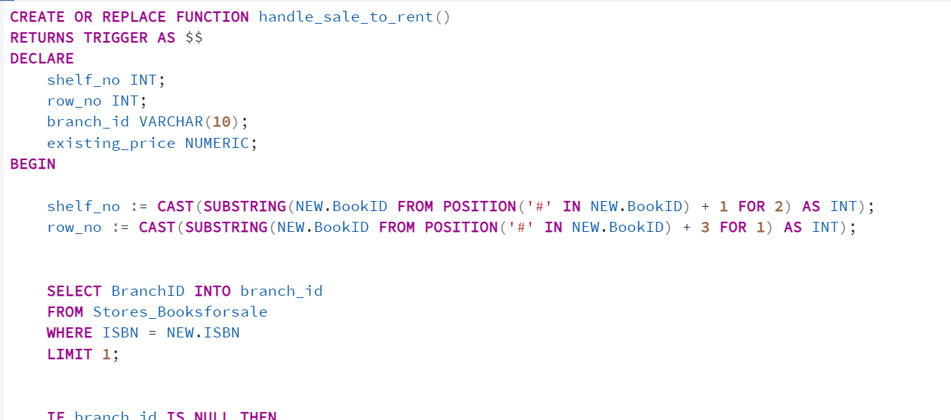

Explanation:

This function automates the process of moving books from sale to rent while ensuring data consistency. It extracts shelf and row numbers from the book ID, identifies the branch where the book is stored, validates stock availability, and updates the inventory by reducing the number of sale copies. It also checks if the same book (based on ISBN) already exists in the rental system to ensure consistent pricing; otherwise, it calculates the rental price by applying a discount. Finally, the function logs the transition for traceability, ensuring all operations are efficient and transparent.

Importance:

This function is crucial for operational efficiency, ensuring accurate inventory management and consistent pricing across branches. It reduces manual errors, maintains data integrity, and provides a seamless customer experience. Its adaptability allows for future enhancements, and real-time updates ensure the library’s records remain accurate, scalable, and reliable, minimizing operational risks and supporting smooth library management.

Code:

CREATE OR REPLACE FUNCTION handle_sale_to_rent()

RETURNS TRIGGER AS $$

DECLARE

shelf_no INT;

row_no INT;

branch_id VARCHAR(10);

existing_price NUMERIC;

BEGIN

shelf_no := CAST(SUBSTRING(NEW.BookID FROM POSITION('#' IN NEW.BookID) + 1 FOR 2) AS INT);

row_no := CAST(SUBSTRING(NEW.BookID FROM POSITION('#' IN NEW.BookID) + 3 FOR 1) AS INT);

SELECT BranchID INTO branch_id

FROM Stores_Booksforsale

WHERE ISBN = NEW.ISBN

LIMIT 1;

IF branch_id IS NULL THEN

RAISE EXCEPTION 'Cannot move book % to rent. It is not stored in any branch.', NEW.ISBN;

END IF;

IF NOT EXISTS (

SELECT 1

FROM Stores_Booksforsale

WHERE ISBN = NEW.ISBN AND BranchID = branch_id AND Number_of_Copies > 0

) THEN

RAISE EXCEPTION 'Cannot move book % to rent, not enough copies available in branch %.', NEW.ISBN, branch_id;

END IF;

UPDATE Stores_Booksforsale

SET Number_of_Copies = Number_of_Copies - 1

WHERE ISBN = NEW.ISBN AND BranchID = branch_id;

SELECT Price INTO existing_price

FROM Books_for_Rent

WHERE ISBN = NEW.ISBN

LIMIT 1;

IF existing_price IS NOT NULL THEN

RAISE NOTICE 'An existing book with ISBN % is found. Using the same price: %.', NEW.ISBN, existing_price;

ELSE

existing_price := ROUND((SELECT Price FROM Books_for_Sale WHERE ISBN = NEW.ISBN) * (1 - NEW.Discount / 100.0), 2);

RAISE NOTICE 'No existing book with ISBN % is found. Using the discounted price: %.', NEW.ISBN, existing_price;

END IF;

INSERT INTO Books_for_Rent (

BookID, ISBN, Title, Genre, Price, Translator, Edition, Pages, Lang, Publisher_Name, Shelf_No, Row_No, BranchID

)

SELECT

NEW.BookID,

b.ISBN,

b.Title,

b.Genre,

existing_price,

b.Translator,

b.Edition,

b.Pages,

b.Lang,

b.Publisher_Name,

shelf_no,

row_no,

branch_id

FROM Books_for_Sale b

WHERE b.ISBN = NEW.ISBN;

RAISE NOTICE 'Book % has been successfully moved from sale to rent in branch % with Shelf_No: %, Row_No: %, and price: %.', NEW.ISBN, branch_id, shelf_no, row_no, existing_price;

RETURN NEW;

END;

$$ LANGUAGE plpgsql;

CREATE or REPLACE TRIGGER trigger_handle_sale_to_rent

BEFORE INSERT ON Sale_to_Rent

FOR EACH ROW

EXECUTE FUNCTION handle_sale_to_rent();

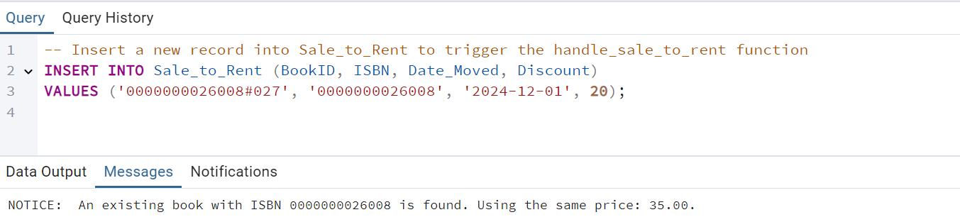

Figure 80: Trigger and Function: Moving a book from Sale to Rent

# **Bonuses**

## **15.1 Recursive Query: Track Borrowing Chains for a Book**

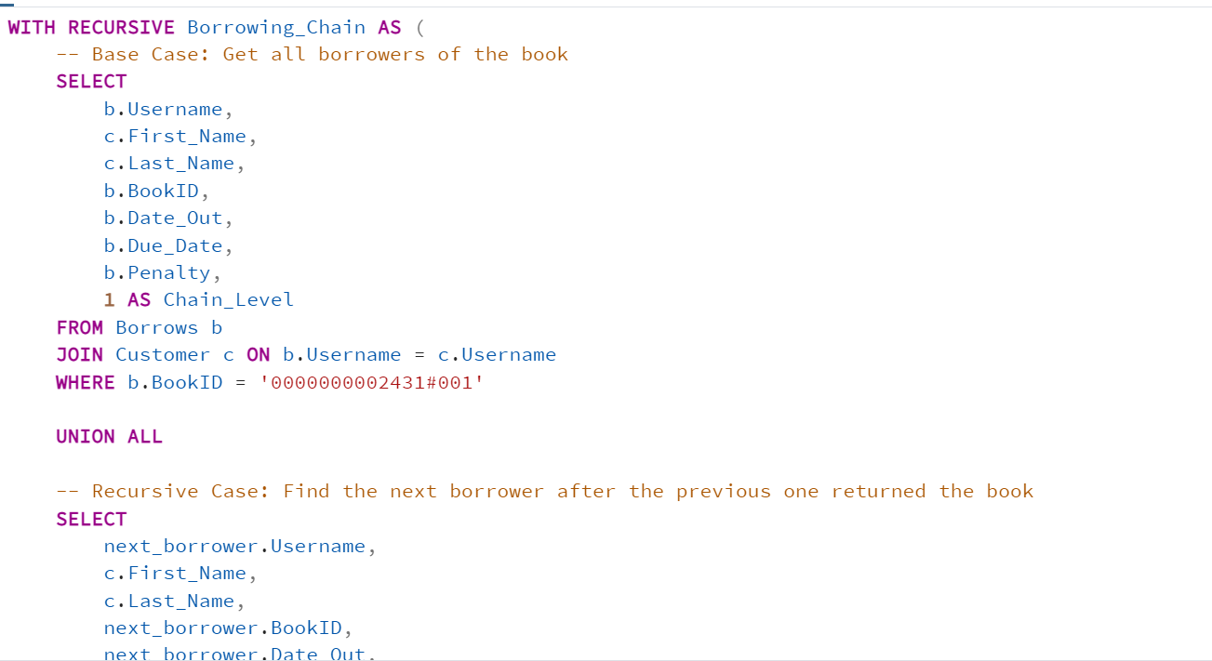

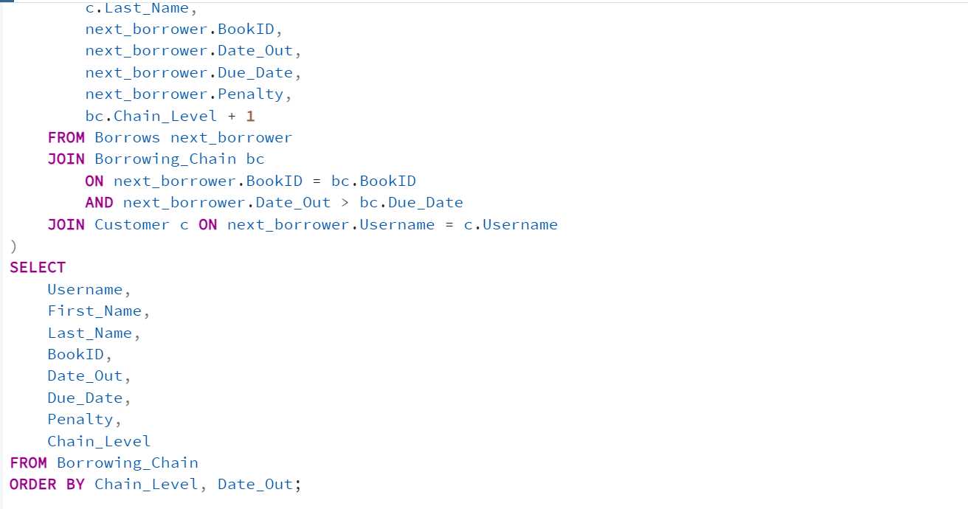

Explanation:

The query begins with the Base Case, which retrieves the initial borrower of the specified book (BookID), including details such as the borrower’s username, name, borrowing and due dates, and any penalties. In the Recursive Case, the query identifies the next borrower who borrowed the book after the previous borrower’s due date. The condition next_borrower.Date_Out > bc.Due_Date ensures that borrowing events are sequential and non-overlapping. The recursion continues iteratively until no more borrowers meet the criteria. The Final Output displays the complete borrowing chain, detailing each borrower, the borrowing and due dates, any penalties incurred, and the chain level (Chain_Level), which indicates the borrowing sequence.

Importance:

This query serves multiple purposes: it tracks book demand by identifying how often a book is borrowed, thereby highlighting its popularity. It helps the library manage inventory by assessing whether additional copies of high-demand books are needed. Lastly, by analyzing borrowing patterns, the library can improve user recommendations, suggesting similar books to frequent borrowers and enhancing the overall user experience.

**Example Usage**

SELECT * FROM Borrowing_Chain;

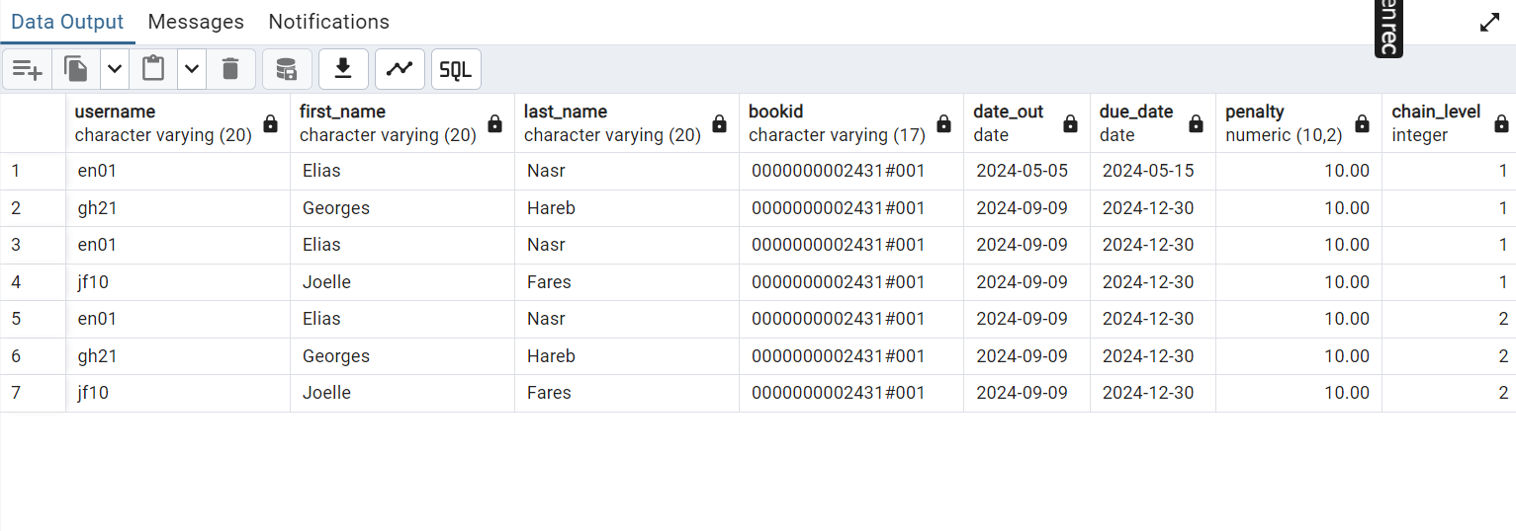

Figure 81: Recursive Query: Track Borrowing Chains for a Book

The output visually represents the borrowing chain, helping the library analyze borrowing behavior and patterns for the specific book.

WITH RECURSIVE Borrowing_Chain AS (

-- Base Case: Get all borrowers of the book

SELECT

b.Username,

c.First_Name,

c.Last_Name,

b.BookID,

b.Date_Out,

b.Due_Date,

b.Penalty,

1 AS Chain_Level

FROM Borrows b

JOIN Customer c ON b.Username = c.Username

WHERE b.BookID = '0000000002431#001'

UNION ALL

-- Recursive Case: Find the next borrower after the previous one returned the book

SELECT

next_borrower.Username,

c.First_Name,

c.Last_Name,

next_borrower.BookID,

next_borrower.Date_Out,

next_borrower.Due_Date,

next_borrower.Penalty,

bc.Chain_Level + 1

FROM Borrows next_borrower

JOIN Borrowing_Chain bc

ON next_borrower.BookID = bc.BookID

AND next_borrower.Date_Out > bc.Due_Date

JOIN Customer c ON next_borrower.Username = c.Username

)

SELECT

Username,

First_Name,

Last_Name,

BookID,

Date_Out,

Due_Date,

Penalty,

Chain_Level

FROM Borrowing_Chain

ORDER BY Chain_Level, Date_Out;

## **15.2 Security Mechanism 1: Encryption & Decryption of Sensitive Data**

As taught in EECE 455 (Cryptography), encrypting data is essential as a security measure. Here is how to decrypt and encrypt in PostgreSQL

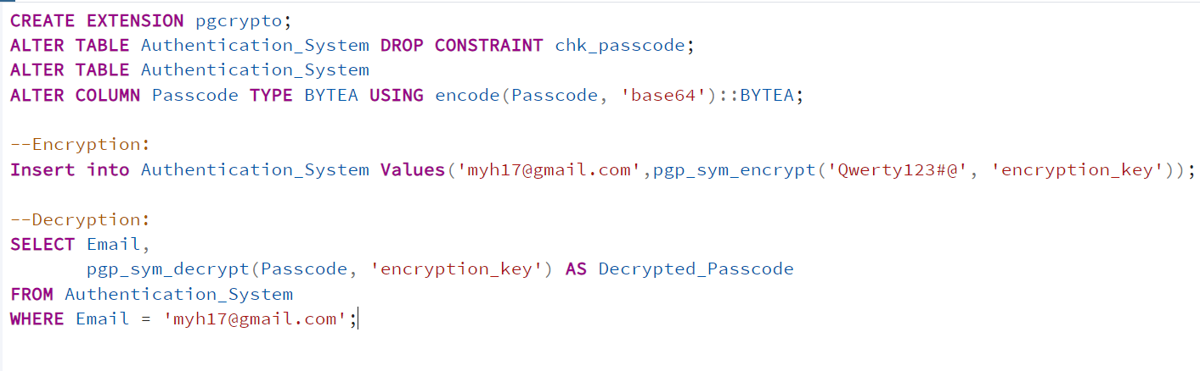

Explanation:

This code utilizes PostgreSQL's pgcrypto extension to securely encrypt and decrypt sensitive data, specifically the Passcode column in the Authentication_System table. It first modifies the table structure by removing any existing constraints on Passcode, changing its data type to BYTEA to store encrypted binary data. During insertion, the passcode is encrypted using pgp_sym_encrypt with a specified encryption key. For decryption, pgp_sym_decrypt is used to retrieve the original passcode securely.

Importance:

The code enhances data security by encrypting sensitive information such as passcodes, ensuring it is stored securely in the database. Encryption prevents unauthorized access, even if the database is compromised, protecting user credentials. The decryption process ensures only authorized parties with the correct key can access the original data. This implementation aligns with best practices for data security and compliance with privacy regulations.

Code:

**--Create Extension:**

CREATE EXTENSION pgcrypto;

**--Drop Existing Constraint:**

ALTER TABLE Authentication_System DROP CONSTRAINT chk_passcode;

**--Modify the Passcode Column:**

ALTER TABLE Authentication_System

ALTER COLUMN Passcode TYPE BYTEA USING pgp_sym_encrypt(Passcode::TEXT, 's3cUr3!kEy#2023@P0stgreSQL^');**--Insert Encrypted Data:**

INSERT INTO Authentication_System (Email, Passcode)

VALUES ('myh17@gmail.com', pgp_sym_encrypt('Qwerty123#@', 's3cUr3!kEy#2023@P0stgreSQL^'));

**--Decrypt Data:**

SELECT Email,

pgp_sym_decrypt(Passcode, 's3cUr3!kEy#2023@P0stgreSQL^') AS Decrypted_Passcode

FROM Authentication_System

WHERE Email = 'myh17@gmail.com';

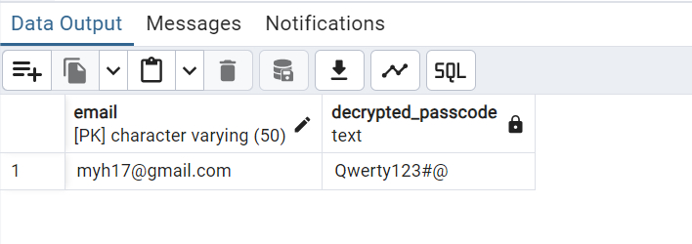

Figure 82: Decryption of Sensitive Data

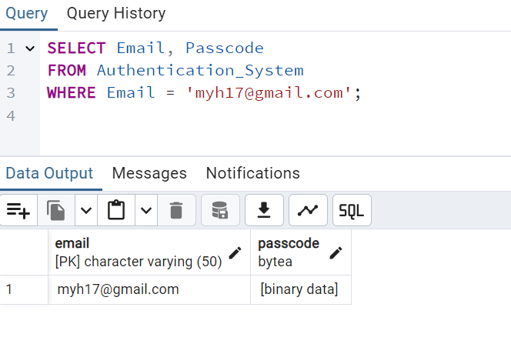

Figure 83: Encryption of Sensitive Data

## **15.3. Security Mechanism 2: Implementing SQL Injection Prevention**

As taken in a cybersecurity internship at POTECH Company, SQL injection is a common database security vulnerability where attackers can manipulate user inputs to execute malicious SQL commands. To prevent SQL injection, we use **prepared statements** in PostgreSQL, which securely handle user inputs. An attacker might inject malicious input like:

SELECT * FROM Customer WHERE Username = 'en01' OR '1'='1';

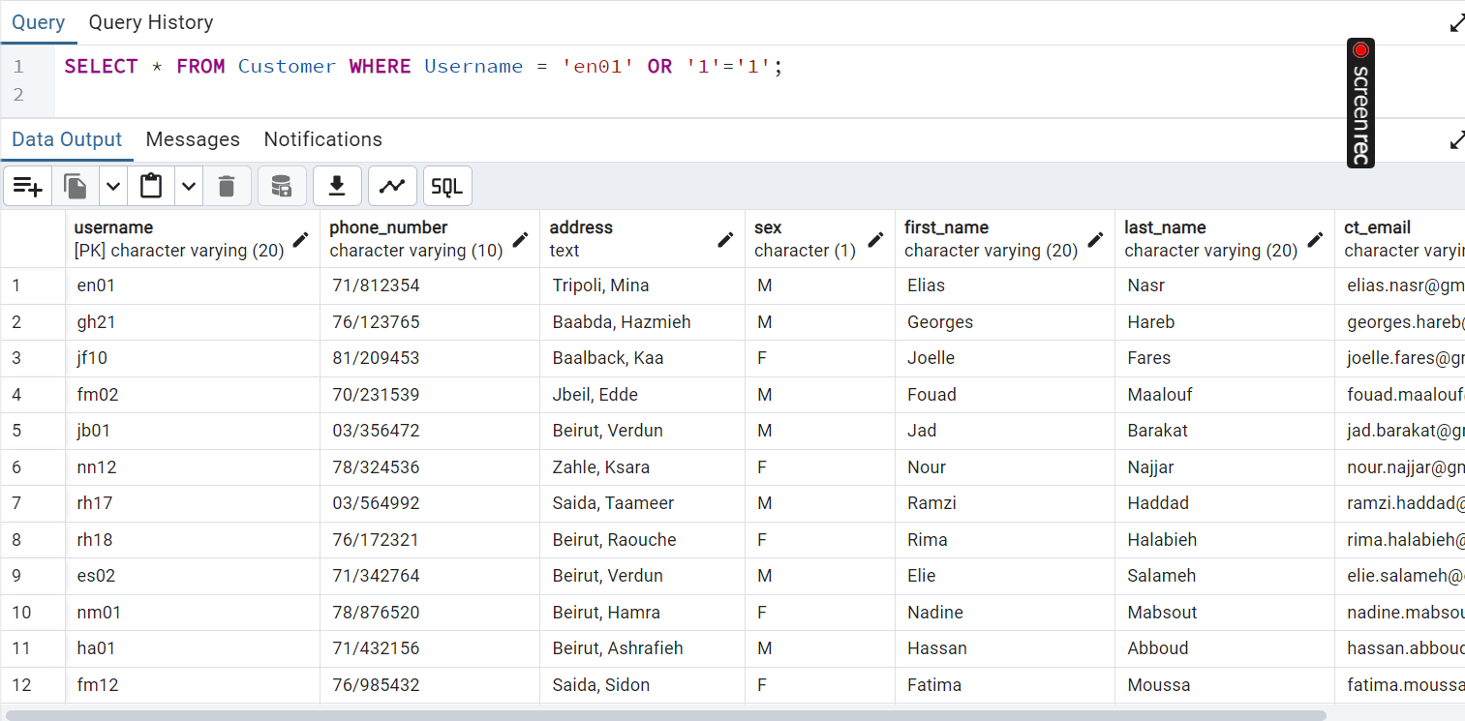

This query bypasses authentication checks, as the condition '1'='1' always evaluates to true.

Using prepared statements can be a countermeasure to SQL injection since Prepared statements separate the SQL query structure from user inputs, ensuring inputs are treated strictly as data.

PREPARE find_customer (VARCHAR) AS

SELECT * FROM Customer WHERE Username = $1;

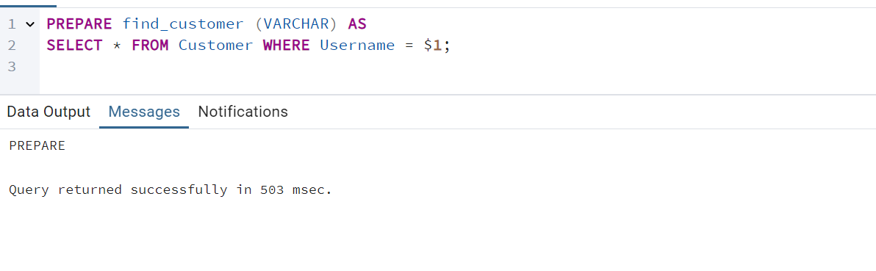

Test with Valid Input

EXECUTE find_customer('en01');

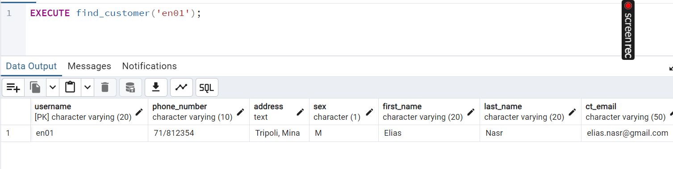

Test with Malicious Input

EXECUTE find_customer('en01 OR 1=1');

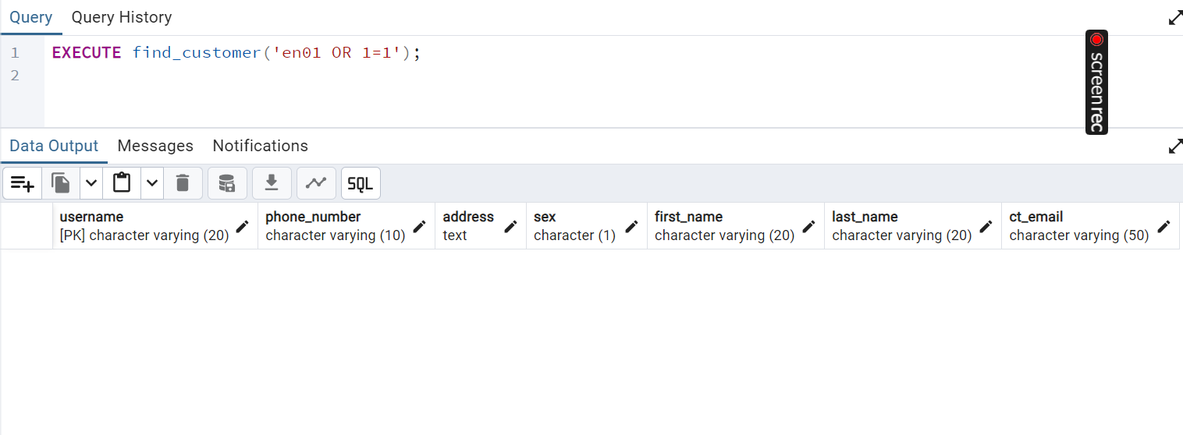

Figure 84:SQL Injection Prevention

The output of this query demonstrates the effectiveness of prepared statements in preventing SQL injection attacks. When executed with a valid username, such as ‘en01’, the query retrieves the corresponding customer record securely. However, if an attacker attempts to inject malicious input like ‘en01 OR 1=1’, the prepared statement treats the entire input as a literal string, ensuring that no unintended SQL logic is executed. This approach sescures the database from unauthorized access and protecting sensitive customer information.

## **15.4 Security Mechanism 3: Row Level Security**

Explanation

This implementation uses **Row-Level Security (RLS)** to restrict access to specific rows of the Customer table based on the current database user's identity. By enabling RLS (ALTER TABLE Customer ENABLE ROW LEVEL SECURITY), the database ensures that row-level policies are enforceable on the table. The security policy created (CREATE POLICY customer_policy ON Customer USING (Username = CURRENT_USER)) restricts access to rows where the Username column matches the currently authenticated database user (CURRENT_USER). Finally, applying the policy with ALTER TABLE Customer FORCE ROW LEVEL SECURITY ensures that the policy is always enforced, even for privileged users, unless explicitly bypassed. This mechanism ensures that each user can only access his/her own data within the table.

Importance:

This implementation enhances **data security** by ensuring users can only access the rows of data they are authorized to view, reducing the risk of unauthorized access or data leaks. Furthermore, RLS simplifies the application logic by offloading access control to the database layer, ensuring consistent enforcement of security policies. It also supports scalability by allowing policies to be applied directly to tables without requiring significant changes to the application code.

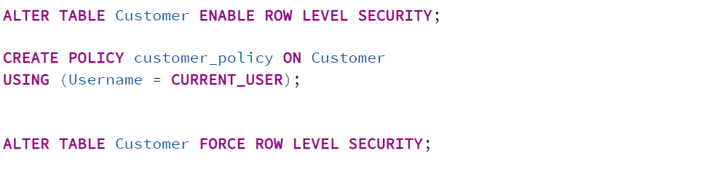

Example Usage:

CREATE USER test_user WITH PASSWORD 'password';

GRANT SELECT, INSERT, UPDATE, DELETE ON Customer TO test_user;

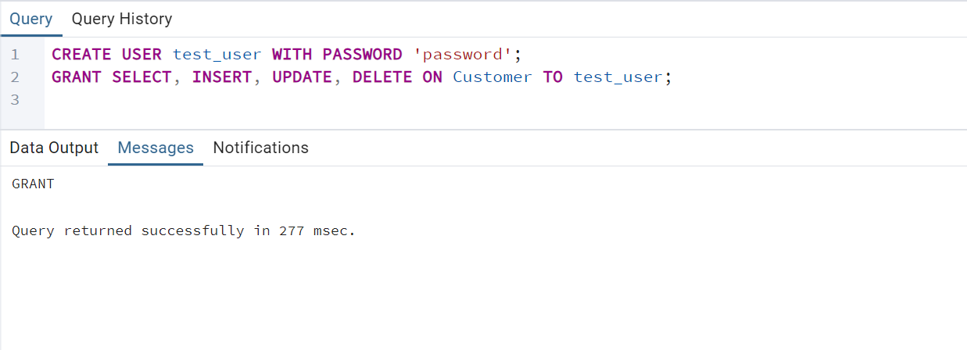

--Switch to the Test User

SET SESSION AUTHORIZATION test_user;

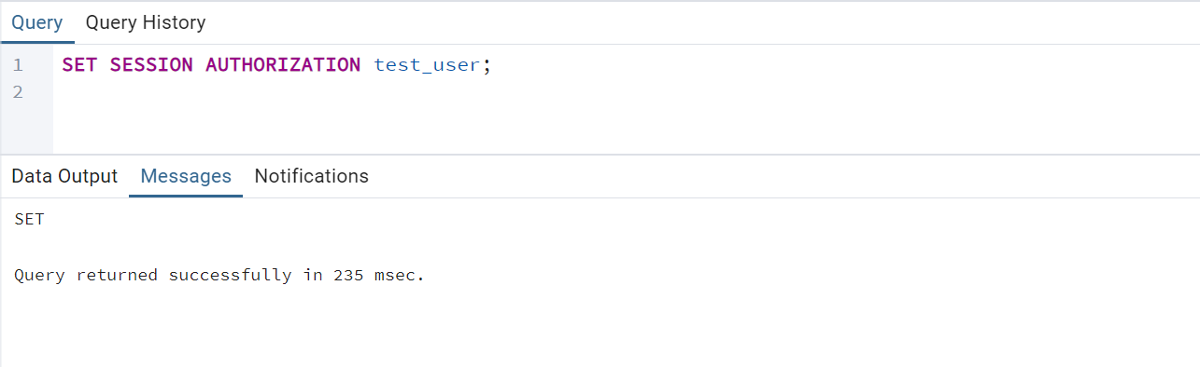

SELECT * FROM Customer;

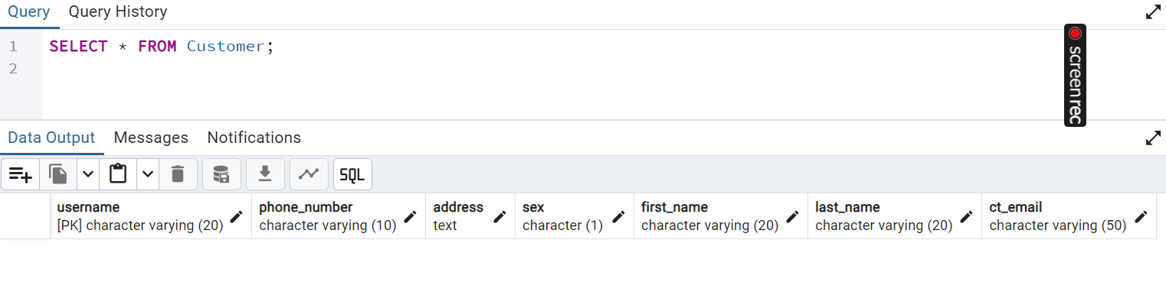

No tuple because only rows where Username = 'test_user' should be visible and this is not the case.

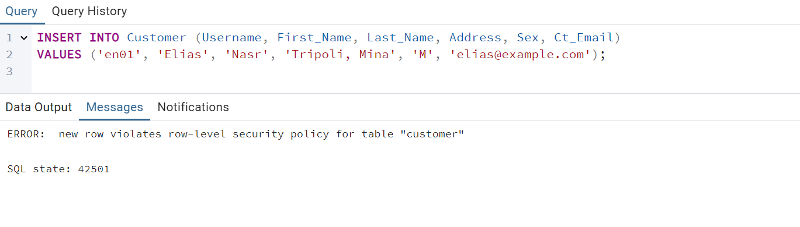

Figure 85: Row Level Security

The insertion fails because the Username does not match CURRENT_USER.

We get the following error:

ERROR: new row violates row-level security policy for table "Customer".

In the Row-Level Security (RLS) implementation, we enabled fine-grained access control on the Customer table to restrict data visibility based on the current user's identity. By activating RLS and defining a security policy, we ensured that each user could only access rows where the Username matched the database username (CURRENT_USER). We applied the FORCE ROW LEVEL SECURITY command, preventing even privileged users from bypassing the policy. This mechanism enhances data privacy by ensuring that sensitive information is accessible only to authorized users.

# **Normalization**

For each relation in our database, we specified the functional dependencies and specified whether the relation satisfies 1NF, 2NF, 3NF, and BCNF. In case of violation, we determined how to normalize the table.

Legend:

* Bold + Underlined = Primary Key
* Italic = Foreign Key
* Bold + Underlined + Italic = Part of the Primary Key + Foreign Key for Another Primary Key

**Relation1: Authentication_System**

|  |  |
| --- | --- |
| **Email** | Passcode |

The functional dependency in this relation is:

Email 🡪 Passcode

**1NF**: The table satisfies 1NF because all attributes contain atomic values, and there are no repeating groups or multi-valued attributes (e.g., ‘[elias.nasr@gmail.com](mailto:elias.nasr@gmail.com)’, ‘Nasr321#’)

**2NF**: The table adheres to 2NF because it is already in 1NF, and all non-prime attributes (e.g., Passcode) are fully functionally dependent on the primary key (Email). Since there is no composite primary key, no partial dependency exists.

**3NF**: The table meets the requirements for 3NF because it is in 2NF, and there are no transitive dependencies. The non-prime attribute (Passcode) depends directly on the primary key (Email) and not on any other non-prime attribute.

**BCNF:** The table satisfies BCNF because it meets the conditions required for Boyce-Codd Normal Form. In this table, the functional dependency Email → Passcode exists, where Email is the primary key and also a superkey. Since Email uniquely identifies each row in the table, and all non-prime attributes (Passcode) depend solely on the primary key, the table adheres to BCNF. There are no other functional dependencies that violate the BCNF rule, so no further decomposition is needed.

**Relation2: Customer**

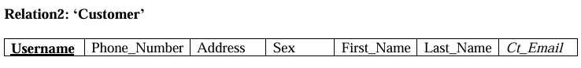

The functional dependencies in this relation are:

Username 🡪 (Phone_Number, Address, Sex, First_Name, Last_Name, Ct_Email)

**1NF**: The table follows 1NF because all columns contain atomic values, there are no repeating groups, and each row is uniquely identified by the primary key (Username).

**2NF**: The table follows 2NF because it is in 1NF, and all non-prime attributes (e.g., Phone_Number, Address, Sex, First_Name, Last_Name, and Ct_Email) depend entirely on the primary key (Username). There are no partial dependencies, as Username is a single-column primary key.

**3NF**: The table follows 3NF because all non-prime attributes depend directly on the primary key (Username) and there are no transitive dependencies. ‘Ct_Email’, even though it is unique and a foreign key, depends only on Username and does not introduce any dependency on another non-prime attribute.

**BCNF:** This table satisfies BCNF because it is in 3NF, and every functional dependency has a superkey determinant. The only functional dependencies are based on the primary key (Username), which uniquely identifies each row.

**Relation3: Libraryy**



The Functional Dependencies in this relation are:

BranchID 🡪 (Address, Phone_Number)

**1NF**: This table satisfies 1NF because all the attributes contain atomic values, with no repeating groups or arrays. Each row in the table is uniquely identified by the primary key (BranchID).

**2NF**: This table satisfies 2NF because it is already in 1NF, and all non-prime attributes (Address and Phone_Number) depend entirely on the primary key (BranchID). Since the primary key consists of a single attribute, there are no partial dependencies.

**3NF**: This table satisfies 3NF because it is in 2NF, and there are no transitive dependencies. Both Address and Phone_Number directly depend on the primary key (BranchID), and not on each other or any other non-prime attribute.

**BCNF:** This table satisfies BCNF because it is in 3NF, and every functional dependency has a superkey determinant. The only functional dependencies are based on the primary key (BranchID), which uniquely identifies each row.

**Relation4: Staff**



The functional dependencies in this relation are:

SSN🡪 (First_Name, Last_Name, DoB, Blood_Type, Address, Salary, Post, Super_SSN, St_Email, BranchID, Hours)

**1NF**: This table satisfies 1NF because all attributes contain atomic values, meaning each field has a single value (e.g., First_Name, Last_Name, DoB, etc.), and there are no repeating groups or arrays. Each row in the table is uniquely identified by the primary key (SSN).

**2NF**: This table satisfies 2NF because it is already in 1NF, and all non-prime attributes (e.g., First_Name, Last_Name, DoB, Salary, etc.) depend entirely on the primary key (SSN). Since the primary key is a single attribute, there are no partial dependencies.

**3NF**: This table satisfies 3NF because it is in 2NF, and there are no transitive dependencies. All non-prime attributes directly depend on the primary key (SSN) and not on other non-prime attributes. For instance, while Super_SSN and BranchID are foreign keys, they do not introduce transitive dependencies within this table.

**BCNF:** This table satisfies BCNF because it is in 3NF, and every functional dependency has a superkey determinant. The only functional dependencies are based on the primary key (SSN), which uniquely identifies each row.

**Relation5: Dependents**



The functional dependencies in this table are:

{SSN, Dep_Name} 🡪 (Relationship, Sex)

**1NF:** This table satisfies 1NF because all attributes contain atomic values and no repeating groups or arrays. Each row is uniquely identified by the composite primary key (SSN + Dep_Name).

**2NF:** This table satisfies 2NF because it is in 1NF, and all non-prime attributes (Relationship and Sex) depend entirely on the composite primary key (SSN + Dep_Name). Since there are no partial dependencies (neither Relationship nor Sex depends on just SSN or Dep_Name alone), the table adheres to 2NF. Indeed, Sex could have been thought of as dependent solely on Dep_Name, but here is a counter-example: consider a dependent whose name is “Nour”, no one can determine the sex of this dependent from the name solely since “Nour” could be a male or a female. Thus, Sex is fully dependent on the composite primary key (SSN + Dep_Name) that uniquely identifies each dependent.

**3NF:** This table satisfies 3NF because it is in 2NF, and there are no transitive dependencies. Both Relationship and Sex directly depend on the composite primary key (SSN + Dep_Name), and not on each other or any other non-prime attributes.

**BCNF:** This table satisfies BCNF because it is in 3NF, and every functional dependency has a superkey determinant. The composite primary key (SSN + Dep_Name) uniquely identifies each row.

**Relation6: Supplier**



The functional dependency in this table is:

{Name, Address} 🡪 Phone_Number

**1NF**: This table satisfies 1NF because all attributes contain atomic values, and there are no repeating groups or arrays. Each row is uniquely identified by the composite primary key (Name, Address).

**2NF**: This table satisfies 2NF because it is in 1NF, and all non-prime attributes (Phone_Number) depend entirely on the composite primary key (Name, Address). Since there are no partial dependencies (i.e., Phone_Number depends on both Name and Address together, not on either individually), the table adheres to 2NF.

**3NF**: This table satisfies 3NF because it is in 2NF, and there are no transitive dependencies. The non-prime attribute Phone_Number directly depends on the composite primary key (Name, Address) and not on any other non-prime attribute.

**BCNF**: This table satisfies BCNF because it is in 3NF, and every functional dependency has a superkey determinant. The composite primary key (Name, Address) uniquely determines all rows in the table.

**Relation7: Publisher**

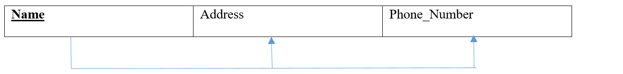

The functional dependencies in this table are:

Name 🡪 (Address, Phone_Number)

**1NF:** The table satisfies 1NF because all columns contain atomic values. There are no repeating groups. Each row is uniquely identified by the primary key (Name).

**2NF:** The table satisfies 2NF because it is in 1NF, and all non-prime attributes (Address, Phone_Number) depend entirely on the primary key (Name).There are no partial dependencies since Name is the single-column primary key.

**3NF:** The table satisfies 3NF because it is in 2NF, and all non-prime attributes (Address, Phone_Number) depend directly on the primary key (Name). There are no transitive dependencies since there is no attribute that depends on another non-prime attribute.

**BCNF:** The table satisfies BCNF because it is in 3NF, and every functional dependency has a superkey determinant. The only functional dependencies in this table are based on the primary key (Name), which uniquely identifies each row.

**Relation8: Items**

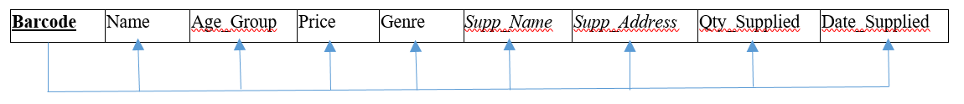

The functional dependencies in this table are:

Barcode 🡪 (Name, Age_Group, Price, Genre)

{Barcode, Supp_Name, Supp_Address, Date_Supplied} 🡪 Qty_Supplied

**1NF:** The table satisfies 1NF because all attributes contain atomic values (e.g., Name, Age_Group, Price, Genre, etc.). There are no repeating groups or multivalued attributes. Each row is uniquely identified by the primary key (Barcode).

**2NF:** The table does not satisfy 2NF because there are attributes (Qty_Supplied) that do not depend solely on the primary key (Barcode) but instead on combinations of attributes.

**3NF:** The table does not satisfy 3NF because it is not in 2NF although there is no direct transitive dependency (no non-prime attribute depends on another non-prime attribute), but the failure to satisfy 2NF disqualifies 3NF.

**BCNF:** The table does not satisfy BCNF because {Barcode, Supp_Name, Supp_Address, Date_Supplied} is not a superkey but determines Qty_Supplied.

**Normalizing “Items”:**

To normalize the table and ensure it satisfies BCNF, we propose decomposing it into two tables. The first table, Product Table, will store product-specific information. This table will include the attributes Barcode, Name, Age_Group, Price, and Genre, with the functional dependency Barcode → (Name, Age_Group, Price, Genre). The second table, Supply Table, will store supply-specific details. This table will include the attributes Barcode, Supp_Name, Supp_Address, Date_Supplied, and Qty_Supplied, with the functional dependency {Barcode, Supp_Name, Supp_Address, Date_Supplied} → Qty_Supplied. This decomposition removes the partial dependency and ensures that both tables adhere to BCNF, as all functional dependencies now have determinants that are superkeys.

Relation: Items A

|  |  |  |  |  |
| --- | --- | --- | --- | --- |
| **Barcode** | Name | Age_Group | Price | Genre |

The functional dependencies are:

Barcode 🡪 (Name, Age_Group, Price, Genre)

Relation: Items B

|  |  |  |  |  |
| --- | --- | --- | --- | --- |
| **Barcode** | **Supp_Name** | **Supp_Address** | **Date_Supplied** | Qty_Supplied |

The functional dependency is:

{Barcode, Supp_Name, Supp_Address, Date_Supplied} 🡪 Qty_Supplied

**Relation9: Books_for_Sale**

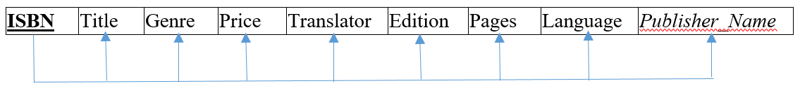

The functional dependency in this table is:

ISBN 🡪 (Title, Genre, Price, Translator, Edition, Pages, Language, Publisher_Name)

**1NF:** The table satisfies 1NF because all attributes contain atomic values (e.g., Title, Genre, Price, Edition, etc.). There are no repeating groups or multivalued attributes within the table itself. Each row is uniquely identified by the primary key (ISBN). Multivalued attributes, such as authors_booksale, are stored in a separate table (Authors_BookSale), ensuring normalization.

**2NF:** The table satisfies 2NF because it is in 1NF and all non-prime attributes (Title, Genre, Price, Translator, Edition, Pages, Language, Publisher_Name) are functionally dependent on the primary key (ISBN). There are no partial dependencies, as ISBN is the single-column primary key.

**3NF:** The table satisfies 3NF because it is in 2NF and there are no transitive dependencies. Each non-prime attribute directly depends on the primary key (ISBN) and does not depend on another non-prime attribute. The foreign key (Publisher_Name) depends only on the primary key (ISBN) and ensures referential integrity with the Publisher table.

**BCNF:** The table satisfies BCNF because it is in 3NF, and every functional dependency has a determinant that is a superkey. The only functional dependencies in the table are based on the primary key (ISBN), which uniquely identifies each row.

**Relation10: Books_for_Rent**



The functional dependency in this table is:

BookID 🡪 (ISBN, Title, Genre, Price, Translator, Edition, Pages, Language, Publisher_Name, Shelf_No, Row_No, BranchID)

**1NF:** The table satisfies 1NF because all attributes contain atomic values (e.g., Title, Genre, Price, Edition, etc.). There are no repeating groups or multivalued attributes within this table itself. Each row is uniquely identified by the primary key (BookID). Multivalued attributes, such as Authors_bookrent, are stored in a separate table (Authors_BookRent), ensuring normalization.

**2NF:** The table satisfies 2NF because it is in 1NF, and all non-prime attributes (ISBN, Title, Genre, Price, Translator, Edition, Pages, Language, Publisher_Name, Shelf_No, Row_No, BranchID) are functionally dependent on the primary key (BookID). The multivalued attribute (Author_bookrent) is managed in the separate table Authors_BookRent, ensuring no partial dependencies.

**3NF:** The table satisfies 3NF because it is in 2NF, and there are no transitive dependencies. Each non-prime attribute depends directly on the primary key (BookID), and no attribute depends on another non-prime attribute. Foreign keys (ISBN, Publisher_Name, BranchID) ensure referential integrity with their respective related tables (Books_for_Sale, Publisher, and Libraryy).

**BCNF:** The table satisfies BCNF because it is in 3NF, and every functional dependency has a determinant that is a superkey. The only functional dependencies in this table are based on the primary key (BookID), which uniquely identifies each row.

**Relation11: Authors_BookSale**



There are no functional dependencies in this table

**1NF:** The table satisfies 1NF because all attributes contain atomic values (e.g., ISBN, Author_Name). There are no repeating groups or multivalued attributes. Each row is uniquely identified by the composite primary key (ISBN, Author_Name). ISBN is a foreign key referencing the Books_for_Sale table, ensuring referential integrity between the two tables.

**2NF:** The table satisfies 2NF because it is in 1NF, and all non-prime attributes (none exist here) are fully functionally dependent on the entire composite key (ISBN, Author_Name). There are no partial dependencies, and ISBN refers to the Books_for_Sale table.

**3NF:** The table satisfies 3NF because it is in 2NF, and there are no transitive dependencies since the only attributes (ISBN, Author_Name) are part of the composite key or depend on it. ISBN references Books_for_Sale, and does not violate 3NF because it is an **external dependency** and does not introduce any redundancy or anomalies within the table itself.

**BCNF:** The table satisfies BCNF because it is in 3NF, and every determinant is a superkey because the only functional dependency is between the composite primary key (ISBN, Author_Name) and the attributes in the tables. ISBN maintains its role as a foreign key to Books_for_Sale.

**Relation12: Authors_BookRent**



There are no functional dependencies in this table

**1NF:** The table satisfies 1NF because all attributes (BookID, Author_Name) are atomic. There are no repeating groups or multivalued attributes. Each row is uniquely identified by the composite primary key (BookID, Author_Name). BookID is a foreign key referencing the Books_for_Rent table, ensuring referential integrity between the two tables.

**2NF:** The table satisfies 2NF because it is in 1NF, and all non-prime attributes (none exist here) are fully functionally dependent on the entire composite primary key (BookID, Author_Name). There are no partial dependencies, and BookID refers to the Books_for_Rent table.

**3NF:** The table satisfies 3NF because it is in 2NF, and there are no transitive dependencies because the only attributes (BookID, Author_Name) are part of the composite key or depend on it. BookID references Books_for_Rent, and does not violate 3NF because it is an **external dependency** and does not introduce any redundancy or anomalies within the table itself.

**BCNF:** The table satisfies BCNF because it is in 3NF, and every determinant is a superkey because the only functional dependency is between the composite key (BookID, Author_Name) and the attributes in the table. BookID maintains its role as a foreign key to Books_for_Rent.

**Relation13: Stores_Items**

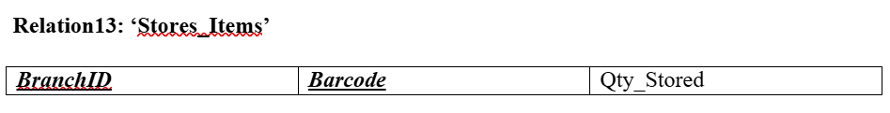

The functional dependency in this table is:

{BranchID, Barcode} 🡪 Qty_Stored

**1NF:** This table satisfies 1NF because all attributes contain atomic values and there are no repeating groups or arrays. Each row is uniquely identified by the composite primary key (BranchID + Barcode).

**2NF:** This table satisfies 2NF because it is in 1NF, and all non-prime attributes (in this case, Qty_Stored) depend entirely on the composite primary key (BranchID + Barcode). Since there are no partial dependencies (i.e., Qty_Stored does not depend on just BranchID or Barcode alone), the table adheres to 2NF.

**3NF:** This table satisfies 3NF because it is in 2NF, and there are no transitive dependencies. The only non-prime attribute, Qty_Stored, directly depends on the composite primary key (BranchID + Barcode) and not on any other non-prime attributes.

**BCNF:** This table satisfies BCNF because it is in 3NF, and every functional dependency has a determinant that is a superkey. The composite primary key (BranchID + Barcode) uniquely identifies each row.

**Relation14: Stores_Booksforsale**



The functional dependency in this table is:

{BranchID, ISBN} 🡪 Number_of_Copies

**1NF:** This table satisfies 1NF because all attributes contain atomic values and there are no repeating groups or arrays. Each row is uniquely identified by the composite primary key (BranchID + ISBN).

**2NF:** This table satisfies 2NF because it is in 1NF, and all non-prime attributes (Number_of_Copies) depend entirely on the composite primary key (BranchID + ISBN). Since there are no partial dependencies (i.e., Number_of_Copies does not depend on just BranchID or ISBN alone), the table adheres to 2NF.

**3NF:** This table satisfies 3NF because it is in 2NF, and there are no transitive dependencies. The only non-prime attribute, Number_of_Copies, directly depends on the composite primary key (BranchID + ISBN) and not on any other non-prime attributes.

**BCNF:** This table satisfies BCNF because it is in 3NF, and every functional dependency has a determinant that is a superkey. The composite primary key (**BranchID + ISBN**) uniquely identifies each row.

**Relation15: Buys_Books**

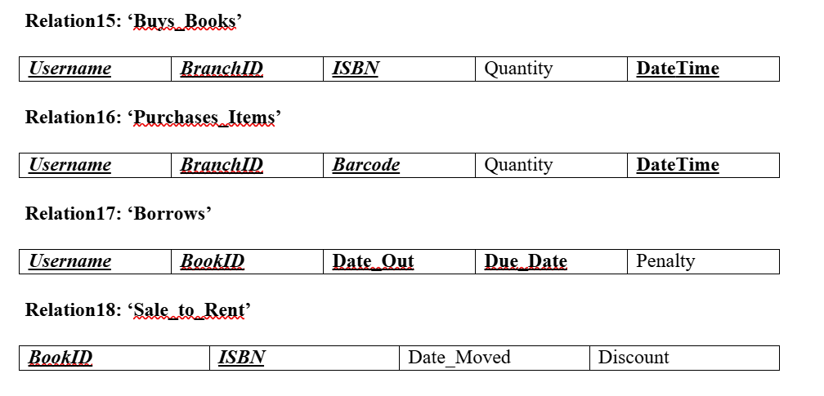

The functional dependency is:

{Username, BranchID, ISBN, DateTime} 🡪 Quantity

**1NF:** This table satisfies 1NF because all attributes contain atomic values and there are no repeating groups or arrays. Each row is uniquely identified by the composite primary key (Username + BranchID + ISBN + DateTime).

**2NF:** This table satisfies 2NF because it is in 1NF, and all non-prime attributes (Quantity) depend entirely on the composite primary key (Username + BranchID + ISBN + DateTime). There are no partial dependencies (i.e., Quantity does not depend on any subset of the composite key alone).

**3NF:** This table satisfies 3NF because it is in 2NF, and there are no transitive dependencies. The only non-prime attribute, Quantity, directly depends on the composite primary key (Username + BranchID + ISBN + DateTime) and not on any other non-prime attributes.

**BCNF:** This table satisfies BCNF because it is in 3NF, and every functional dependency has a determinant that is a superkey. The composite primary key **(Username + BranchID + ISBN + DateTime)** uniquely identifies each row.

**Relation16: Purchases_Items**



**The functional dependency in this table is:**

{Username, BranchID, ISBN, DateTime} 🡪 Quantity

**1NF:** This table satisfies 1NF because all attributes contain atomic values and there are no repeating groups or arrays. Each row is uniquely identified by the composite primary key (**Username + BranchID + Barcode + DateTime**).

**2NF:** This table satisfies 2NF because it is in 1NF, and all non-prime attributes (Quantity) depend entirely on the composite primary key (**Username + BranchID + Barcode + DateTime**). There are no partial dependencies (i.e., Quantity does not depend on any subset of the composite key alone).

**3NF:** This table satisfies 3NF because it is in 2NF, and there are no transitive dependencies. The only non-prime attribute, Quantity, directly depends on the composite primary key (**Username + BranchID + Barcode + DateTime**) and not on any other non-prime attributes.

**BCNF:** This table satisfies BCNF because it is in 3NF, and every functional dependency has a determinant that is a superkey. The composite primary key (**Username + BranchID + Barcode + DateTime**) uniquely identifies each row, and there are no anomalies arising from other dependencies.

**Relation17: Borrows**

|  |  |  |  |  |  |
| --- | --- | --- | --- | --- | --- |
| ***Username*** | ***BookID*** | **Date_Out** | Due_Date | Penalty | Status |

The functional dependencies in this table are:

{Username, BookID, Date_Out} 🡪 (Due_Date, Penalty, Status)

**1NF:** This table satisfies 1NF because all attributes contain atomic values and there are no repeating groups or arrays. Each row is uniquely identified by the composite primary key (Username + BookID + Date_Out + Due_Date).

**2NF:** This table satisfies 2NF because it is in 1NF, and all non-prime attributes (Due_Date, Penalty, Status) are fully functionally dependent on the entire composite primary key {Username, BookID, Date_Out}. There are no partial dependencies, as all non-prime attributes depend on the full composite key rather than just part of it.

**3NF:** This table satisfies 3NF because it is in 2NF, and there are no transitive dependencies. All non-prime attributes (Due_Date, Penalty, Status) depend directly on the composite primary key {Username, BookID, Date_Out}, and there are no intermediate dependencies between non-prime attributes.

**BCNF:** This table satisfies BCNF because it is in 3NF, and every determinant (e.g., {Username, BookID, Date_Out}) is a superkey. There are no functional dependencies where a non-superkey determines other attributes, ensuring no violations of BCNF rules.

**Relation18: Sale_to_Rent**



The functional dependencies in this table are:

BookID 🡪 (ISBN, Date_Moved, Discount)

**1NF:** This table satisfies 1NF because all attributes contain atomic values and there are no repeating groups or arrays. Each row is uniquely identified by the composite primary key (BookID + ISBN).

**2NF:** This table does not satisfy 2NF because while it is in 1NF, the non-prime attributes (Date_Moved and Discount) are functionally dependent only on BookID, which is a **part** of the composite primary key (BookID, ISBN). This creates a partial dependency, violating 2NF.

**3NF:** This table does not satisfy 3NF because it fails 2NF due to the partial dependency. Additionally, ISBN is also determined by BookID, meaning there’s redundancy in the composite key (BookID, ISBN).

**BCNF:** This table does not satisfy BCNF because BookID, which is not a superkey on its own, determines ISBN, Date_Moved, and Discount.

**Normalization of “Sale_to_Rent”:**

To normalize the table and ensure it adheres to BCNF, we must address the issue that BookID determines ISBN, Date_Moved, and Discount, which violates 2NF and BCNF because BookID is not the full primary key (the composite key is (BookID, ISBN)). The proposed fix involves decomposing the table into two smaller tables, each with its own meaningful functional dependencies, as follows:

Relation: Sale_to_Rent A

|  |  |  |  |
| --- | --- | --- | --- |
| **BookID** | ISBN | Date_Moved | Discount |

The functional dependencies are:

BookID 🡪 (ISBN, Date_Moved, Discount)

Relation: Sale_to_Rent B

|  |  |
| --- | --- |
| **BookID** | ISBN |

The functional dependency is:

BookID 🡪 ISBN

# **Conclusion**

In conclusion, we have successfully designed the database system by drawing the Entity Relationship (ER) diagram and mapping it into corresponding relational schemas. The tables were created, and data was inserted seamlessly to reflect the requirements of the system. Furthermore, we implemented a range of advanced functionalities, including queries, views, triggers, functions, stored procedures, and recursive queries, ensuring comprehensive support for complex operations and data manipulation. Security mechanisms were integrated to safeguard data integrity and access control. Moreover, normalization techniques were applied to eliminate redundancies and maintain data consistency. This approach ensures the system is robust, secure, and capable of meeting both functional and non-functional requirements effectively.